**[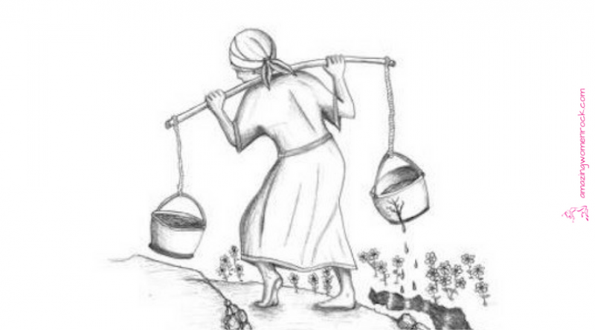](https://amazingwomenrock.com/the-cracked-pot-a-story-for-anyone-who-s-not-quite-perfect)THE CRACKED POT:**

**A STORY FOR ANYONE WHO'S NOT QUITE PERFECT**

**A water bearer in India had two large pots, one hung on each end of a pole, which she carried across her neck.**

**One of the pots had a crack in it. While the other pot was perfect, and always delivered a full portion of water at the end of the long walk from the stream to the mistress's house, the cracked pot arrived only half full.**

**For a full two years this went on daily, with the bearer delivering only one and a half pots full of water to her master's house.**

**https://ir-na.amazon-adsystem.com/e/ir?t=marpomultimed-20&l=li2&o=1&a=1492727679  https://ir-na.amazon-adsystem.com/e/ir?t=marpomultimed-20&l=li2&o=1&a=B0186N9LSO  https://ir-na.amazon-adsystem.com/e/ir?t=marpomultimed-20&l=li2&o=1&a=147740970X**

**The perfect pot was proud of its accomplishments, perfect to the end for which it was made. But the poor cracked pot was ashamed of**[**its own imperfection**](https://amazingwomenrock.com/killing-ourselves-softly-while-trying-to-be-perfect)**, and miserable that it was able to accomplish only half of what it had been made to do.**

**After two years of what it perceived to be a**[**bitter failure**](https://amazingwomenrock.com/the-fringe-benefits-of-failure-and-the-importance-of-imagination)**, it spoke to the water bearer one day by the stream: "I am ashamed of myself, and I want to apologize to you."**

**Why?" asked the bearer. "**[**What are you ashamed of**](https://amazingwomenrock.com/brene-brown-listens-to-shame)**?"**

**"I have been able, for these past two years, to deliver only half my load because this crack in my side causes water to leak out all the way back to your mistress's house. Because of my flaws, you have to do all of this work, and you don't get full value from your efforts," the pot said.**

**The water bearer felt sorry for the old cracked pot, and in her compassion she said, "As we return to the mistress's house, I want you to notice the beautiful flowers along the path."**

