**A survey- Smartphone usage habits questionnaire**

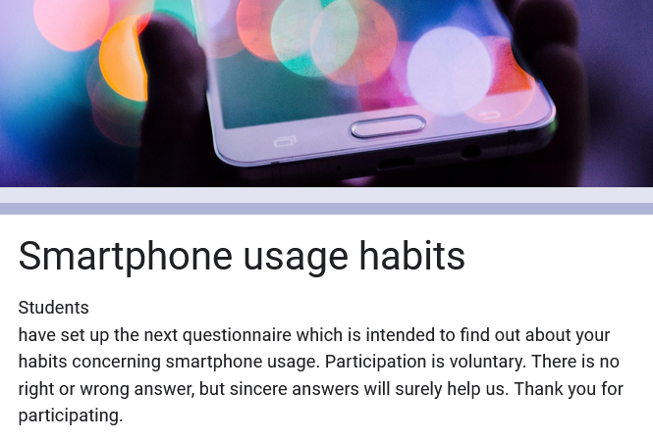 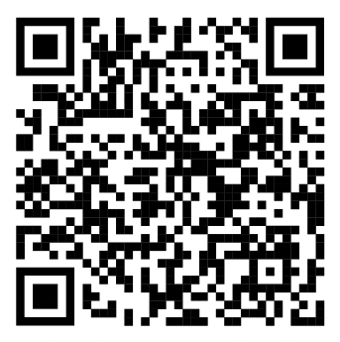

Students have set up the next questionnaire which is intended to find out about your habits concerning smartphone usage. Participation is voluntary. There is no right or wrong answer, but sincere answers will surely help us. Thank you for participating.

<https://forms.gle/uPP2xQEXg4Rxvx5SA>