**Kahoot! - Mobile phone addiction and social media security**

Play this Kahoot – **Scan the QR code**

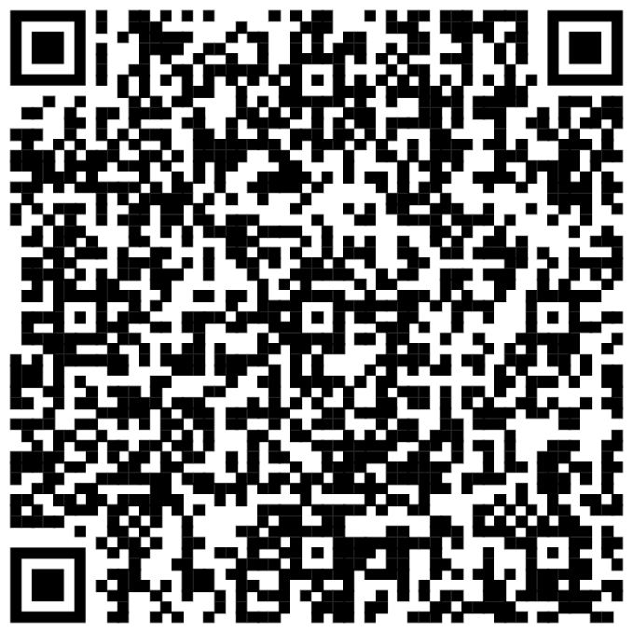

OR

**Follow the link**

<https://kahoot.it/challenge/02821776?challenge-id=1023edc3-368f-4a31-a6be-827a0d8cf324_1739993210971>

Game PIN

02821776