Kid’s Healthy Eating Plate

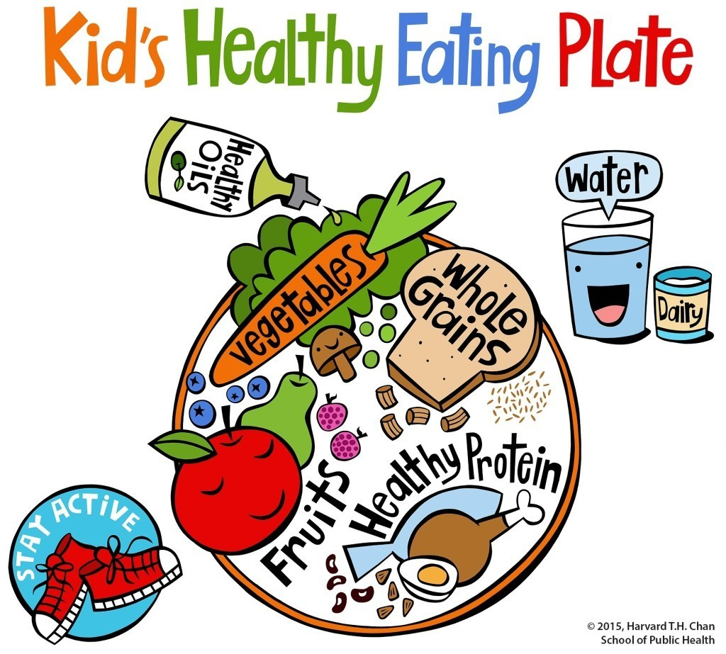

* **Fill half of your plate with colourful vegetables and fruits, split the other half between whole grains and healthy protein.**
* **Go for munchies that crunch! (apples, carrot sticks, popcorn, nuts, seeds)**
* **Drink plain water (Not glam enough? Add some fruit and herbs to it!)**
* **Finally (drumroll please): Snacks to curb your sweet tooth such as baked apple, frozen fruit salad, raisins, figs, homemade banana-nut bread…**

**Answer the questions in full sentences.**

* **Do you eat plenty of vegetables and fruits of all colours?**
* **Do you choose whole fruits rather than fruit juices?**
* **Do you know what whole grains are? Do you prefer them?**
* **Do you eat healthy protein such as peas, nuts, fish, eggs and poultry?**
* **Do you avoid red meat and sausages?**
* **Do you choose unflavoured milk and plain yoghurt?**
* **Do you avoid sugary drinks?**
* **How much water do you drink?**
* **Do you always eat breakfast?**
* **Do you always clean your plate?**
* **Do you eat too fast?**
* **Do you eat when you are not hungry?**
* **Do you eat while watching television?**
* **Do you skip meals?**
* **Do you eat when you feel bored or tired and need a little pick-me-up?**

