# *Remembrance Day*

Remembrance honours those who serve to defend democratic freedoms and way of life.

Unity across faiths, cultures and backgrounds to remember the service and sacrifice of the Armed Forces community from Britain and the Commonwealth.

* Listen to [The Last Post](https://www.youtube.com/watch?v=EDS3TxtGaQ0)

During WW1, much of the fighting took place in Western Europe. The countryside was blasted, bombed and fought over repeatedly. Previously beautiful landscapes turned to mud; bleak and barren scenes where little or nothing could grow.

There was a notable and striking exception to the bleakness - the bright red Flanders poppies. These resilient flowers flourished in the middle of so much chaos and destruction, growing in the thousands upon thousands.

## In the Spring of 1915

Shortly after losing a friend in Ypres, a Canadian doctor, Lieutenant Colonel John McCrae was moved by the sight of these poppies and that inspiration led him to to write the now famous poem **'In Flanders Fields'.**

**In Flanders' fields the poppies blow  
Between the crosses, row on row,  
That mark our place: and in the sky  
The larks, still bravely singing, fly  
Scarce heard amid the guns below.**

**We are the dead. Short days ago  
We lived, felt dawn, saw sunset glow,  
Loved and were loved, and now we lie  
In Flanders' fields.**

**Take up our quarrel with the foe;  
To you from failing hands we throw  
The torch; be yours to hold it high,  
If ye break faith with us who die  
We shall not sleep, though poppies grow  
In Flanders' Fields.**

* Listen to the [poem](https://www.youtube.com/watch?v=cKoJvHcMLfc) recited by Leonard Cohen.

**Remembrance Sunday**, in the [United Kingdom](https://www.britannica.com/place/United-Kingdom), [holiday](https://www.britannica.com/topic/holiday) held on the second Sunday of November that [commemorates](https://www.merriam-webster.com/dictionary/commemorates) British service members who have died in wars and other military conflicts since the onset of [World War I](https://www.britannica.com/event/World-War-I). By tradition, a two-minute period of silence is observed throughout the country at 11 AM, and church services and other ceremonial gatherings take place during the day. A nationally televised remembrance service, generally attended by politicians, religious leaders, military personnel, and members of the British royal family, has been held for decades at the Cenotaph monument in central London.

The holiday has its origins in Armistice Day, which was dedicated in Great Britain on Nov. 11, 1919, in commemoration of the one-year anniversary of the peace agreement that ended World War I.

The poem then inspired an American academic named Moina Michael to adopt the poppy in memory of those who had fallen in the war and she campaigned to get it adopted as an official symbol of Remembrance across the United States and worked with others who were trying to do the same in Canada, Australia and the UK.

Also involved with those efforts was a French woman, Anna Guérin who was in the UK in 1921 where she planned to sell the poppies in London.

There she met Earl Haig, founder of the Royal British Legion, who was persuaded to adopt the poppy as an emblem for the Legion in the UK. The Legion, which had been formed in 1921, ordered nine million poppies and sold them on 11 November that year.

The poppies sold out almost immediately. That first 'Poppy Appeal' raised over £106,000 to help veterans with housing and jobs; a considerable sum at the time. Today's Poppy Appeal? 40,000 volunteers distribute 40 million poppies.

**Kohima Epitaph**

The Kohima Epitaph is the epitaph carved on the Memorial of the 2nd British Division in the cemetery of Kohima (North-East India). It reads:

**'When You Go Home, Tell Them Of Us And Say,  
For Your Tomorrow, We Gave Our Today.'**

The verse is attributed to John Maxwell Edmonds (1875-1958), and is thought to have been inspired by the epitaph written by Simonides to honour the Greeks who fell at the Battle of Thermopylae in 480BC.

Ω ξειν, αγγέλλειν Λακεδαιμονίοις ότι τήδε κείμεθα τοις κείνων ρήμασι πειθόμενοι

Σιμωνίδης ο Κείος

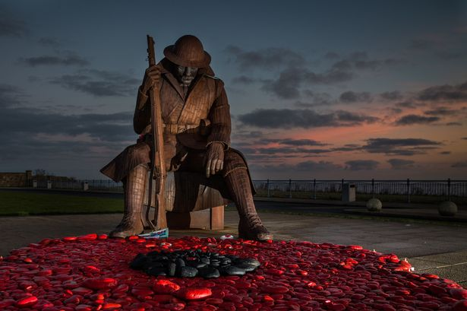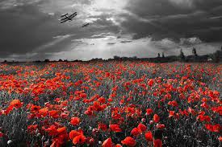

Source: https://www.britishlegion.org.uk/get-involved/remembrance