**ΦΥΛΛΟ ΕΡΓΑΣΙΑΣ 1 – A Human Rights Champion**

1. **Warm-up: What are ‘human rights?’**
   1. **Brainstorming game:** In groups, write down as many words/phrases related to ‘human rights’ as you can in 30 seconds. Then, report back to the class. The group that has the most correct words/phrases is the winner.
   2. Which of the following statements are true? Discuss in your group, then report back to the class.
      * Human rights may vary from country to country.
      * There is a specific list of human rights.
      * All human rights are included in a single official document.
   3. Watch a video about Human Rights by Youth for Human Rights International (YHRI) and check your answers in ex. 1b above.

**Video link:** <https://www.youthforhumanrights.org/what-are-human-rights/> **(beginning to 2.05’)**

1. **Reading: A Human Rights Champion**
   1. Read the following text about Eleanor Roosevelt. What was her role in formulating and implementing the Universal Declaration of Human Rights? Write a short answer.

__________________________________________________________________________________________________________________________________________________________________________

* 1. Read again and choose the correct answer (A, B or C) for questions 1-4.

1. Who would be most interested in reading this text?
2. Historians b. Politicians c. The general public
3. Eleanor Roosevelt became interested in human rights issues
4. before she became First Lady.
5. when her husband died.
6. when she was appointed as a US delegate to the United Nations.
7. The quotation by Eleanor Roosevelt implies that the Universal Declaration of Human Rights
8. secured the rights of men only.
9. was a great step for humanity.
10. was influenced by her ideas.
11. President Truman called Eleanor Roosevelt “First Lady of the World” because
    1. she had travelled to many countries.
    2. people all around the world loved her.
    3. she fought for people’s rights throughout her life.
    4. In pairs, write a different title for the text. Report back to the class, then vote for the best title.

Champions of Human Rights: Eleanor Roosevelt (1884–1962)

As the Chair of the United Nations Human Rights Commission, Eleanor Roosevelt was the driving force in creating the 1948 charter which will always be her legacy: The Universal Declaration of Human Rights.

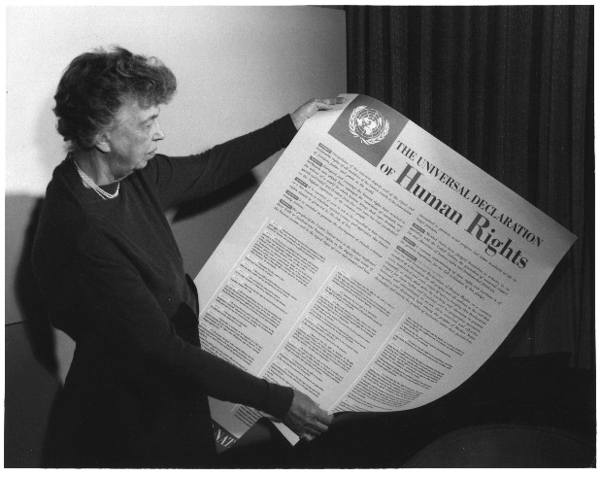Born in New York City, Eleanor married rising politician Franklin Delano Roosevelt in 1905 and became fully immersed in public service. By the time they arrived in the White House in 1933 as President and First Lady, she was already deeply involved in human rights and social justice issues. Continuing her work on behalf of all people, she advocated equal rights for women, African-Americans and Depression-era workers bringing inspiration and attention to their causes. Courageously outspoken, she publicly supported Marian Anderson when in 1939 the black singer was denied the use of Washington’s Constitution Hall because of her race. Roosevelt saw to it that Anderson performed instead on the steps of the Lincoln Memorial, creating an enduring and inspiring image of personal courage and human rights.

**As United Nations Delegate**

In 1946, Roosevelt was appointed as a delegate to the United Nations by President Harry Truman, who had succeeded to the White House after the death of Franklin Roosevelt in 1945. As head of the Human Rights Commission, she was instrumental in formulating the *Universal Declaration of Human Rights*, which she submitted to the United Nations General Assembly with these words:

“We stand today at the threshold of a great event both in the life of the United Nations and in the life of mankind. This Declaration may well become the international Magna Carta for all men everywhere.”

Called “First Lady of the World” by President Truman for her lifelong humanitarian achievements, Roosevelt worked to the end of her life to gain acceptance and implementation of the rights set forth in the Declaration. The legacy of her words and her work appears in the constitutions of scores of nations and in an evolving body of international law that now protects the rights of men and women across the world.

**Source:** <https://www.youthforhumanrights.org/voices-for-human-rights/champions/eleanor-roosevelt.html>

1. **Speaking**
   1. How would you describe Eleanor Roosevelt as a person? Talk in pairs and justify your answer with reasons and examples from the text. Share your answers with the class.
   2. Read the following quote by Eleanor Roosevelt about Universal Rights. Do you agree? Why?/Why not? Share your thoughts with the class.

***Where Do Universal Rights Begin?***

*“In small places, close to home - so close and so small that they cannot be seen on any maps of the world. Yet they are the world of the individual person; the neighborhood he lives in; the school or college he attends; the factory, farm or office where he works. Such are the places where every man, woman, and child seeks equal justice, equal opportunity, equal dignity without discrimination. Unless these rights have meaning there, they have little meaning anywhere.”*

Source: (extract from video): <https://www.youthforhumanrights.org/what-are-human-rights/> (8.28’ to the end)

**ΦΥΛΛΟ ΕΡΓΑΣΙΑΣ 1 - ΑΠΑΝΤΗΣΕΙΣ**

**1.**

1. Students provide their own answers.
2. Students provide their own answers.
3. F
4. T
5. T

**2.**

1. **Suggested answer**: Being actively engaged with human rights and social justice issues and as US delegate to the UN and Head of the Human Rights Commission, Eleanor Roosevelt’s role was crucial in the formulation of the Universal Declaration of Human Rights. Moreover, she worked hard until the end of her life towards the acceptance and implementation of the rights included in the Declaration.
2. c
3. a
4. b
5. c
6. Students provide their own answers. Suggested titles:

* Eleanor Roosevelts Legacy in the History of Human Rights
* Eleanor Roosevelt: First Lady of the World

**3.**

1. Students provide their own answers using relevant vocabulary (e.g. inspiring, courageous, outspoken etc.) and examples from the text (e.g. “She publicly supported Marian Anderson when in 1939 the black singer was denied the use of Washington’s Constitution Hall because of her race.”)
2. Students provide their own answers.