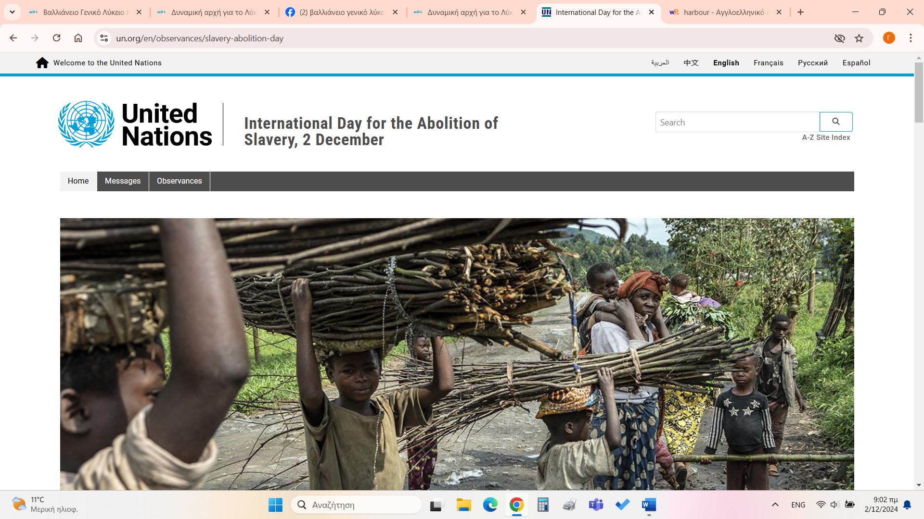

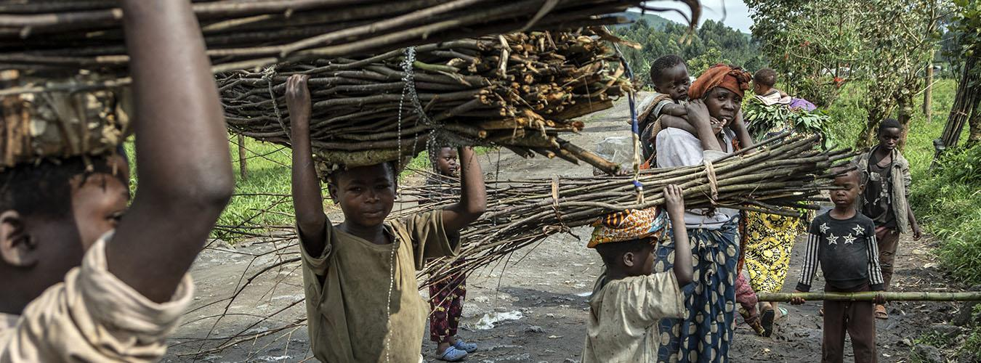

Displaced children carry bundles of sticks along the road between Kitchanga and Mweso, North Kivu, Democratic Republic of Congo.

**Photo:**Photo: © UNICEF/UN0390912/LeMoyne

1. ____________________________

Latest estimates by the International Labour Organisation (ILO) show that forced labour and forced marriage have increased significantly in the last five years. 10 million more people were in modern slavery in 2021 compared to 2016 global estimates, bringing the total to 50 million worldwide. Women and children remain disproportionately vulnerable.

Modern slavery occurs in almost every country in the world, and cuts across ethnic, cultural and religious lines. More than half (52 per cent) of all forced labour and a quarter of all forced marriages can be found in upper-middle income or high-income countries.

1. ___________________________

The International Day for the Abolition of Slavery, 2 December, marks the date of the adoption, by the General Assembly, of the United Nations Convention for the Suppression of the Traffic in Persons and of the Exploitation of the Prostitution of Others (resolution 317(IV) of 2 December 1949).

The focus of this day is on eradicating contemporary forms of slavery, such as trafficking in persons, sexual exploitation, the worst forms of child labour, forced marriage, and the forced recruitment of children for use in armed conflict.

1. _____________________________

Slavery has evolved and manifested itself in different ways throughout history. Today some traditional forms of slavery still persist in their earlier forms, while others have been transformed into new ones. The UN human rights bodies have documented the persistence of old forms of slavery that are embedded in traditional beliefs and customs. These forms of slavery are the result of long-standing discrimination against the most vulnerable groups in societies, such as those regarded as being of low caste, tribal minorities and indigenous peoples.

1. _____________________________

Alongside traditional forms of forced labour, such as bonded labour and debt bondage there now exist more contemporary forms of forced labour, such as migrant workers, who have been trafficked for economic exploitation of every kind in the world economy: work in domestic servitude, the construction industry, the food and garment industry, the agricultural sector and in forced prostitution.

1. ____________________________

Globally, one in ten children works. The majority of the child labour that occurs today is for economic exploitation. That goes against the Convention on the Rights of the Child, which recognizes “the right of the child to be protected from economic exploitation and from performing any work that is likely to be hazardous or to interfere with the child’s education, or to be harmful to the child’s health or physical, mental, spiritual, moral or social development.”

1. ____________________________

According to the Protocol to Prevent, Suppress and Punish Trafficking in Persons Especially Women and Children, trafficking in persons means the recruitment, transportation, transfer, harbouring or receipt of persons, by means of the threat or use of force or other forms of coercion for the purpose of exploitation. Exploitation includes prostitution of others or other forms of sexual exploitation, forced labour or services, slavery or practices similar to slavery, servitude or the removal of organs. The consent of the person trafficked for exploitation is irrelevant and if the trafficked person is a child, it is a crime even without the use of force.

Source: <https://www.un.org/en/observances/slavery-abolition-day>

1. **Read the text and match the following headings to the paragraphs (1-6).**
   1. Background
   2. Trafficking
   3. Main Forms of Modern Slavery
   4. Forced labour
   5. Child labour
   6. Modern slavery is on the rise
2. **Find an alternative title for the text.**
3. **What is the purpose of the text? Where would you read this kind of text?**
4. **Mark the following sentences as T or F.**
   1. Women and children are more often victims of modern slavery than men.
   2. Forced labour occurs mostly in low-income countries.
   3. Old forms of slavery still exist today.
   4. Migrant workers are mentioned as an example of forced labour.
   5. Most children who work today do it of their own free will.
   6. If a person is not trafficked by force, it is not considered a crime.
5. **What examples of modern day slavery can you think of that exist in your country?**