**The power of poetry: Meet Amanda Gorman**

**Glossary**

**to stand on (someone’s) shoulders (idiom):** to make discoveries, insights or progress due to the discoveries or previous work of those who have come before. / to benefit from the previous experience of (a predecessor in your field). (source: The Free Dictionary)

**to stand for (something) (phr v):** to support or represent a particular idea or set of ideas (source: Cambridge Dictionary)

**Lead-in – Speaking & Video**

1. What is the power of poetry? What does poetry mean to you?
2. How would you answer the following questions?

* Whose shoulders do you stand on?
* What do you stand for?

1. Watch the following TED-Ed talk by Amanda Gorman and answer the questions that appear during the video.

<https://edpuzzle.com/media/602e0f5840e5fe428813f7eb>

**Reading**

**A. Read the New York Times article about Amanda Gorman and answer the following questions.**

1. Who is Amanda Gorman?
2. What is special about her?
3. Why did she write the poem ‘The Hill We Climb’? Which event inspired her to complete the poem?
4. What message is she trying to convey in her poem?
5. What do we learn about Amanda’s background as a poet?
6. Think of an alternative title for the article.

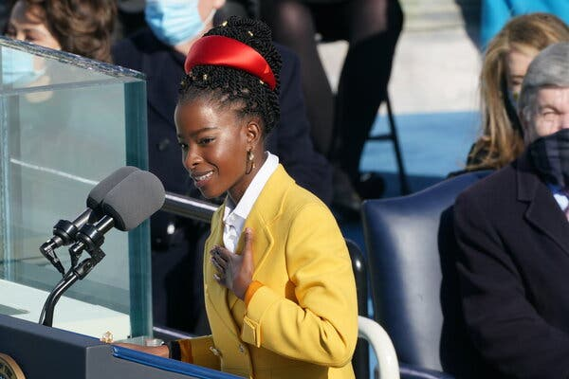Amanda Gorman Captures the Moment, in Verse

**By** [**Alexandra Alter**](https://www.nytimes.com/by/alexandra-alter)

Published Jan. 19, 2021 Updated Jan. 21, 2021

Two weeks ago, the poet [Amanda Gorman](https://www.nytimes.com/2021/01/21/books/amanda-gorman-biden-inauguration-poet-performance.html) was struggling to finish a new work titled “The Hill We Climb.” She was feeling exhausted, and she worried she wasn’t up to the monumental task she faced: composing [a poem about national unity](https://www.nytimes.com/2021/01/21/books/amanda-gorman-biden-inauguration-poet-performance.html) to recite at President-elect Joseph R. Biden Jr.’s **inauguration**.

“I had this huge thing, probably one of the most important things I’ll ever do in my career,” she said in an interview. “It was like, if I try to climb this mountain all at once, I’m just going to pass out.”

Gorman managed to write a few lines a day and was about halfway through the poem on Jan. 6, when pro-Trump rioters stormed into the halls of **Congress**, some bearing weapons and **Confederate** flags. She stayed awake late into the night and finished the poem, adding verses about the apocalyptic scene that unfolded at the Capitol that day:

*We’ve seen a force that would shatter our nation rather than share it,*

*Would destroy our country if it meant delaying democracy.*

*And this effort very nearly succeeded.*

*But while democracy can be periodically delayed,*

*It can never be permanently defeated.*

At 22, Gorman is the youngest **inaugural** poet ever in the United States. But none of her predecessors faced the challenge that Gorman did. She set out to write a poem that would inspire hope and foster a sense of collective purpose, at a moment when Americans are reeling from a deadly pandemic, political violence and partisan division.

“In my poem, I’m not going to in any way **gloss over** what we’ve seen over the past few weeks and, dare I say, the past few years. But what I really aspire to do in the poem is to be able to use my words to envision a way in which our country can still come together and can still heal,” she said. “It’s doing that in a way that is not erasing or neglecting the harsh truths I think America needs to reconcile with.”

On Wednesday, [as she recited “The Hill We Climb,”](https://www.nytimes.com/2021/01/21/books/amanda-gorman-biden-inauguration-poet-performance.html) in front of the Capitol in the bright sunlight, her voice animated and full of emotion, Gorman described her background as a “skinny Black girl, descended from slaves and raised by a single mother,” who can dream of being president one day, “only to find herself reciting for one.” She spoke about the weight of loss that the country has endured, in verses that reflected the fragile state of the country.

*When day comes, we ask ourselves:*

*Where can we find light*

*In this never-ending shade?*

*The loss we carry, a sea we must wade.*

Reading lines that echoed the theme of the inauguration, “America United,” she spoke of the possibility of unity and reconciliation.

*And yet the dawn is ours before we knew it.*

*Somehow, we do it.*

*Somehow, we’ve weathered and witnessed*

*A nation that isn’t broken, but simply unfinished.*

Gorman fell in love with poetry at a young age and distinguished herself quickly as a rising talent. Raised in Los Angeles, where her mother teaches middle school, she would write in journals at the playground. At 16, she was named the Youth Poet Laureate of Los Angeles. A few years later, when she was studying sociology at Harvard, she [became the National Youth Poet Laureate](https://www.nytimes.com/2017/11/03/style/amanda-gorman-first-youth-poet-laureate.html), the first person to hold the position.

Biden’s inaugural committee contacted Gorman late last month. During a video call, she learned that Jill Biden had seen a reading she gave at the Library of Congress and suggested Gorman read something at the inauguration. She wasn’t given any explicit guidelines about what to write, she said.

“They did not want to put up guardrails for me at all,” she said. “The theme for the inauguration in its entirety is ‘America United,’ so when I heard that was their vision, that made it very easy for me to say, great, that’s also what I wanted to write about in my poem, about America united, about a new chapter in our country.”

Source: <https://www.nytimes.com/2021/01/19/books/amanda-gorman-inauguration-hill-we-climb.html>

**Glossary\***

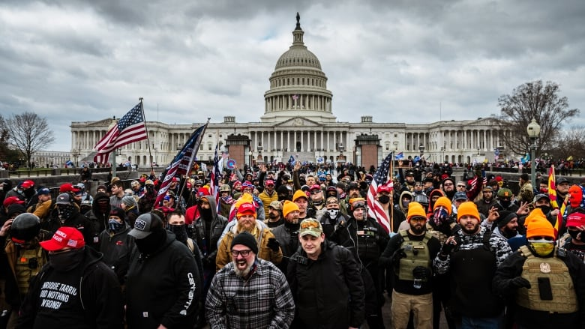Rioters outside the US Capitol

**inauguration (n)**: the act of [officially](https://dictionary.cambridge.org/dictionary/english/officially) putting someone into an [important](https://dictionary.cambridge.org/dictionary/english/important) [position](https://dictionary.cambridge.org/dictionary/english/position), or the [ceremony](https://dictionary.cambridge.org/dictionary/english/ceremony) at which this is done (ορκωμοσία)

**inaugural** **(adj):** relating to an inauguration, e.g. inaugural speech (εναρκτήριος λόγος)

**the Capitol:** the building in which the US Congress meets (Καπιτώλιο)

**the U.S. Congress:** the [elected](https://dictionary.cambridge.org/dictionary/english/elect) [group](https://dictionary.cambridge.org/dictionary/english/group) of [politicians](https://dictionary.cambridge.org/dictionary/english/politician) in the US who are [responsible](https://dictionary.cambridge.org/dictionary/english/responsible) for making the [law](https://dictionary.cambridge.org/dictionary/english/law), consisting of the [Senate](https://dictionary.cambridge.org/dictionary/english/senate) and the [House](https://dictionary.cambridge.org/dictionary/english/house-of-commons) of [Representatives](https://dictionary.cambridge.org/dictionary/english/house-of-representatives) (Κογκρέσο)

Confederate States flag (left) and Confederate battle flag (right)

**Confederate** **flag**: the flag of the Confederate States of America or the Confederacy, a [group](https://dictionary.cambridge.org/dictionary/english/group) of [southern](https://dictionary.cambridge.org/dictionary/english/south) [states](https://dictionary.cambridge.org/dictionary/english/state) in the American Civil War that [fought](https://dictionary.cambridge.org/dictionary/english/fought) to [leave](https://dictionary.cambridge.org/dictionary/english/leave) the [United](https://dictionary.cambridge.org/dictionary/english/united-church-of-canada) [States](https://dictionary.cambridge.org/dictionary/english/confederate-states) and [keep](https://dictionary.cambridge.org/dictionary/english/keep) [slavery](https://dictionary.cambridge.org/dictionary/english/slavery) (σημαία της Συνομοσπονδίας)

**laureate (n):**  [a person](https://dictionary.cambridge.org/dictionary/english/person) who has been given a very high [honour](https://dictionary.cambridge.org/dictionary/english/honour) because of [their](https://dictionary.cambridge.org/dictionary/english/their) [ability](https://dictionary.cambridge.org/dictionary/english/ability) in a [subject](https://dictionary.cambridge.org/dictionary/english/subject) of [study](https://dictionary.cambridge.org/dictionary/english/study), e.g. a Nobel laureate (βραβευμένος)

**\*definitions by Cambridge Online Dictionary**

**B. For questions 1-5, choose the best answer (a, b or c).**

1. Before the riots at the Capitol, Amanda

1. had almost finished her poem.
2. had written almost half of her poem.
3. had run out of ideas for her poem.

2. Amanda’s task was more difficult than that of the previous inaugural poets because of

1. her young age.
2. her lack of experience.
3. the difficult historic moment.

3. The word **gloss over** on page 2 means

1. to make something seem not important.
2. to explain something in detail.
3. to make something attractive.

4. Amanda started writing poetry

1. because of her mother.
2. when she was sixteen.
3. at an early age.

5. The inaugural committee

1. set specific guidelines for Amanda’s poem.
2. gave her the main idea of the event.
3. did not make any suggestions as to what they expected.

**Follow-up – So, what is poetry? Food for thought…**

1. What makes a poem… a poem? What poetic elements can you find in the following poems?

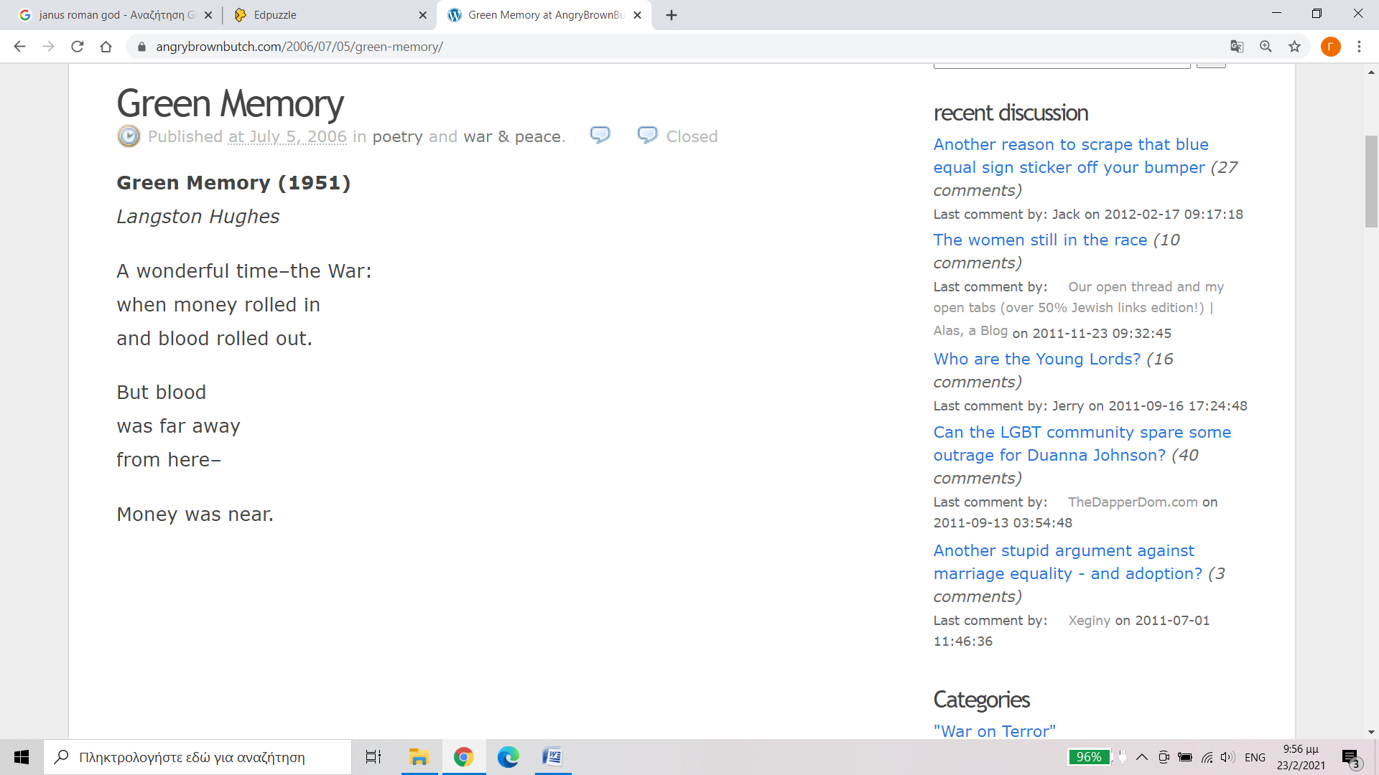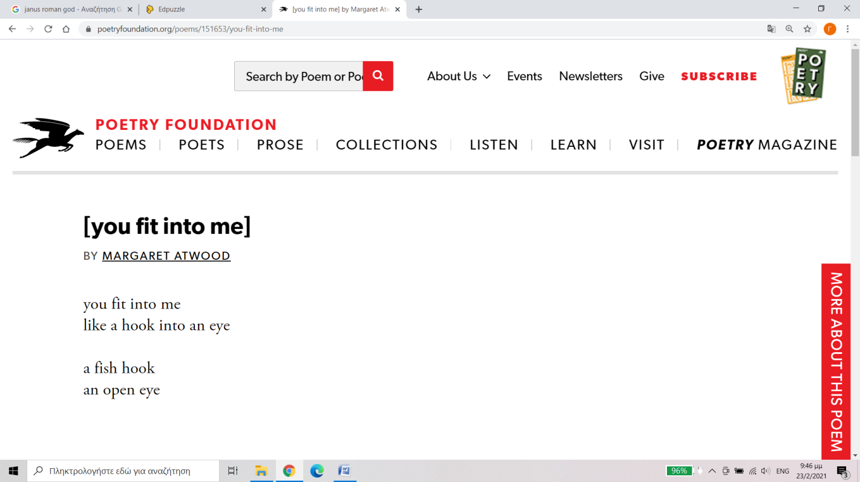

**In A Station Of The Metro  
*by Ezra Pound (1916)***

The apparition of these faces in the crowd;  
Petals on a wet, black bough.

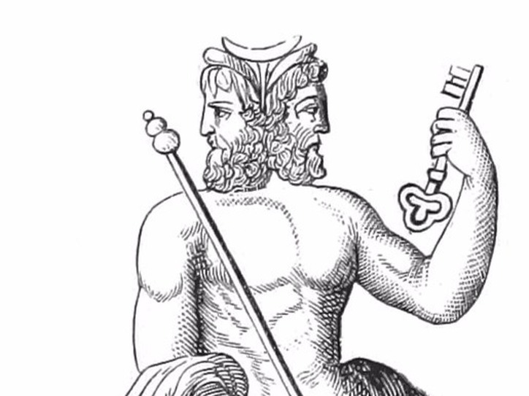  
Janus, the two-faced Roman god of beginnings, doors, gates, passages and endings

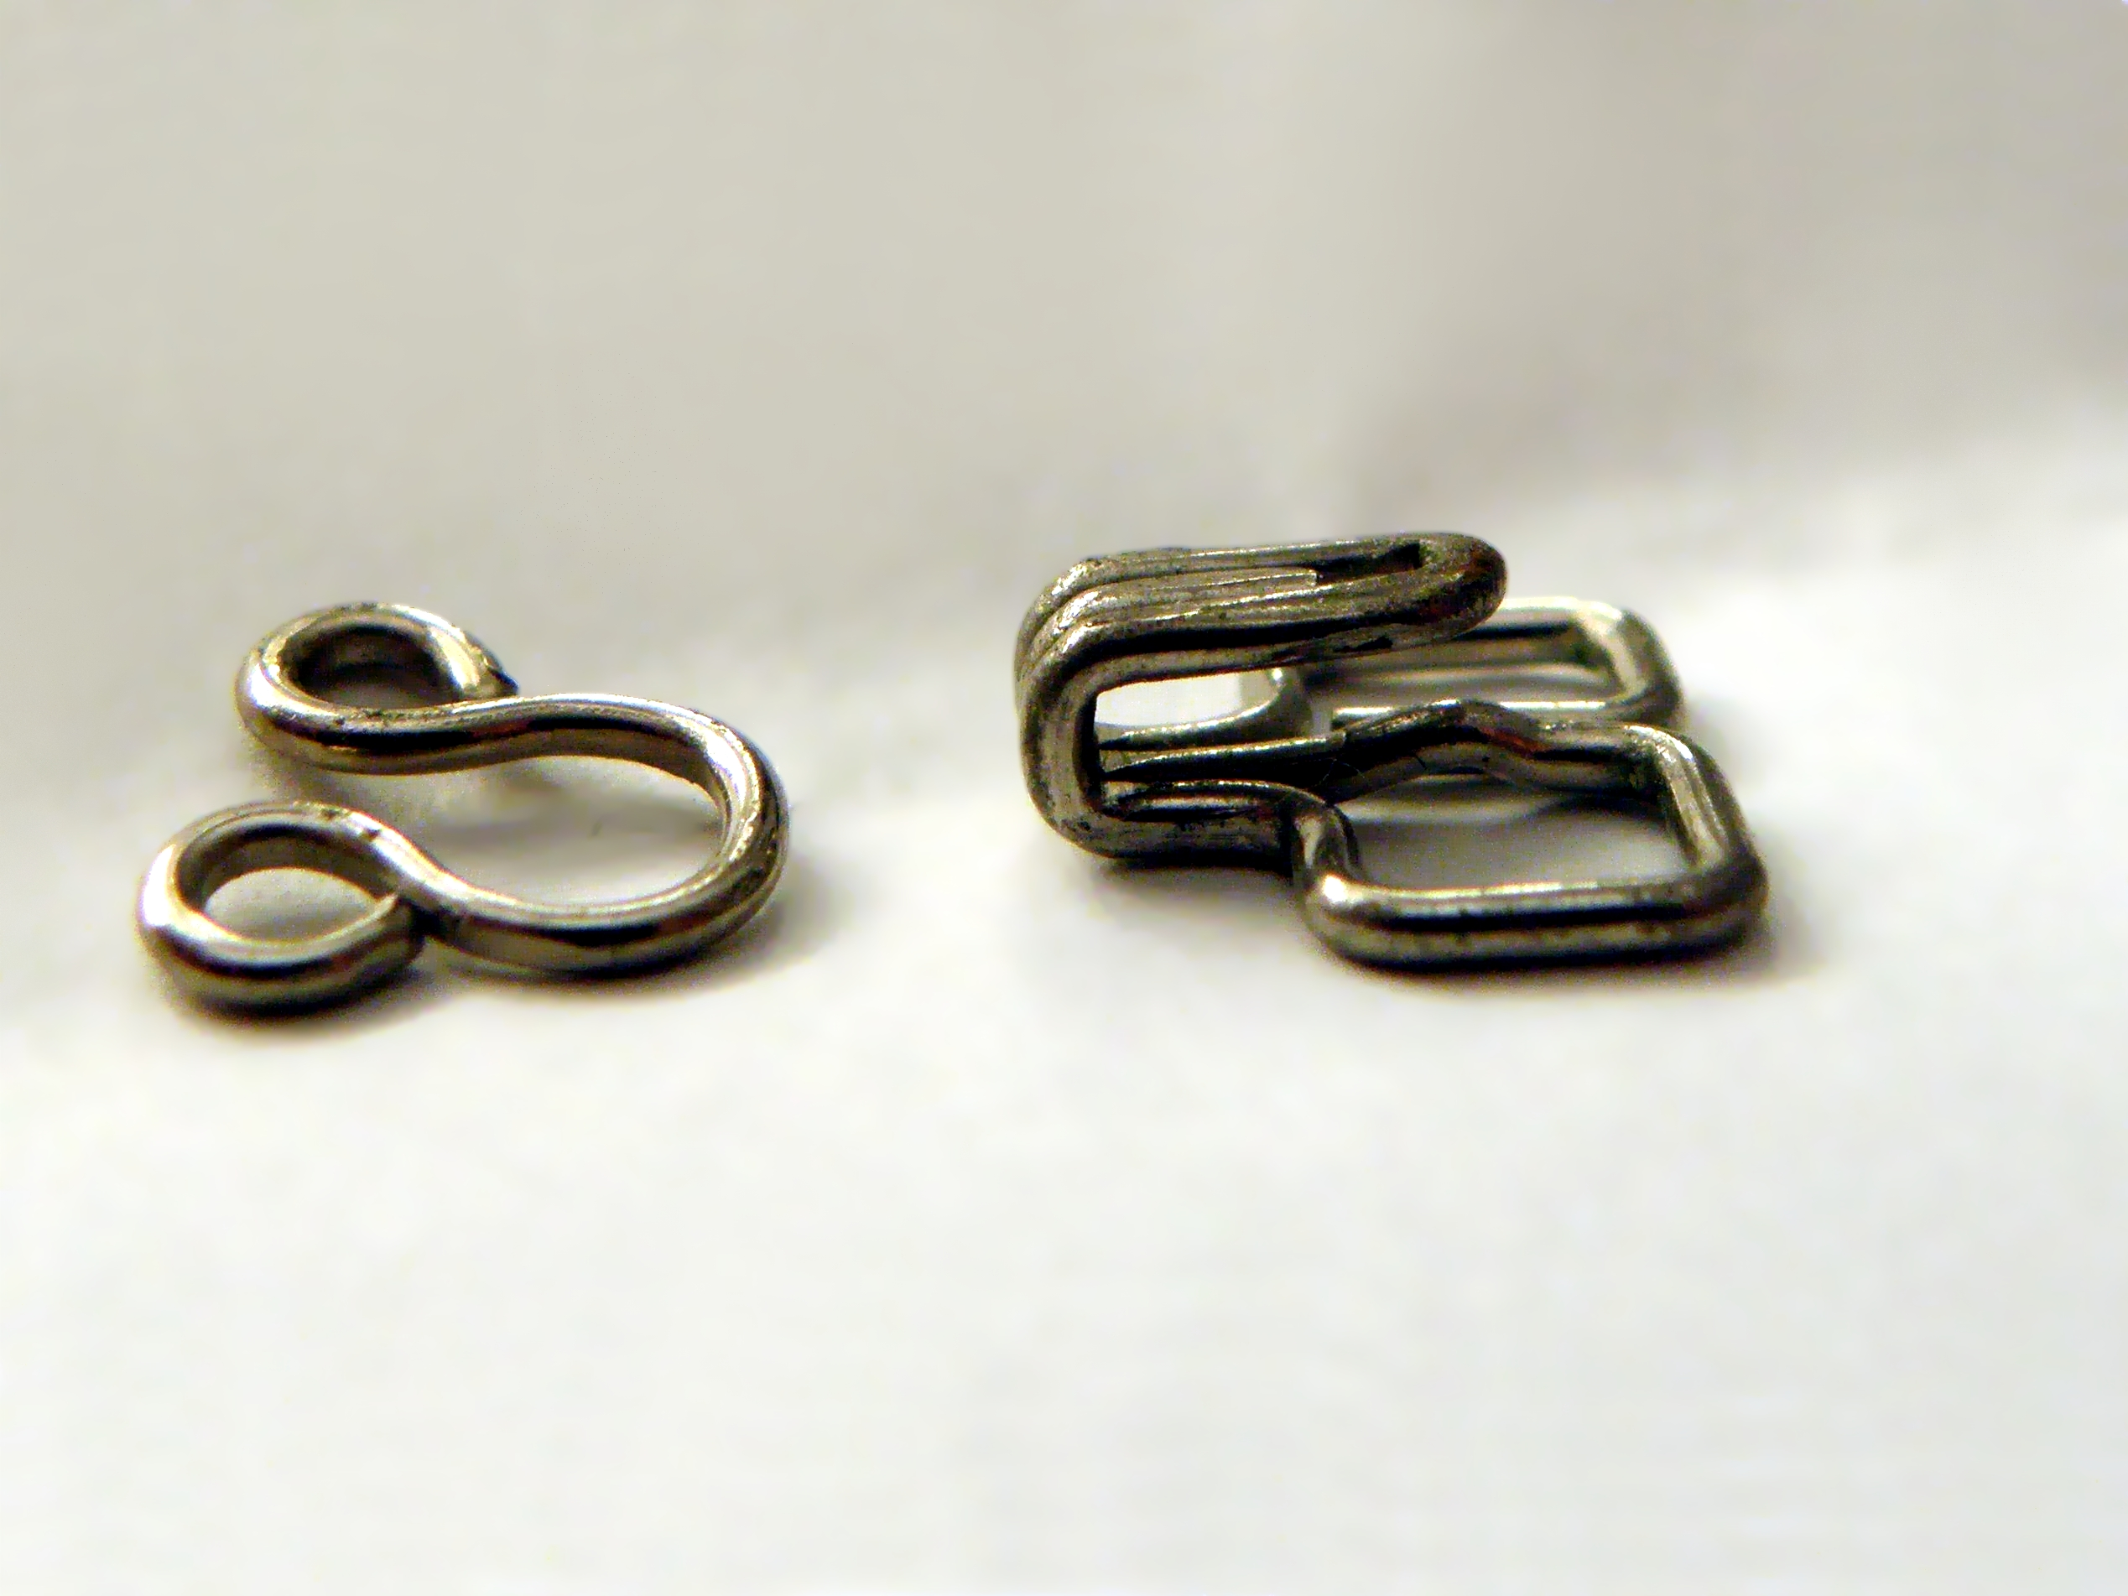  
hook and eye closure

**Janus   
*by Laurence Perrine (1984)***

Janus writes books for women’s liberation  
His wife types up the scripts from his dictation.

1. In her TED-Ed presentation, Amanda Gorman argues that writing poetry is a political act. Would you consider any of the above poems ‘political’? In what way?