Unit 9 – The Merchant of Venice:   
An Introduction to Shakespeare and his Work

1. **Brainstorm: What do you know about William Shakespeare?**

Write a word or a phrase about William Shakespeare’s personality and work on the board. One student will some up the board content for the whole class.

1. a) You are going to watch a short biography of Shakespeare. <http://photodentro.edu.gr/video/r/8522/868>

Then, read the following notes and, in pairs, try to complete as many gaps as you can.

**William Shakespeare – Biography**

**Introduction**

* William Shakespeare was a ____________, _____________ and _______________.
* He is widely considered to be the greatest _______________ of English language.
* He was born in ______________________ (place), in _____________________ (time)
* He died in ____________________ (place), in _________________ (time) at the age of _______________
* He is best known for his _________________, but his ________________ are also popular.

**Family life**

* He was the eldest of __________ children.
* At the age of ___________, he married _____________________. Together, they had ___________ children.
* His son, _____________, died when he was __________ years old.

**Shakespeare in London**

* In the late 1580s, he went to _____________.
* There, he worked as an actor, playwright and co-owner of a ____________ ____________ called The Lord Chamberlain’s Men, later known as The King’s Men (under the patronage of King James I).
* He remained with the company for the rest of his career, producing an average of ________ plays a year, for almost __________ years.
* During his time in the company Shakespeare wrote many of his most famous tragedies, such as ___________, [____________](https://www.shakespeare.org.uk/explore-shakespeare/shakespedia/shakespeares-plays/king-lear/) , ____________ and [____________](https://www.shakespeare.org.uk/explore-shakespeare/shakespedia/shakespeares-plays/macbeth/), as well as great romances, like [______________](https://www.shakespeare.org.uk/explore-shakespeare/shakespedia/shakespeares-plays/winters-tale/) and [________________](https://www.shakespeare.org.uk/explore-shakespeare/shakespedia/shakespeares-plays/tempest/).
* In 1599, the company built their own theatre, ________________, on the South banks of the River Thames.

**His works**

* Shakespeare’s works include:
* 38 ___________
* 2 narrative __________
* 154 ______________
* and a variety of other poems
* There have been countless ______________ of Shakespeare’s plays for stage and film.
* After his death, a group of actors from his company saved about _____________ of his plays in a collection known as the ___________________.

1. Now read the biography below and correct / complete the missing information.

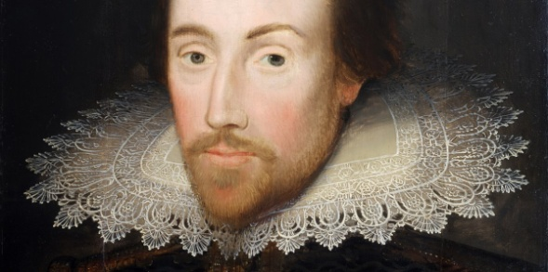

**William Shakespeare Biography**

Who was William Shakespeare?

**An Introduction**

William Shakespeare was a renowned English poet, playwright, and actor born in 1564 in[Stratford-upon-Avon](https://www.shakespeare.org.uk/explore-shakespeare/shakespedia/stratford-upon-avon/). He is widely considered to be the greatest writer in the English language. His birthday is most commonly celebrated on 23 April, which is also believed to be the date he died in 1616.

Shakespeare was a prolific writer during the Elizabethan and Jacobean ages of British theatre (sometimes called the English Renaissance). [Shakespeare’s plays](https://www.shakespeare.org.uk/explore-shakespeare/shakespedia/shakespeares-plays/) are perhaps his most enduring legacy, but they are not all he wrote. [Shakespeare’s poems](https://www.shakespeare.org.uk/explore-shakespeare/shakespedia/shakespeares-poems/) also remain popular to this day.

**Shakespeare's Family Life**

[John Shakespeare](https://www.shakespeare.org.uk/explore-shakespeare/shakespedia/william-shakespeare/william-shakespeares-family/john-shakespeare/) married[Mary Arden](https://www.shakespeare.org.uk/explore-shakespeare/shakespedia/william-shakespeare/william-shakespeares-family/mary-arden/), and together they had eight children. John and Mary lost two daughters as infants, so William became their eldest child. John Shakespeare worked as a glove-maker, but he also became an important figure in the town of Stratford by fulfilling civic positions. His elevated status meant that he was even more likely to have sent his children, including William, to the [local grammar school](https://www.shakespeare.org.uk/explore-shakespeare/shakespedia/william-shakespeare/shakespeares-school/).

When he was eighteen, [Shakespeare married Anne Hathaway](https://www.shakespeare.org.uk/explore-shakespeare/shakespedia/william-shakespeare/shakespeares-wife-and-marriage/), who was twenty-six. It was a rushed marriage because [Anne](https://www.shakespeare.org.uk/explore-shakespeare/shakespedia/william-shakespeare/william-shakespeares-family/anne-hathaway/) was already pregnant at the time of the ceremony. Together they had three children. Their first daughter, [Susanna](https://www.shakespeare.org.uk/explore-shakespeare/shakespedia/william-shakespeare/william-shakespeares-family/susanna-hall/), was born six months after the wedding and was later followed by twins [Hamnet](https://www.shakespeare.org.uk/explore-shakespeare/shakespedia/william-shakespeare/william-shakespeares-family/hamnet-shakespeare/) and [Judith](https://www.shakespeare.org.uk/explore-shakespeare/shakespedia/william-shakespeare/william-shakespeares-family/judith-shakespeare/). Hamnet died when he was just 11 years old.

**Shakespeare in London**

[Shakespeare's career](https://www.shakespeare.org.uk/explore-shakespeare/shakespedia/william-shakespeare/shakespeare-career/) jump-started in London, but when did he go there? We know Shakespeare's twins were baptised in 1585, and that by 1592 his reputation was established in London, but the intervening years are considered a mystery. Scholars generally refer to these years as ‘[The Lost Years](https://www.shakespeare.org.uk/explore-shakespeare/shakespedia/william-shakespeare/shakespeares-lost-years/)’.

During his time in London, Shakespeare’s first printed works were published. They were two long poems, 'Venus and Adonis' (1593) and 'The Rape of Lucrece' (1594). He also became a founding member of The Lord Chamberlain’s Men, a company of actors. Shakespeare was the company's regular dramatist, producing on average two plays a year, for almost twenty years.

He remained with the company for the rest of his career, during which time it evolved into The King’s Men under the patronage of King James I (from 1603). During his time in the company Shakespeare wrote many of his most famous tragedies, such as *Hamlet,* [*King Lear*](https://www.shakespeare.org.uk/explore-shakespeare/shakespedia/shakespeares-plays/king-lear/)*, Othello*and [*Macbeth*](https://www.shakespeare.org.uk/explore-shakespeare/shakespedia/shakespeares-plays/macbeth/), as well as great romances, like [*The Winter’s Tale*](https://www.shakespeare.org.uk/explore-shakespeare/shakespedia/shakespeares-plays/winters-tale/) and [*The Tempest*](https://www.shakespeare.org.uk/explore-shakespeare/shakespedia/shakespeares-plays/tempest/).

**Shakespeare's Works**

Altogether [Shakespeare's works](https://www.shakespeare.org.uk/explore-shakespeare/shakespedia/shakespeares-works/) include 38 plays, 2 narrative poems, 154 sonnets, and a variety of other poems. No original manuscripts of Shakespeare's plays are known to exist today. It is actually thanks to a group of actors from Shakespeare's company that we have about half of the plays at all. They collected them for publication after Shakespeare died, preserving the plays. These writings were brought together in what is known as the [First Folio](https://www.shakespeare.org.uk/explore-shakespeare/shakespedia/shakespeares-works/shakespeares-first-folio/). It contained 36 of his plays, but none of his poetry.

Shakespeare’s legacy is as rich and diverse as his work; his plays have spawned countless adaptations across multiple genres and cultures. His plays have had an enduring presence on stage and film.

**Death of Shakespeare**

Shakespeare died in 1616; it is not clear how he died, and numerous suggestions have been put forward. John Ward, the local vicar of Holy Trinity Church in Stratford (where Shakespeare is buried), writes in a diary account that:

“Shakespeare, Drayton, and Ben Jonson had a merry meeting and it seems drank too hard, for Shakespeare died of a fever there contracted.”

In 1616, there was an outbreak of typhus (“The new fever”) which may have been the cause. The average life expectancy of someone born in London, England in the Sixteenth Century was about 35 years old, Shakespeare died age 52.

Sources: <https://www.shakespeare.org.uk/explore-shakespeare/shakespedia/william-shakespeare/william-shakespeare-biography/>

<https://www.biographyonline.net/poets/william_shakespeare.html>

*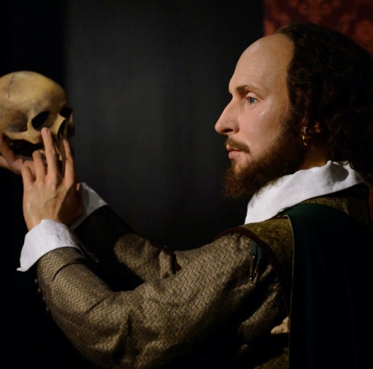“All the world’s a stage,  
and all the men and women merely players:  
they have their exits and their entrances;  
and one man in his time plays many parts…”*

—*As You Like It*, Act II,

1. **Find out more**
2. Now, watch British Council’s video about William Shakespeare’s life in London. What more did you learn about Shakespeare’s life and work?

<https://learnenglish.britishcouncil.org/general-english/shakespeare/london-1-piece-by-piece>

1. What was it like to watch one of Shakespeare's plays in the 1600s? Find out about **Shakespeare’s Globe Theatre in London.**

<https://learnenglish.britishcouncil.org/general-english/shakespeare/london-2-a-penny-for-the-yard>

1. What is today’s Globe Theatre like? Take this virtual tour and see it for yourself!

<https://www.shakespearesglobe.com/discover/about-us/virtual-tour/#virtual-tour-online>

1. Find out more about Globe Theatre on the official website. Gather information about:

* Performances and other events
* Location and how to get there
* Tickets

<https://www.shakespearesglobe.com/>