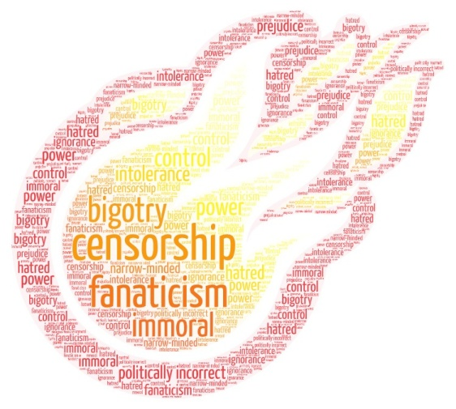**Unit 8 – Book burning, now and then – Video lesson 1**

**Before you watch**

1. What have you heard about book burning? On what occasions - moments in history have people burned books? Is it still happening?
2. Why do people burn books? Think of some possible reasons and write down all the relevant words that come to mind.

Optional activity: Create a word cloud with all the words related to book burning here:

<https://wordart.com/> Then, download it and share it with your class.

**While you watch**

1. You are going to watch a scene from a movie. Take notes and answer these questions.

Watch the video here: <https://www.youtube.com/watch?v=zkuVZf-ZqHM>

1. Where and when does the story take place?
2. What is happening?
3. Who is the main character?
4. What is the main character doing in this scene? How does she feel?
5. The scene you watched is from the 2013 movie “The Book Thief”. Watch the trailer and keep notes in the following table. Watch it again, if necessary.

Watch the movie trailer here: <https://www.youtube.com/watch?v=92EBSmxinus&t=2s>

|  |  |
| --- | --- |
| Time, place |  |
| Main character – what we know about her |  |
| Other characters – what we know about them |  |

**After you watch**

In groups: Based on the two videos that you have seen, write the plot of the movie (as you imagine it) in no more than 100 words. Then, present it to the class. Compare your versions of the plot.

In your group, use one of the following shared Google documents to work together on your text:

Group 1: <https://docs.google.com/document/d/1vYFYlHjkrppUiLC6okS3LvgPzLo7_jZLI08ZSmannEE/edit?usp=sharing>

Group 2: <https://docs.google.com/document/d/1M2V2TSjxN7TZCgRvPGkGi5_s5lnd0TBJxSDOmDOpGE0/edit?usp=sharing>

Group 3:  
<https://docs.google.com/document/d/1ZGnODJfk-dw0q38JAX6X0_NPcUaVZgcUoDoLZNI0nzU/edit?usp=sharing>