SPEAKING & WRITING – BOOK BURNING NOW
- Speaking: A class debate

- Watch the video and answer the questions.
https://edpuzzle.com/media/67e4fd96852e0a03205d5763
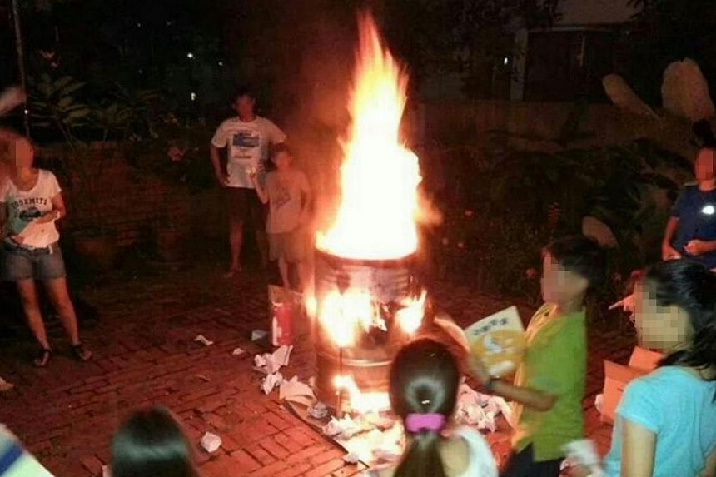
- Organise a class debate on this topic: “Students burning their books on the last day of school year.” Follow these steps:

- Students are divided into 3 groups:
  - Group A: ‘For’,
  - Group B: ‘Against’
  - Group C: ‘Judges’
- Prepare:
  - Students in groups A and B choose a representative to present their case to the class. All members work together to find strong arguments to support their case.
  - The judges (group C) prepare one question for each group.
  - Here’s an article that might give you some ideas for your arguments:
https://www.straitstimes.com/singapore/post-psle-book-burning-photo-inflames-netizens
- The debate:
  - Groups take turns presenting their case, while the judges listen and take notes.The judges ask their questions and each group responds.
- The winners:
  - The judges say which group presented a stronger case (justifying their opinion) and vote for the winners.

Group A: Students believe that they should go on burning their textbooks because this ritual symbolizes their freedom.

Group B: Students believe that book burning symbolizes censorship and should be avoided. They suggest alternative ways of celebrating the end of the school year.
In your group, talk about how you are going to support this opinion. Choose a representative to talk and present your case.

Judges: Listen to each group supporting their case. Then, ask each group a question. Finally decide which side presented a stronger case voting for the winners of the debate.

b) Write an article
Some students in your school are organizing a book burning ritual to celebrate the end of the school year, but you disagree with this idea. Write an article for your school blog (180 – 200 words) in which you:
- support your opinion against burning school books using two arguments.
- suggest an alternative way of celebrating the end of the school year.
Choose an appropriate title for your article.
Analysing the topic
- What kind of text are you going to write? Who is going to read it (target reader)?
- What kind of language are you going to use? (e.g. formal, informal)
- What are you asked to do in your article?
- How many paragraphs are you going to write?
Think of ideas
- Write down two arguments against burning school books.
- Write down an alternative idea for celebrating the end of the school year.

