**The Book Thief (movie) – Writing assignment**

**Choose and write ONE of the following assignments:**

1. **Topic from Panhellenic Exams 2018 (strongly suggested for those taking the English exam):**

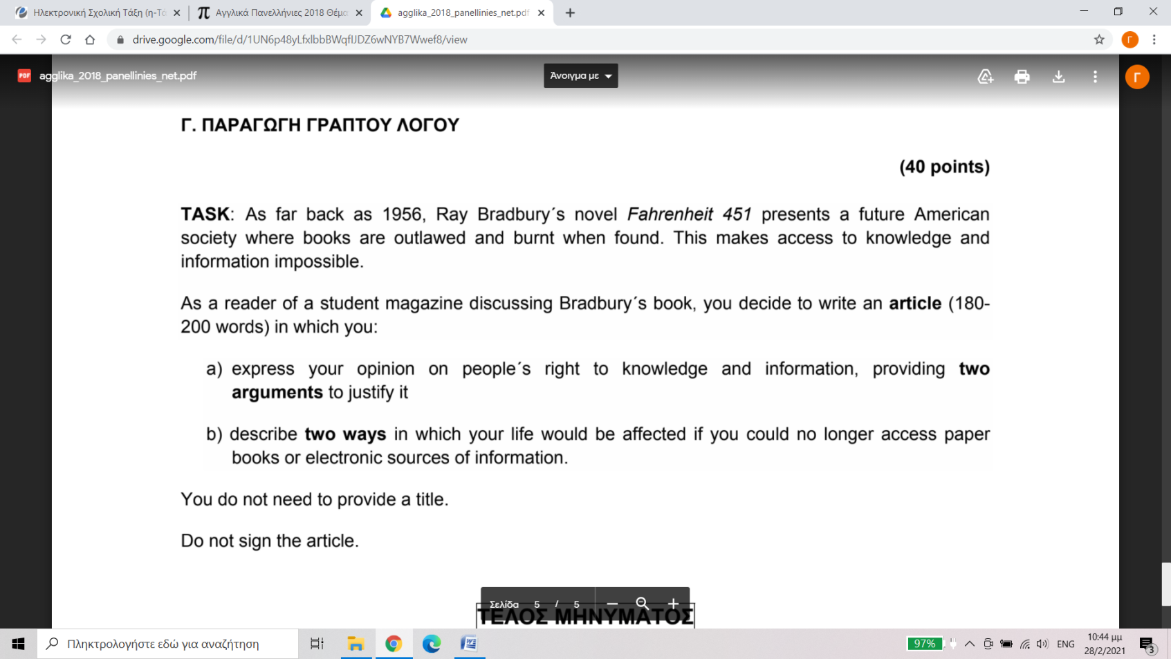

1. Write a **review** of The Book Thief movie for your school website. In your review:

* give information about the movie: the setting (time and place), the plot, the main characters, cast, director
* say what you liked/disliked about it (e.g. plot, acting, direction, photography, music etc)
* say whether and to whom you would recommend it

1. **Choose a character** from the movie and **write an analysis**. More specifically:

* Introduce him/her (say who he/she is, say a few things about his her background)
* Describe his/her appearance and personality
* Comment on his/her actions, behaviour and relationships with the other characters
* Talk about his/her role / significance in the story

1. Discuss the importance of **language, reading and writing** in the movie. How are these elements presented by the characters’ actions and events in the movie?
2. The following **contrasting themes** appear in the movie:

* **Love vs. Hatred**
* **Life vs. Death**
* **Peace vs. War**

Choose one pair of contrasting themes and discuss how they are presented in the movie. Refer to specific characters, events, actions or specific scenes and settings which are used to present them.

1. a) What is its **role/significance** of **book burning** in the movie? What does it **symbolize**?

b) Do some **internet research** and write about book burning during:

* the Nazi era
* other times in history
* today

Say when, by whom and for what reasons was / is still practised, giving specific examples.

**Remember:**

* Paraphrase using your own words. Don’t copy – paste sentences or whole parts of text.
* Always cite your sources of information. (Write the author’s name/title/date of the article, website name and address)