**Unit 6 - Leaders. Born or Made?**

1. What makes a good leader? Write down any **qualities** of good leaders that you can think of.

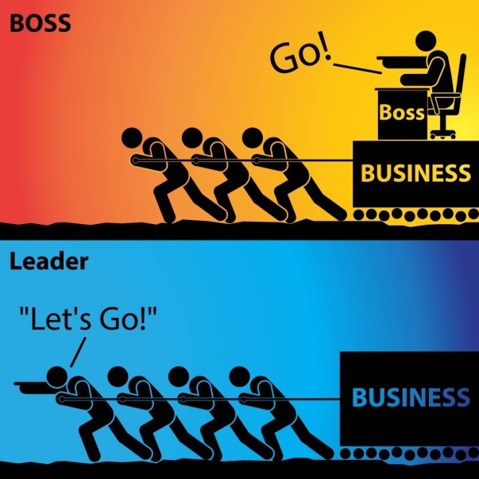

1. You are going to watch a video in which people talk about leadership. Make notes as you watch. What leadership qualities are mentioned? Compare your notes with your answers in ex.

Watch the video here: <https://www.youtube.com/watch?v=18UVXW-x2_8>

1. Think of examples of great leaders from the past or the present. Choose one you think is/was particularly gifted and say why.

**READING ACTIVITIES pp.83-87**

1. Read the biographies on pp.83-84 and write K (Martin L. King), M (Nelson Mandela) or B (Both) next to each of the following statements.
2. He was honoured posthumously.
3. He received numerous honours during his lifetime.
4. He served a long time in prison.
5. He was an advocate for civil rights.
6. He fought against racism and inequality.
7. He was South African.
8. He had a tragic end.
9. He became President of his country.
10. He was awarded the Nobel Peace Prize.
11. He is regarded as a national symbol.
12. **a**. **Read the two texts again and answer the following questions.**
13. Find a suitable title for each text.
14. What is the purpose of these two texts?
15. Based on the information in the texts, what similarities can you find between these two leaders?

**b.** **Choose the correct answer (A, B or C) for items (1-6) below.**

1. Martin Luther King was

a. a famous politician

b. a civil rights advocate

c. an American president

2. The civil rights movement

a. brought changes in law regarding civil rights in the US

b. used some violent methods in order to achieve its goals

c. didn’t manage to bring any major changes in the US.

1. Martin Luther King was awarded the Nobel Peace Prize
   1. after his assassination
   2. for fighting against poverty
   3. for his peaceful action to secure equal rights
2. Nelson Mandela was

a. South Africa’s first black President

b. President of South Africa from 1991 to 1997

c. born in Great Britain

5. Apartheid was a political system that

a. discriminated against black people.

b. was established by the African National Congress Party

c. was favoured by some African leaders.

6. Nelson Mandela

a. was released from prison a few years before his death.

b. was supported by the international community.

c. did not cooperate with President F.W. de Klerk

1. Read the extract from M.L. King’s speech “I have a dream” on pp. 86-87. Which of the following techniques does he use? Write an example for each technique.
   1. Repetition
   2. Questions
   3. Lists
   4. Opposites
   5. Metaphor
   6. The rule of three (repeating something three times for emphasis)

**Glossary: Biographies of two great leaders (p.83-84)**

**Martin Luther King**

accomplish: (reach a goal) επιτυγχάνω

boycott: μποϊκοτάζ

civil rights movement: κίνημα για τα ατομικά δικαιώματα

combat: μάχη, μάχομαι (fight against)

discrimination: διάκριση

encompass: συμπεριλαμβάνω

federal law: ομοσπονδιακός νόμος

grassroots: (ordinary people) απλοί πολίτες

impact: αντίκτυπος, επίδραση (a powerful effect)

legislative: νομοθετικός

minister: ιερέας

posthumously: μετά θάνατον

Reconstruction era: εποχή της ανασυγκρότησης (1863-77: period in American history following the American Civil War, which focused mainly on civil rights)

riots: επεισόδια, ταραχές

secure: διασφαλίζω

segregation: διαχωρισμός

**Nelson Mandela**

amid: (in the middle of) εν μέσω

apartheid: political system in the past in South Africa in which people of different races are separated

coalition: συνασπισμός

colonial: αποικιακός

commission: επιτροπή

commit: δεσμεύομαι

constitution: σύνταγμα

dismantle: αποδομώ

foster: ενθαρρύνω

institutionalised: θεσμοθετημένος

legacy: κληρονομιά

negotiate: διαπραγματεύομαι

overthrow: ανατροπή

privilege: ευνοώ / πλεονέκτημα

promulgate: διακηρύσσω

reconciliation: συμφιλίωση

revolutionary: επαναστάτης

segregation: διαχωρισμός

tackle (a problem): αντιμετωπίζω (deal with)

**Extract from “I have a dream speech”, p.86 –**

creed: δόγμα, το «πιστεύω»

crooked: στραβός (μτφ. στρεβλός, διεφθαρμένος)

despair: απόγνωση

drip: στάζω

exalt: εξυψώνω, εξυμνώ, δοξάζω

interposition: παρέμβαση

nullification: ακύρωση, εκμηδένιση

oppression: καταπίεση

prodigious: τεράστιος

self-evident: αυταπόδεικτος, αυτονόητος

swelter: λιώνω, καίγομαι

vicious: κακός, μοχθηρός

wallow in sth: κυλιέμαι, βυθίζομαι σε

**Vocabulary practice**

1. **Complete the table below.**

|  |  |  |
| --- | --- | --- |
| **Verb** | **Noun** | **Adjective** |
|  | leader |  |
|  | movement |  |
| secure |  |  |
|  |  | legislative |
|  | discrimination |  |
|  | recognition |  |
|  | (in)equality |  |
|  | opposition |  |
|  |  | revolutionary |
| elect |  |  |
|  | abuse |  |
|  | reconciliation |  |
| commit |  |  |

1. **Complete the following sentences with suitable words from the above table in the correct form.**
2. The professor is a ______________ expert in his field.
3. He made a ________________ to stay at the job for another year.
4. The national ______________ will take place on June 10th.
5. He ______________ his wife for many years before she went to the police.
6. The government has promised to introduce _______________ to limit fuel emissions from cars.
7. It took hours of negotiations to bring about a ________________ between the two sides.
8. **Choose 10 words you learned from the texts and write example sentences with them.**