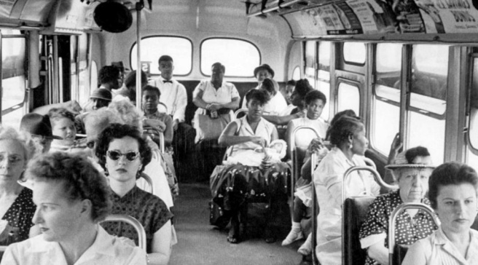Rosa Parks and the Montgomery Bus Boycott   
(Video lesson)

1. Watch the video and answer these questions:

* When does the story take place?
* Where are the people?
* What is happening? What does the bus driver ask people to do?
* What does the woman do? Why?
* 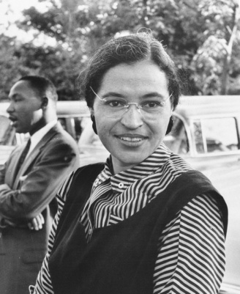What happens in the end? How do you feel about the woman?
* Watch the video here: <https://youtu.be/Q-MLurRcUxg>

1. Watch a short biography of Rosa Parks and complete the notes below.

Watch the video here: <https://www.youtube.com/watch?v=v8A9gvb5Fh0>

ROSA PARKS – A SHORT BIOGRAPHY

* Rosa Louise McCauleyParks was born in Alabama in 1) ________.
* As a child, she was exposed to the realities of 2) _____________.
* She walked to school because 3) __________ students were not allowed on school buses.
* After her marriage to Raymond Parks in 1932, she earned her high school 4) __________.
* She joined the NAACP* and served as a 5) __________ and youth leader.

*The **NAACP** or **National Association for the Advancement of Colored People** was established in 1909 and is America’s oldest and largest civil rights organization.

* On 6) ___ __________ _______, Rosa was on a bus, going home after work, in Montgomery, 7) __________. She was told to give up her seat to a 8) _______ male passenger, but she 9) ____________ and was 10) _____________.
* An all-day 11) ___________ boycott was organized on, the day of Rosa’s   
  12) _________, December 5th, 1955, where she was found guilty and given a fine.
* Rosa became a role model for 13) ____________ in the face of racial injustice.
* The boycott lasted 14) ______ days, with Martin Luther King Jr as their 15) _________.
* In 16) _________, the Supreme Court supported the civil rights position calling for an end to racial segregation on buses.
* Rosa co-founded the Rosa and Raymond Parks Institute for Self-Development, which educates young people on the civil rights 17) _____________ and provides them with 18) ______________ guidance.
* She also gave 19) __________ and advocated for social 20) _____________.
* She died on 21) ___________ _____ ________. She was the first woman and the second black person to lie in honor in the US Capitol.
* Among numerous awards, she received the Medal of 22) ___________ from President Clinton and the Congressional Gold Medal of 23) ____________.
* Rosa was a grassroots activist for social justice and 24) ________, through her efforts in the civil rights movement to her participation in the anti-apartheid movement for 25) ________ _________.

1. Do you know any other women pioneers who made a difference in world history? Choose one of them and write a short biography. Present her to the class.

* For further information about the Montgomery Bus Boycott, you can watch this video: <https://www.youtube.com/watch?v=A9R9R-xVi04>