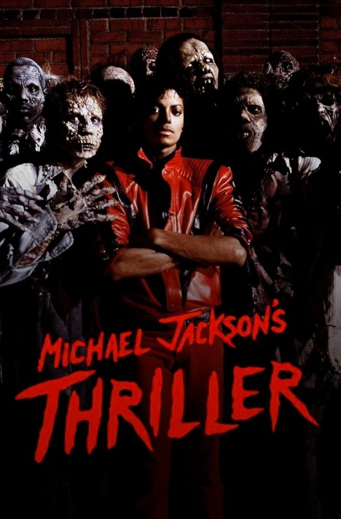**Thriller (A short story inspired by Michael Jackson’s ‘Thriller’ music video)**

1. **Read part 1 of the story and fill in the gaps with the VERBS in the box.**

**stormed out cried muttered grabbed slammed**

“Enough! I’m not going to watch that!” said Sandy angrily. “Come on, baby! It’s getting better later,” said Michael with a grin on his face, his eyes fixed on the big screen, while eating one more handful of popcorn. Sandy   
**1)** _______________ her jacket and **2)** _____________ of the cinema hall. “Damn!” Michael **3)** _______________ as he stood up and followed her outside. “Baby, come on! Where are you going?” he **4)** ______________ before the exit door **5)** ________________ in front of his face.

1. **Read part 2 of the story and fill in the gaps with the ADVERBS in the box.**

**softly apologetically indifferently shyly nervously**

Sandy zipped up her jacket and walked up and down the street **1)** ______________ as Michael approached her. “What’s the matter honey?” Michael asked **2)** _____________. “Were you scared?” “I wasn’t THAT scared. I was just bored”, she replied **3)** ________________. “Well, I thought it would be nice to watch ‘Thriller’ for Halloween. Come on, wasn’t it funny when he turned into a werewolf? It was hilarious!” Michael started chuckling again and Sandy became furious. “Not funny at all! You’re so annoying! I’m going home…” As she was about to step away, he grabbed her arm and pulled her towards him. “Wait. I’m sorry. Let’s not ruin our night. We can go for a walk… I love you Sandy!” he said and kissed her lips **4)** _______________. “I love you, too, Michael. I suppose I overreacted…” Sandy replied **5)** ______________ and smiled.

1. **Read part 3 of the story and fill in the gaps with the ADJECTIVES in the box.**

**long dry old cold creepy full empty mysterious**

Holding hands, they started walking and laughing again. It was **1)** _____________ and the wind was sweeping the **2)** ______________ autumn leaves away. The **3)** _____________ moon was playing hide-and-seek behind the clouds and the trees were casting **4)** _____________ shadows in the **5)** ______________ street. The only sound that could be heard was Michael and Sandy’s footsteps and laughter as they went past the **6)** _____________________ cemetery. They stopped at the end of the street to admire the **7)** ___________________ dance of the moon. “Isn’t it beautiful?” asked Michael as they were staring at the night sky. “Wait!” said Sandy. “Did you hear that?” “Hear what?” Michael replied. “That **8)** _________________ sound, like footsteps… and a moan… is it someone, or maybe something?”

1. **Read part 4 of the story and fill in the gaps with the ADJECTIVES in the box.**

**hideous terrified dark motionless paralyzed hollow**

The shadows behind the trees became **1)** _______________ silhouettes. Figures of corpses dragging their feet on the ground, groaning menacingly were coming closer and closer, staring with their dark, **2)** _________________ eyes straight into Sandy and Michael’s **3)** _________________ faces. Standing **4)** __________________back-to-back, the couple was soon surrounded by **5)** ___________________zombies performing their macabre waltz. Sandy started screaming hysterically. “I don’t want to die! Michael…?” She turned round and saw a **6)** ___________________ face and two yellow eyes fixed on her. “Michael, what’s happening? Talk to me!!!” The monster grabbed her arms while she was frantically trying to set herself free, in the middle of the zombie circle. Michael had become one of them, holding his prey, ready to attack. “Help me! Somebody help!!! …”

**5) Read the last part of the story and put the verbs in brackets in the correct past tense (past simple, past continuous, past perfect simple).**

“What’s the matter baby? Wake, up!” Sandy **1)** _______________ **(jump up)** gasping for air and **2)** ____________ **(open)** her eyes. Michael was there, smiling and stroking her hair gently. She **3)** ________________ **(fall)** asleep in his living room. “Come on, I’ll take you home,” he said calmly and gave her his hand. She **4)** ________________ (stand up) and **5)** _______________ **(wrap)** her arms around him in relief. “It was just a nightmare,” she thought. As they walked towards the door, she **6)** ________________ **(remember)** she **7)** _____________________ **(leave)** her jacket on the sofa. Turning round to get it, she **8)** ________________ **(catch)** a glimpse of Michael’s reflection in the hallway mirror and **9)** ______________________ **(freeze).** The same cold motionless face with yellow eyes from her nightmare **10)** ______________________ **(stare)** back at her…