**"Shake Up Christmas" - Train**

Ho, ho, ho...  
  
*Shake up the happiness  
Wake up the happiness  
Shake up the happiness  
It's Christmas time*  
There was a story that I was 1) _________  
And I want to tell the world   
before I get too old  
And don't 2) ________ it, so let's December it  
And **reassemble** it, oh yeah  
  
Once upon a time in a town like this  
A little girl made a great big 3) __________  
To fill the world full of happiness  
And be on Santa's magic 4) ___________  
  
*Shake it up, shake up the happiness  
Wake it up, wake up the happiness  
Come on y’all, it's Christmas time  
Shake it up, shake up the happiness  
Wake it up, wake up the happiness  
Come on y’all, it's Christmas time  
Ho, ho, ho,  
Ho, ho, ho,  
It's Christmas time*  
At the same time miles away  
A little boy made a wish that day  
That the world 5) _________ be okay  
And Santa Claus would hear him say  
I got dreams and I got love  
I got my feet on the 6) ____ and family above  
Can you send some happiness with my best  
To the rest of the people of east and   
the 7) ___________  
  
And maybe every once in a 8) ________  
You give my grandma a reason to smile  
'Tis the 9) ____________ to smile  
It's cold but we'll be freezing in style  
  
And let me meet a girl one day  
That wants to spread some love this 10) _______  
We can let our souls run free  
And she can open some 11) ___________ with me  
  
*Shake it up, shake up the happiness  
Wake it up, wake up the happiness  
Come on y’ all, it's Christmas time  
Shake it up, shake up the happiness  
Wake it up, wake up the happiness  
Come on y’ all, it's Christmas time*  
I know you're out there  
I hear your 12) __________  
I see the snow where  
Your boots have 13) _________  
  
I'm gonna show them  
So they will 14) ________ then  
Then love will grow and  
They 15) __________ again  
  
*Shake it up, shake up the happiness  
Wake it up, wake up the happiness  
Come on all, it's Christmas time  
Shake it up, shake up the happiness  
Wake it up, wake up the happiness  
Come on y’ all, it's Christmas time  
Ho, ho, ho,  
Ho, ho, ho,  
It's Christmas time*  
*Shake it up, shake up the happiness*……………………

**Activities**

1. Listen to the song and fill in the missing words.

You can do this activity **online** here: <https://learningapps.org/watch?v=p4yy7tirk20>

1. Choose the correct answer.
2. The word ***reassemble*** means:

**Shake up**: a) shake something in order to mix its contents. b) To do something different from one's normal routine in order to make things feel new or interesting

**Shake it up!** (idiom): Hurry up! Move faster!

* 1. to put something back together
  2. to remember something
  3. to look like something

1. *y’all* is an informal expression meaning
   1. to yell
   2. to get together
   3. all of you
2. 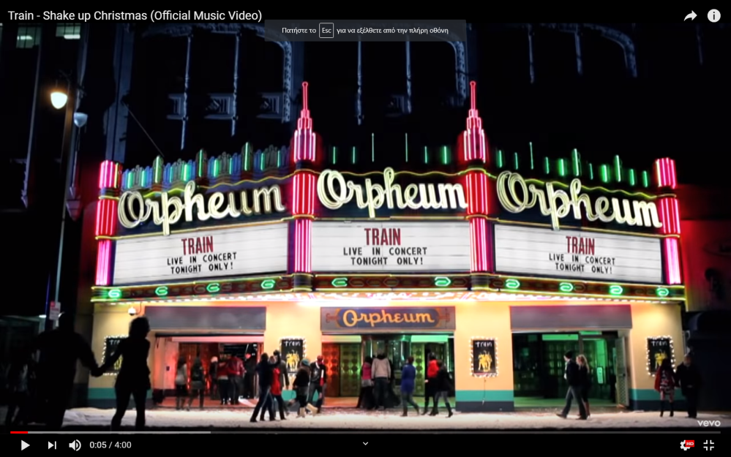What does the title of the song mean? Read the language box.
3. **Speaking**
4. “I know you’re out there…” Who’s the singer talking to?
5. What’s happening in the video? Use the pictures below to help you tell the story.
6. 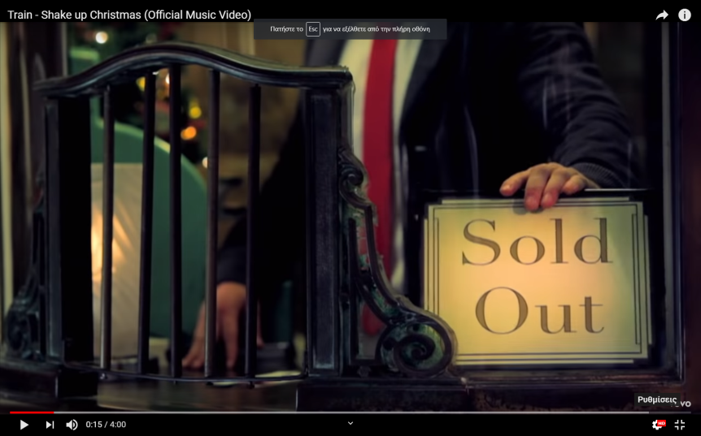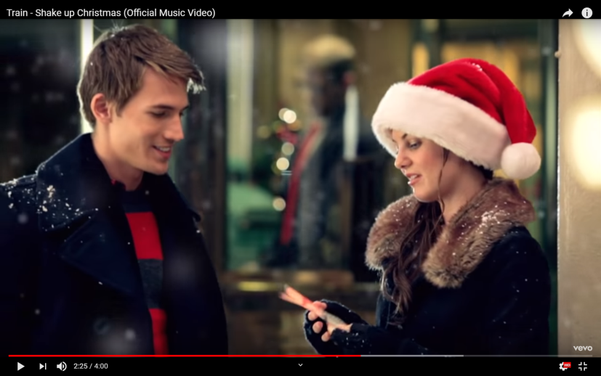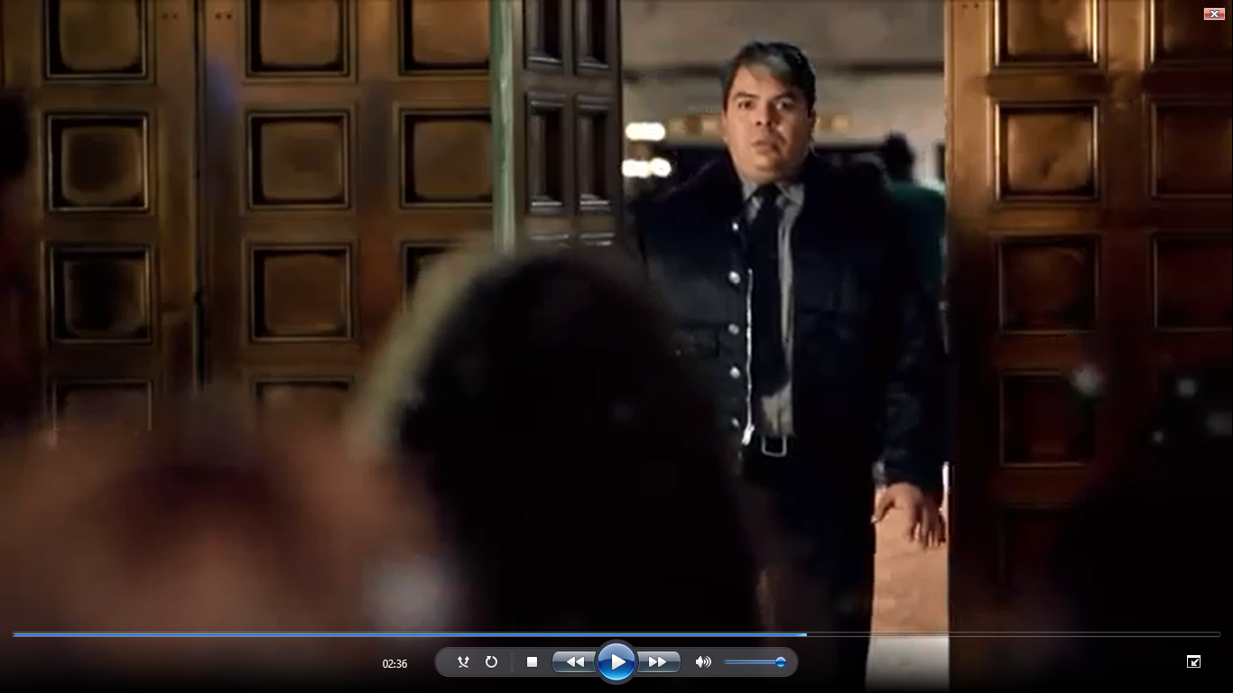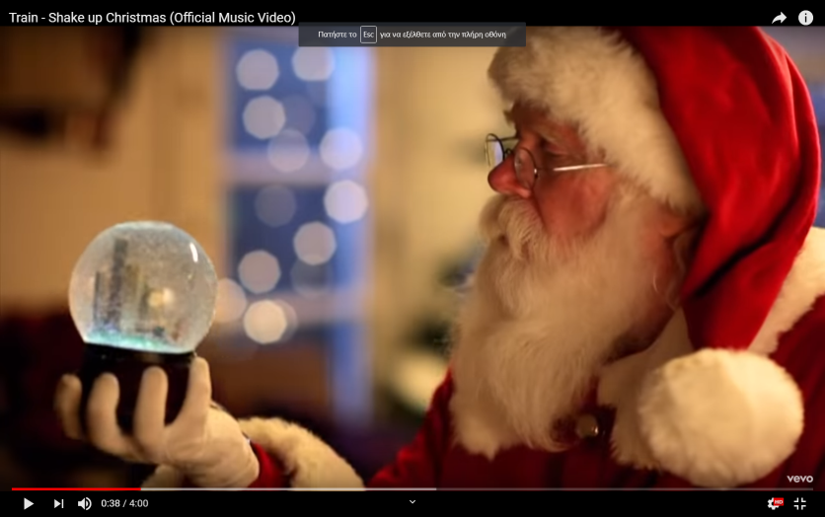What do you wish for Christmas?