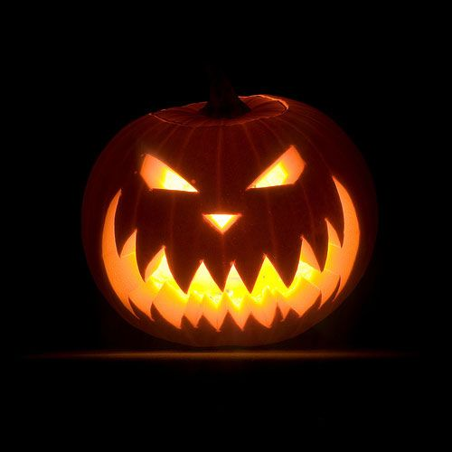A HALLOWEEN SPECIAL

**Where did Halloween come from?**

1. *Watch the video and complete the missing words in the sentences below.*

Video link: <https://youtu.be/dHQZErtwA3E>

1. When most people think of Halloween they think of _______________________, _______________, _______________________, and other family-friendly activities.
2. It all goes back some ________________ years to the ancient Celtic festival known as Samhain celebrated on __________________.
3. On the night before Samhain, people believed that the ______________ returned as _________________.
4. They would leave ______________ and _______________ on their doorstep to keep roaming spirits at bay or wore __________ so that they would be mistaken for fellow ghosts.
5. The Christian church turned Samhain into _____________________________ or All Hallows in the _________ century.
6. The night before became All Hallow’s Eve later shortened to ___________________.
7. You’ve heard of trick-or-treating on Halloween, but what about _______________ or _________________.
8. All of these traditions originated in ______________________________.
9. On All Souls’ Day, the needy would beg for pastries known as ___________________. In return they would pray for people’s dead relatives.
10. In the medieval Halloween tradition of guising, young people would dress up in ________________ and accept _____________, _____________, ____________ and other offerings in exchange for singing, reciting poetry or telling jokes.
11. In 19th century America Irish and Scottish immigrants revived these old traditions. The result was __________________________.
12. At first it was much more about the _______________ in the form of pranks and hijinks, then the _____________.
13. It wasn’t until the _______’s that the custom took on its current family-friendly __________________________ form.
14. Today Halloween is big ____________________, with U.S. consumers spending more than 2.5 billion on costumes annually. Add in the candy, and it’s estimated that Americans spend up to _______________________ on Halloween each year, making it the second most commercial holiday after _____________________.
15. *Read again the notes above and answer these questions.*
16. What was *Samhain*?
17. Where does the name *Halloween* come from?
18. Who brought the tradition of Halloween to the States?

**Speaking**

*Have you got a similar festival in your country? When and how is it celebrated?*

**Spooky Cloze**

**Glossary:**

**in sheets** *– in large quantities*

**to loom** – *to appear large and threatening*

**menacingly** – *threateningly*

**gloom** – *darkness*

**messing around** – *playing, joking*

**to scowl** – *to show anger or displeasure in your facial expression*

**to blaze** – *to shine*

**fiery** *– bright red, like fire*

**bloodcurdling** *– causing a feeling of extreme fear*

***hurl*** *– throw sth with great force, in an angry or violent way*

**shriek** ‐ *scream*

*Complete the story with the correct form of the verbs in brackets.*

It was a dark and stormy night, just after midnight. The cold rain 1_______________ (come) down in sheets and every time the lightning 2______________ (flash), silhouettes of the bare trees 3____________________ (loom) menacingly overhead.

Earlier in the evening, Ron and his five friends 4_________________ (collect) a bag of candy and were looking forward to a sweet feast. As they were jumping over the locked fence and 5_________________ (run) through the muddy schoolyard on their way to the forbidding gloom of the old, abandoned school, they suddenly 6________________ (remember) stories of the ghost teacher. “We shouldn’t go in!” Ron 7_______________ (shout), but the others 8_______________ (not stop), so he had to follow.

They 9________________ (find) an empty classroom. It was so cold that the boys could see their breath hanging in the air like ghosts. Using pieces of the old wooden desks for firewood, they 10______________ (build) a fire, then put on some loud music and started messing around, throwing chalk, yelling, drawing rude pictures on the board and singing. They 11____________ (not notice) that a dark, menacing form 12______________ (appear) slowly out of the shadows. It was the ghost teacher! He 13______________ (scowl) and his eyes were blazing with a fiery light. He let out a bloodcurdling shriek as he hurled himself at the boys. Screaming at the top of their lungs, the boys 14_____________ (run) out of the building leaving everything behind. They never went there again.

***Nouns:***

alley

apparition

bat

castle

cemetery

churchyard

evening

expression

forest

house

moon

moonlight

night

road

ruins

scream

shadow

shriek

sound

spectre

**Scary collocations**

*Make spooky collocations with nouns and adjectives. Use the nouns in the box or add your own. Choose one of each and write a short descriptive paragraph or story. Underline the collocations.*

***Adjectives:*** mysterious haunted dark gloomy spooky



**Example story:**

It was a gloomy night in the haunted forest. The moonlight made dark shadows in the trees. As I walked, I heard a mysterious sound, then I saw a spooky house ahead of me on the path…