**Unit 5 – Animal Rights: Factory Farms (p. 56)**

1. **Watch the video. What is its purpose? How does it make you feel?**

[**https://www.youtube.com/watch?v=yrHT_Z33ivA**](https://www.youtube.com/watch?v=yrHT_Z33ivA)

1. **Complete the following sentences using the passive voice.**

In the U.S:

1. Over 99% of farm animals _________ (raise) in factory farms.
2. Approximately 8.5 million chickens ___________ (kill) for their meat every year.
3. 300 million chickens __________(use) in egg production.
4. All birds ____________ (protect) by federal animal protection laws.
5. Chickens used for egg production ___________ (not use) for meat production.
6. Each type of chicken __________ (breed) for hyperproduction.
7. **Now read the text on p. 56 and see if the statements in ex. 2 are True (T) or False (F).**
8. **Read the text again and answer the questions.**
   1. What is a factory farm?
   2. What is the problem with factory farms?
   3. Why are birds in need of protection?
   4. What is the difference between chicken raised for meat and those used for egg production?

**Grammar Focus: Passive Voice**

1. **Underline all the examples of passive voice in the text and try to rewrite them in the active. Which form (active or passive) is better in this text and why?**

**Vocabulary Practice**

1. **Match the synonyms in the two columns.**
2. abuse a. well-being
3. efficiency b. productiveness
4. trumps c. type, variety
5. welfare d. control
6. at the expense of e. female chicken
7. hen f. at the cost of
8. breed g. ill-treatment
9. manipulation h. beats
10. **Complete the following sentences with the correct prepositions.**
11. Everyone has the right to be safe and to live free ________ fear.
12. The majority ______ high school students in Greece feel stressed.
13. You need to focus ________ your exams if you want to succeed.
14. Students who break the school rules will be excluded ______ school trips.
15. Animals in captivity often suffer _________ depression.
16. She bought fame _______ the expense of her happiness.

**Video Lesson – Speaking: Factory Farming**

**Lead in:** Look at these pictures of factory farms and describe them. What are the living conditions of these animals?

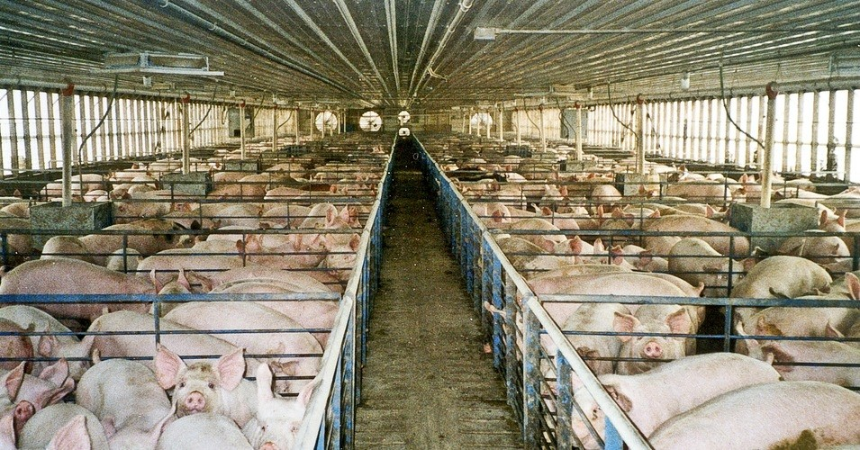

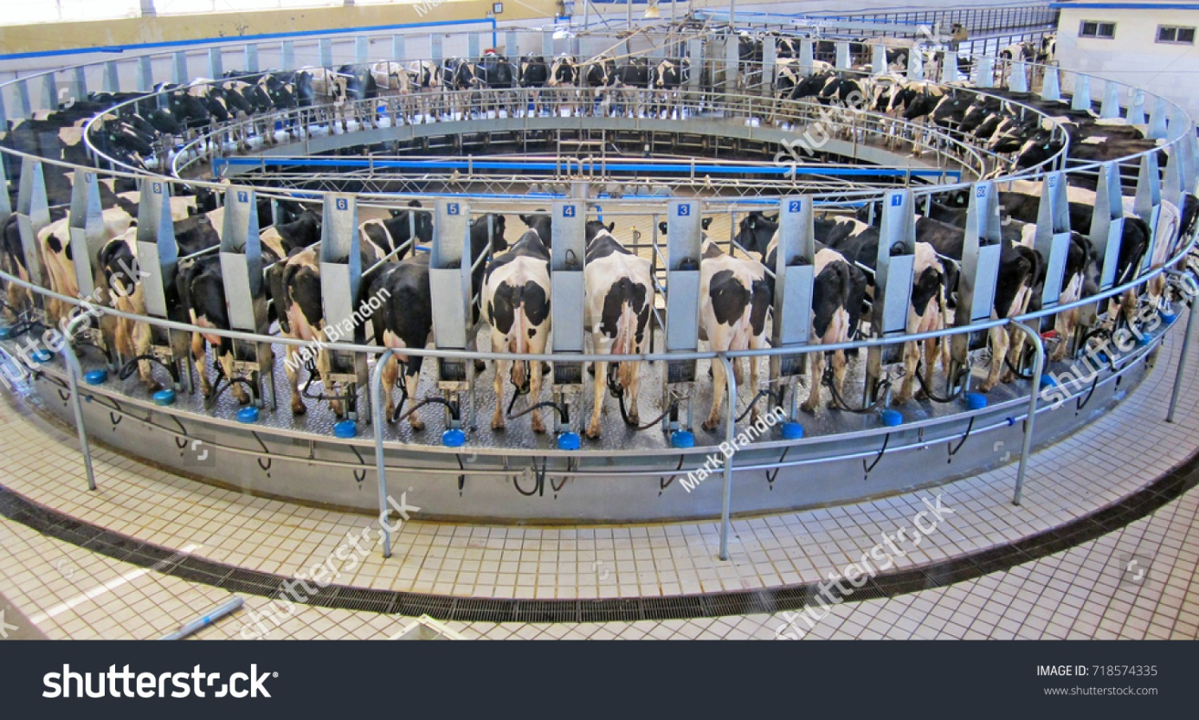

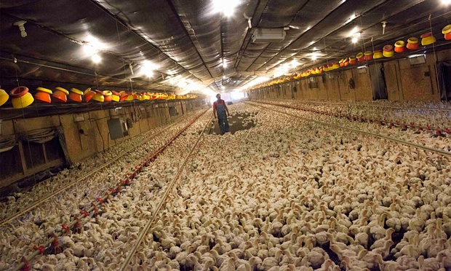

1. Watch the video “What is factory farming? US and the planet” and keep notes to answer the questions below. **\***

<https://www.youtube.com/watch?v=7I0v3LhKhQg>

* **How can eating fewer animal products help save**:
  1. the planet?
  2. food resources?
  3. our health?

1. Watch the video “Life on a factory farm”. Keep notes and answer the questions below.

<https://www.youtube.com/watch?v=oRIvr5aI6bs>

* What is life like for animals raised in factory farms? What problems do they face?

1. **\* Watch the video “Why is factory farming such a big deal?” and keep notes to answer the questions below.**

<https://www.youtube.com/watch?v=GLhjzSm5rG4>

* **What are the negative effects of factory farming on**:
  1. the planet?
  2. food resources?
  3. our health?

**Class discussion**

* What do you think about factory farming? Justify your opinion.
* What can we do to reduce the negative effects of factory farming?