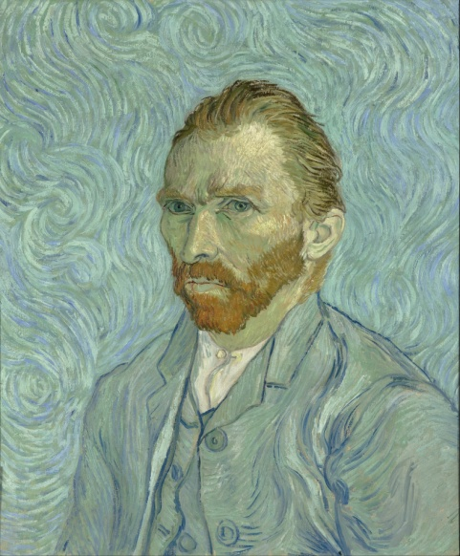**Unit 4 – Vincent Van Gogh**

**Lead-in**

1. How many famous painters’ names can you think of? Can you name some of their works?
2. What do you know about Vincent Van Gogh?

**Listening to a song: Vincent (Starry starry night)**

Listen to a song about Vincent Van Gogh by Don McLean and complete the missing words.

You **can do this exercise online here**:

[**https://learningapps.org/watch?v=p5y638u5a20**](https://learningapps.org/watch?v=p5y638u5a20)

**Pronunciation & Vocabulary**

1. Find the rhyming words in the song, e.g. hills – daffodils, blaze - haze
2. Now go to pages 36-37 in your book and match the underlined phrases in the song with the relevant Van Gogh painting.

**Speaking**

1. Which of the paintings in the pictures do you like best and why? Describe it to the class.
2. What do you learn about Van Gogh’s life and character from the song? Write down 4 sentences.

_________________________________________________________________________________________________________________________________________________________________________________________________________________________________________________________________________________________________________________________________________________________________________________

1. How did the song make you feel?

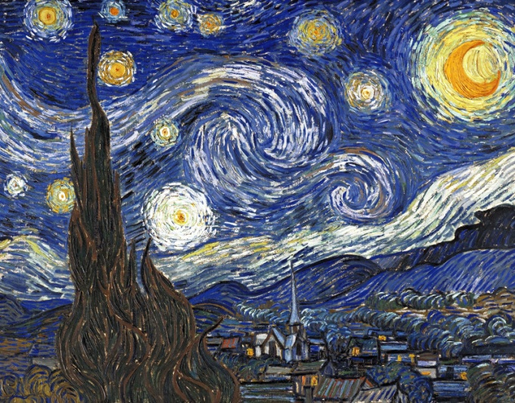**VINCENT (STARRY-STARRY NIGHT)**

Starry, starry night  
Paint your palette blue and gray  
Look out on a summer's 1) ________  
With eyes that know the darkness in my soul

Shadows on the hills  
Sketch the trees and the daffodils  
Catch the breeze and the winter 2) _________  
In colors on the snowy linen land

CHORUS:

Now I understand what you tried to say to me  
And how you suffered for your sanity  
And how you tried to set them 3)__________  
They would not listen, they did not know how  
Perhaps they'll listen 4)__________

Starry, starry night  
Flaming flowers that brightly blaze  
Swirling clouds in violet haze  
Reflect in Vincent's eyes of china 5) _________

Colors changing hue  
Morning fields of amber grain  
Weathered faces lined in 6) __________  
Are soothed beneath the artist's loving hand

CHORUS:  
Now, I understand, what you tried to say to me  
……

For they could not love you  
But still your love was 7) __________  
And when no hope was left in sight  
On that starry, starry night

You took your life as lovers often 8) ______  
But I could have told you, Vincent  
This world was never meant for one  
As 9) _____________ as you

Starry, starry night  
Portraits hung in empty halls  
Frameless heads on nameless 10) __________  
With eyes that watch the world and can't forget

Like the strangers that you've 11) ________  
The ragged men in ragged clothes  
The silver thorn of bloody 12) ________  
Lie crushed and broken on the virgin snow

CHORUS:

Now I think I 13) _________ what you tried to say to me  
And how you suffered for your sanity  
And how you tried to set them free  
They would not listen, they're not listening still  
Perhaps they never 14) ________

**GLOSSARY**

1. amber: κεχριμπάρι / χρυσοκίτρινο
2. beneath: κάτω από
3. blaze: καίω, λάμπω, φεγγοβολώ
4. bloody: ματωμένος
5. breeze: αεράκι
6. chill: παγωνιά, κρύο
7. china blue: πορσελάνινο μπλε
8. crushed: θρυμματισμένος, κομματιασμένος
9. daffodil: ασφόδελος
10. field: χωράφι, λιβάδι
11. flaming: φλεγόμενος (flame: φλόγα)
12. grain: σιτηρά, σπαρτά
13. haze: ομίχλη, θολούρα
14. hue: απόχρωση, τόνος
15. in sight: ορατός, κοντά
16. lie (lay - lain): κείτομαι, είμαι ξαπλωμένος / είμαι σκορπισμένος
17. linen: λινός
18. palette: παλέττα
19. ragged: ρακένδυτος / κουρελιασμένος
20. reflect: αντικατοπτρίζομαι
21. sanity: πνευματική/ψυχική υγεία, λογική
22. set someone free: ελευθερώνω κάποιον
23. sketch: σκιτσάρω, σχεδιάζω
24. sooth: ανακουφίζω
25. starry: έναστρος
26. swirling: περιστρεφόμενος (swirl: στροβιλίζομαι)
27. thorn: αγκάθι
28. violet: βιολετί
29. weathered: φθαρμένος, ταλαιπωρημένος