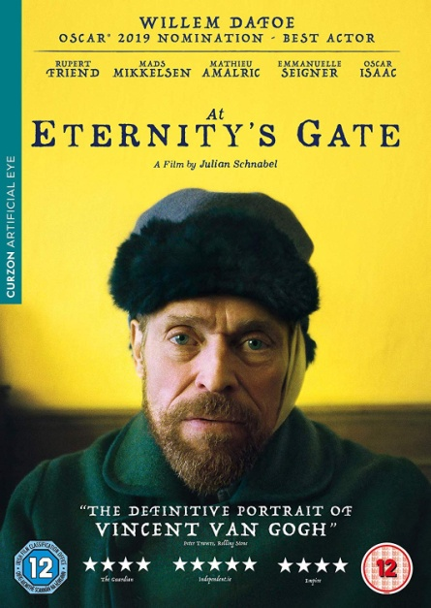**Unit 4 - Vincent Van Gogh: Watching a movie trailer**

**BEFORE YOU WATCH**

1. Write 3 facts about Vincent Van Gogh’s life that you’ve learned from the song “Starry Starry Night”.

____________________________________________________________________________________________________________________________________________________________________________________

**WHILE YOU WATCH**

1. Now, watch the trailer of a movie about Van Gogh’s life. Does it include the facts that you mentioned above?

<https://youtu.be/T77PDm3e1iE>

1. a. What other information about the artist and his life can you get from this movie trailer?
2. Who are the different characters?

Watch it again and make notes below. Then share them with the class.

________________________________________________________________________________________________________________________________________________________________________________________________________________________________________________________________________________________________________________________________________________________________________________________________________________

**AFTER YOU WATCH**

1. a. Do you think the movie title “At Eternity’s Gate” is a suitable one? Justify your answer.
2. Would you be interested in watching this movie? Why? Why not?
3. This movie is a **biopic**. Have you seen another biopic? Who was it about? What did you think of it?