**Reading – pp. 46-47**

**Glossary**

1. absorb (n): απορροφώ
2. affection (adj): στοργή
3. ashes (n): στάχτες
4. blackberry (n): βατόμουρο

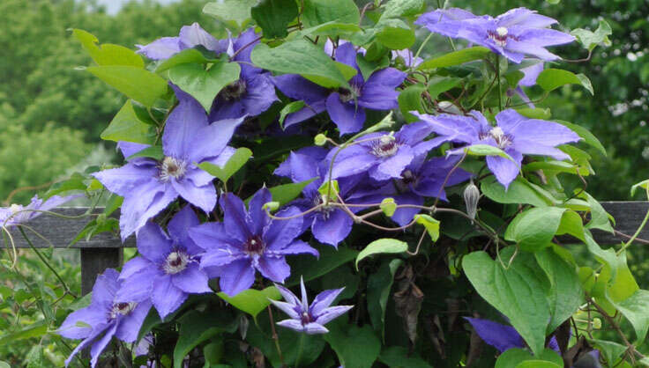clematis

1. bond (n): δεσμός
2. clematis (n): (flowering vine) κληματίδα, αγράμπελη
3. convention (n): κανόνας, σύμβαση, συνθήκη – conventional (adj): συμβατικός
4. discouragement (n): απογοήτευση, αποθάρρυνση
5. disillusioned (adj): (disappointed) απογοητευμένος – disillusionment (n)
6. dusk (n): σούρουπο
7. elm tree (n): φτελιά

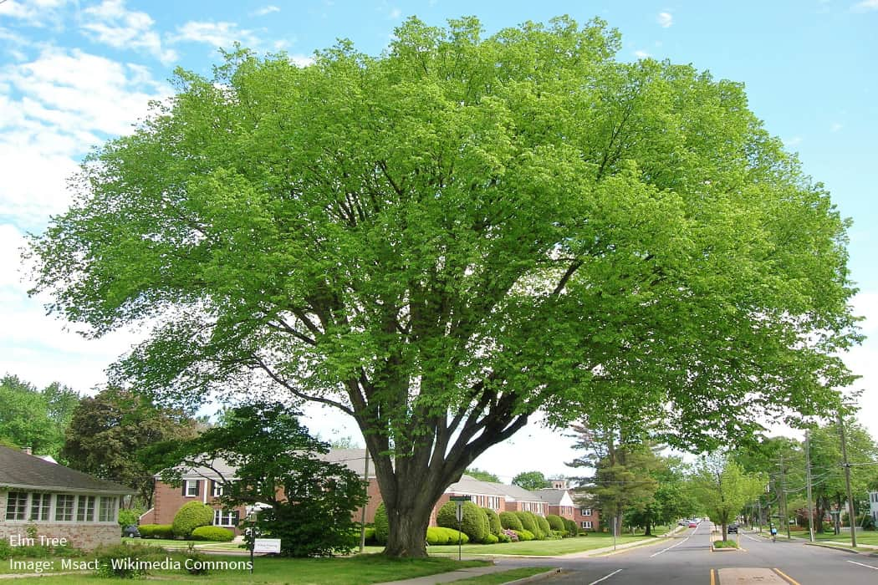  
elm tree

1. endow (v): προικίζω, ευλογώ
2. flicker (v): τρεμοπαίζω
3. hawthorn (n): (thorny shrub) κράταιγος, λευκάγκαθο (είδος φυτού)
4. hedge (n): φράκτης με θάμνους
5. hue (n): απόχρωση
6. immaculate (adj): (perfect, flawless) άψογος, αψεγάδιαστος
7. long (to do sth / for sth) (v): (yearn, crave for, desire) λαχταρώ, επιθυμώ - longing (n): λαχτάρα, επιθυμία

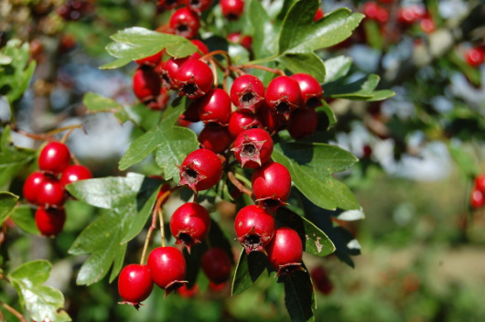hawthorn

1. loosen (v): χαλαρώνω
2. meadow (n): λιβάδι, αγρός με λουλούδια

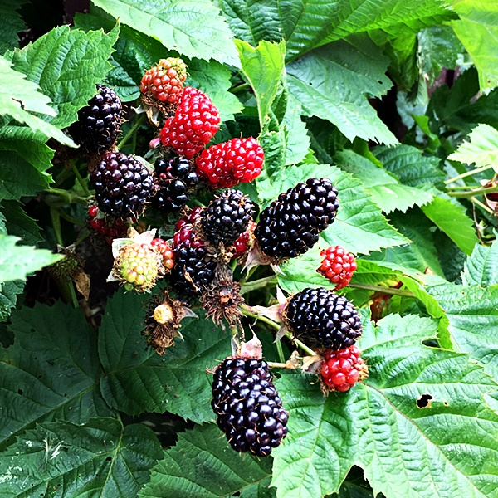blackberry

1. moor (n): χερσότοπος
2. moral (adj): ηθικός
3. penetrate (v): διαπερνώ
4. ray (n): αχτίδα
5. regain (v): ανακτώ
6. renewed (adj): ανανεωμένος – renew (v)
7. retain (v): διατηρώ
8. settle (v): εγκαθίσταμαι / (come to rest) κατακάθομαι, κατακαθίζω
9. stifled (adj): (suffocated, suppressed) καταπιεσμένος, που ασφυκτιά
10. supplant (v): (replace) παραγκωνίζω, αντικαθιστώ, υποκαθιστώ
11. throw (sth) off (v): (get rid of, set oneself free) ξεφορτώνομαι
12. tidings (n pl): μαντάτα, νέα
13. vague (adj): αόριστος, ασαφής
14. yoke (n): ζυγός

**Reading activities**

1. **Mark the following statements as T (true), F (false) or NM (not mentioned).**

**Extract A (p. 46)**

1. Vincent expresses his desire to meet his brother.
2. The village is within short walking distance.
3. Vincent had never been to that village before.
4. He wanted to visit an old teacher of his.
5. His father’s letter was a pleasant surprise.
6. His brother had not been well.
7. Vincent hadn’t seen his mother for years.

**Extract B (p.47)**

1. Vincent had been feeling depressed before going to the moors.
2. Nature made him feel calm and renewed.
3. He became ill again.
4. As he was writing this letter, Vincent was sitting outside, looking at the sky.
5. **Answer the questions.**
6. Describe Van Gogh’s feelings for his brother and his family. Justify your answer with examples from the text.
7. Describe 2 images of nature mentioned in Extract 1.
8. How does nature make Vincent feel? Justify your answer with quotes from the Extract 2.
9. What is Vincent’s attitude to life? Justify your answer with examples from Extract 2.