**Unit 3 - On duty**

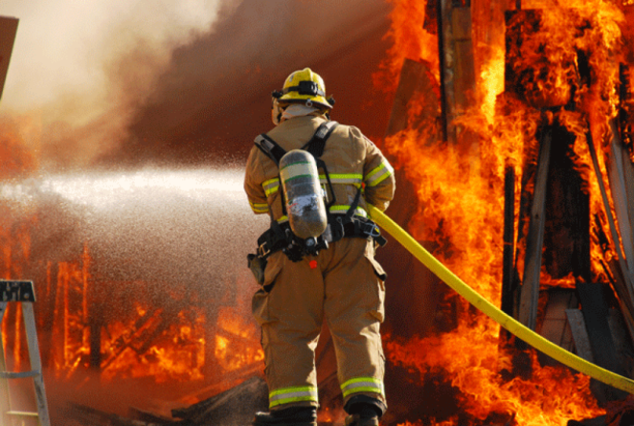**Speaking / Vocabulary (Work)**

1. **In pairs, discuss:**
2. Which of the following factors do you think are the most important for choosing a job/career?

* money
* social status
* skills and talents needed
* working conditions
* personal interests
* 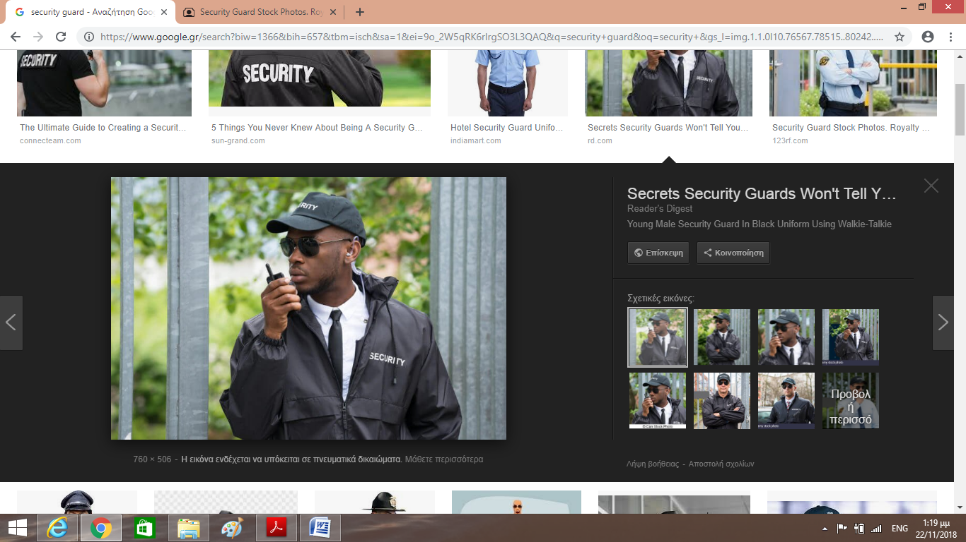job satisfaction

1. 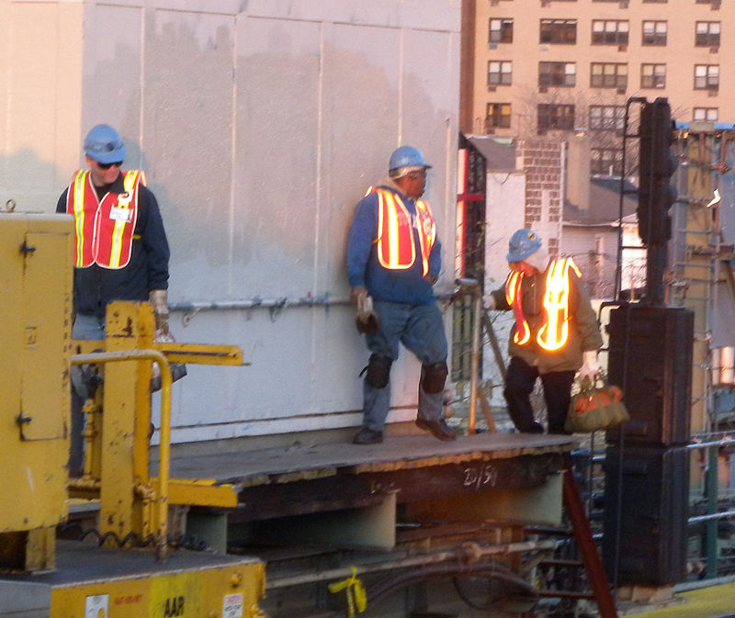a. Name the following jobs. What do these professionals do? What are they doing in the pictures?

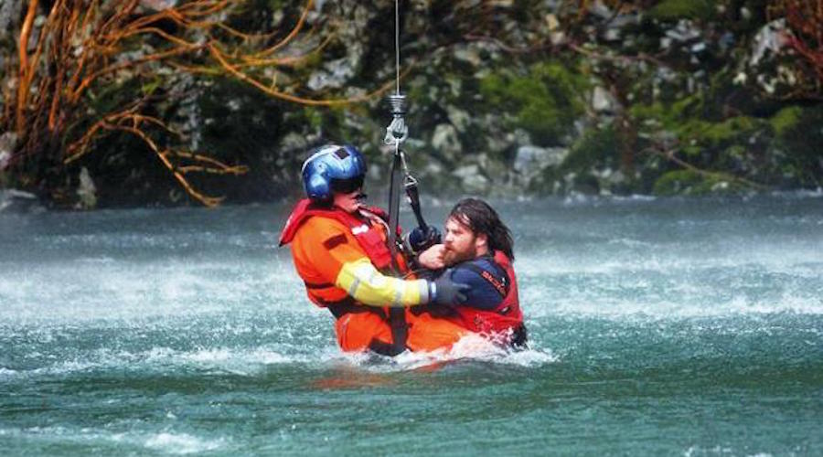

b. Do you think these jobs are dangerous? Why? What other dangerous jobs can you think of?

1. a. Would you choose a "dangerous" job? Why? / Why not?
2. Why do you think some people choose to risk their lives for others? What are the characteristics / personality traits of these people?

* You can practice some **basic vocabulary** on **jobs** here:

<https://learnenglish.britishcouncil.org/en/basic-vocabulary/jobs-1>

<https://learnenglish.britishcouncil.org/en/basic-vocabulary/jobs-2>

**Vocabulary activities (dangerous jobs)**

1. **Match the parts of the sentences to say what each professional does. What tense is used?**
2. A nurse a. works at a building site.
3. A security guard b. saves people in dangerous situations.
4. A rescuer c. puts out fires
5. A firefighter d. takes care of patients in a hospital.
6. A construction worker e. protects a building (e.g. a store or a museum) and   
    keeps people safe.
7. **a. Match the words with their definitions.**

**brave adventurous hard-working patient committed caring**

1. Someone who is kind and helps others. …………………………………
2. Someone who is not scared in dangerous situations. ………….……………………..
3. Someone who works hard. …………………………………
4. Someone who does not complain easily, despite difficulties. …….…………………………
5. Someone who is willing to give their time and energy to something. …………………………….
6. Someone who likes adventure. …………………………………

**b. Which of these characteristics should the professionals in ex. 1 above have?**

**Grammar: Present Continuous (describing pictures)**

1. **Use the words below to describe what the people in the pictures are doing. Make any necessary changes.**
2. nurse/talk/patient/hold/hand

______________________________________________________________________

1. security guard/speak/walkie-talkie

______________________________________________________________________

1. rescuer/pull out/man/river

______________________________________________________________________

1. construction workers/stand/platform/outside/tall building

______________________________________________________________________

1. firefighter/put out/fire

______________________________________________________________________