**Unit 2 - A Refugee’s “Dreamland”**

**Α) VIDEO LESSON**

BEFORE YOU WATCH

1. a. What is a refugee? Why does somebody become a refugee?

b. What is a “dreamland”? What do you think this unit will be about?

1. You are going to watch a video about refugees. Look at the pictures. Where are they? What are they doing?

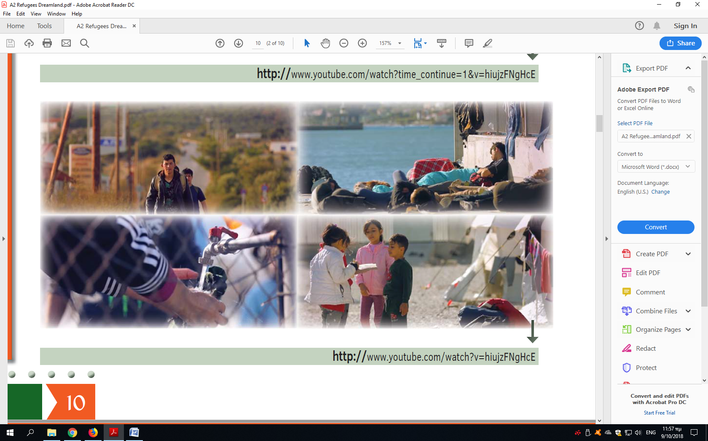

WHILE YOU WATCH

1. Watch a National Geographic video about Syrian Refugees.

<https://www.youtube.com/watch?v=hiujzFNgHcE&t=1s>

Make some notes about:

* their age

…………………………………………………………………………………………………………

* living conditions

…………………………………………………………………………………………………………

* how they feel

…………………………………………………………………………………………………………

Share your information with your partner. Then report back to the class.

1. a. You are going to watch a BBC video. Look at the picture and read the title below. What do you think is the video about?

b. Watch the video and check your answers. Do you agree with this title?

<https://www.youtube.com/watch?v=pwa9KPxbZWQ>

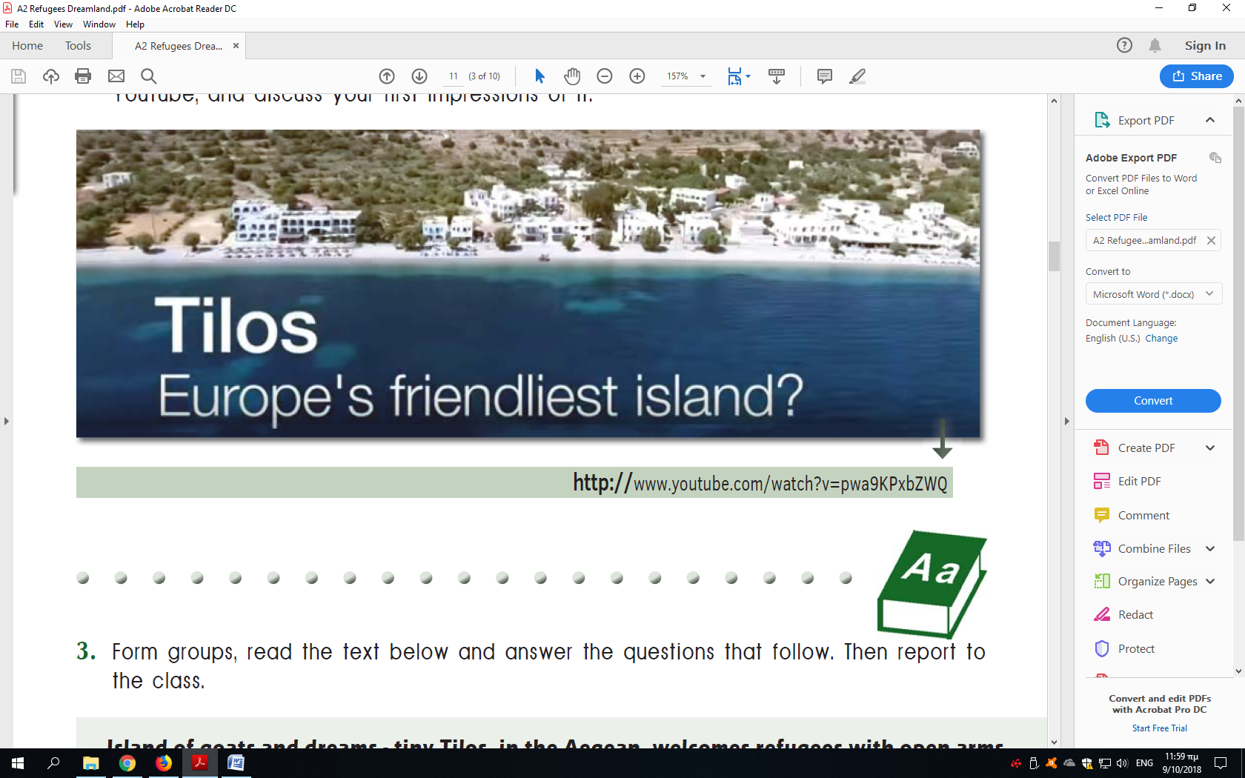

c. Which of the following jobs were the refugees doing in the video? Watch it again and check your answers.

baker

fisherman

farmer

kitchen assistant

maid

waiter

What other jobs do refugees usually do in your country?

AFTER YOU WATCH

**Vocabulary**

1. Check the meaning of these words, then make sentences with them.

*mayor encourage employed locals dairy business goats*

**Speaking**

1. What problems do refugees face in another country? How do the people in Tilos help them with these problems? Share your ideas with your partner. Then tell the class.