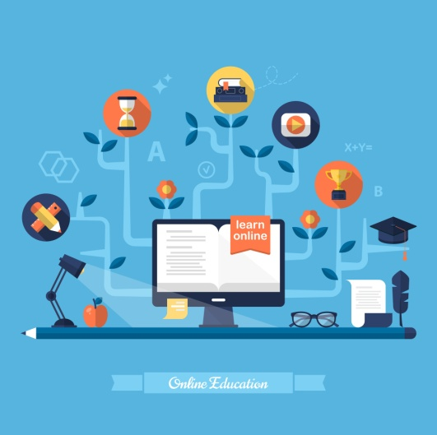How do you feel about distance learning?   
<https://drive.google.com/file/d/1s5foVfm4nGUskC-HrUZ_91F6AFm3JRK2/view?usp=sharing>

In this unit you will:

* Listen to students and parents talking about how they feel about home schooling
* Read an article about the pros and cons of distance learning
* Express your opinion about online learning and based on your personal experience
* Write a letter of advice / a pros & cons essay about distance education

**Listening & Speaking: Studying at home during lockdown**

1. Watch a video in which teenagers talk about how coronavirus has affected studying and do the following tasks.  
   Video 1 : ‘How coronavirus has affected studying’ – BBC World Service

<https://www.facebook.com/bbcworldservice/videos/625034841686860/>

* 1. Match the speakers to the statements.  
     Task: <https://www.educaplay.com/learning-resources/5696575-matching.html>

1. I’m worried about exams, but I love learning and I will do my best to pass.

1. Anya (11, UK)  
  
2. Alma (14, Denmark)  
  
3. Unai (13,Spain)  
  
4. Masato (14, Japan)

b. I find it very difficult to concentrate at home because it’s so noisy.

c. I’m feeling stressed because my exams have been cancelled and all my hard work has gone to waste.

d. I like having an art break or getting some exercise outside every day.

* 1. Which of these students is/are: worried? determined? positive? disappointed? anxious? motivated? lost? pessimistic?

1. Watch the video in which a father talks about homeschooling during lockdown and answer the following questions.  
   Video 2: Surviving lockdown with kids – BBC 2  
   <https://www.facebook.com/bbctwo/videos/555848772005526/>

How does this man feel about:

* 1. parents worrying about homeschooling?
  2. adults being on social media all the time?
  3. parents trying to ‘super-educate’ their children during lockdown?

1. Discussion: Do you agree with any of the speakers in the videos? How do you feel about studying at home?  
     
   **Reading: The pros and cons of distance learning**
2. Before you read: Would you consider attending an online university course? What are the pros and cons of distance learning? Write your ideas here.

# Reading: Read the article and do the following tasks. “5 Pros and Cons for Studying a Distance Learning Degree in 2020”

<https://www.distancelearningportal.com/articles/174/5-pros-and-cons-for-studying-a-distance-learning-degree-in-2020.html>

* 1. Pros and cons: Put the ideas in the correct column.  
     <https://learningapps.org/watch?v=p5jgxr3tk20>
  2. Which of these statements are true about the future of online learning, according to the article?  
     <https://learningapps.org/watch?v=pp1qqvn5320>

1. Distance learning programmes will have to adapt their content to mobile devices.

2. Online institutions should offer career counselling services.

3. Business studies will become more popular.

4. Online institutions will offer a wider range of courses.  
5. It will never replace traditional education.

**Writing: Distance learning**

1. **Choose and write about one of the following topics**:

a. This is part of a letter you received from your Italian friend Marcello:

*“After coronavirus pandemic, I’ve started thinking about attending an online university course, but I’m not sure about the quality of such courses. How valid are online degrees? I also love meeting new people, so I think studying online will be a bit lonely. However, our finances are low, which means I might have to get a part-time job next year, so a distance course might be my only chance to study. What do you think?”*

Write a reply giving some advice about what he should do.

Write 140-200 words.

b. During the COVID-19 lockdowns, schools around the world have closed down and children have been offered online classes instead. Write an **essay** to discuss the **pros and cons of home schooling** based on the ideas discussed in this unit and your own experience.

Write 140-200 words.

**Further reading and listening practice about home schooling and distant learning:**

# Listening & reading: The pros, cons, and privilege of online learning during a pandemic

# <https://www.kuow.org/stories/the-pros-cons-and-privilege-of-online-learning-during-a-pandemic>

# Reading:

# Coronavirus: The impossibility of home-schooling a nation

<https://www.bbc.com/news/education-52151411>

33+ Pros & Cons of Online School (in 2020)  
<https://helpfulprofessor.com/pros-and-cons-of-online-learning/>