**Unit 4 - Learning to fly**

1. Read the following text. In what ways   
   are children like kites?   
   Find the metaphors in the text.

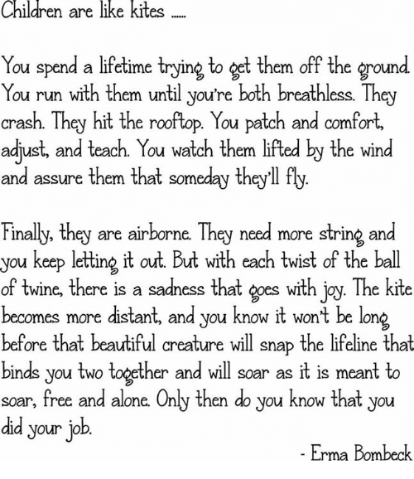

1. a. Read the following information about blackbirds (κοτσύφια):

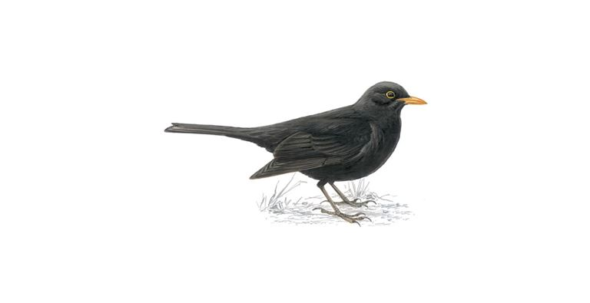

*Blackbirds usually feed off the ground. The majority of English blackbirds seldom move any distance from where they were hatched*. They are rather solitary birds with a very melodious voice.*

*hatch: εκκολάπτομαι

b. Now, listen to “Blackbird”, a song by the Beatles and fill in the missing words.

Follow this link: <https://learningapps.org/watch?v=pshqmkc8t21>

c. What do you think is the meaning of this song? Find lines or phrases from the song that support your point.

1. Compare your ideas with what Paul McCartney had in mind when he wrote the song. (ex. 6 p. 56 in the Student’s book)

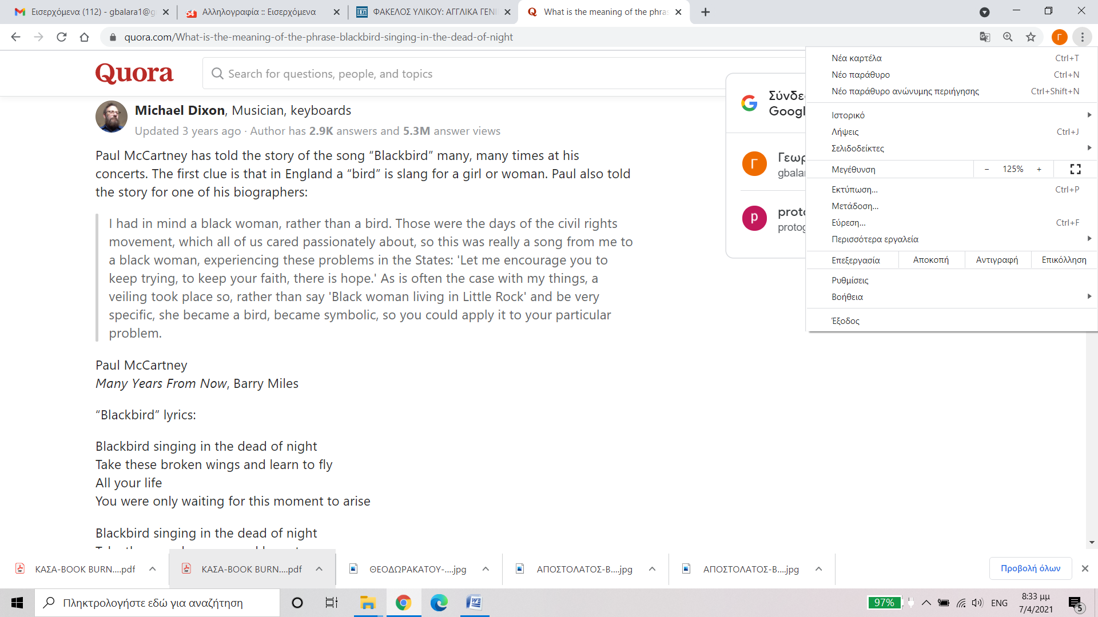

<https://www.quora.com/What-is-the-meaning-of-the-phrase-blackbird-singing-in-the-dead-of-night>

d. Underline the words and phrases in the song (p. 57 in the Student’s book) expressing positive or negative ideas.

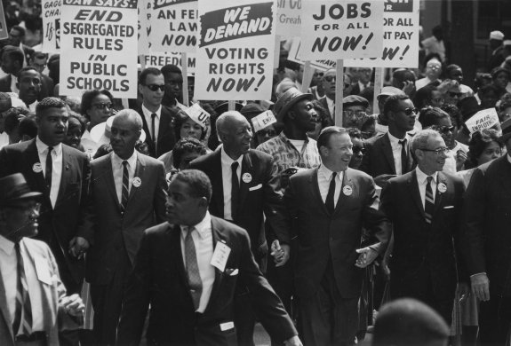**Reading and vocabulary**

Complete the notes about the **Civil Rights Movement** and **Little Rock Crisis** with the following words.

**The Civil Rights Movement**

**protests discrimination slavery century rights political**

* The civil rights movement in the [United States](https://en.wikipedia.org/wiki/United_States) was a social and 1) ____________ movement between 1954 and 1968 against [institutionalized](https://en.wikipedia.org/wiki/Institutionalisation) 2) ______________  and  [segregation](https://en.wikipedia.org/wiki/Racial_segregation_in_the_United_States) in the United States.
* The movement has its origins in the [Reconstruction era](https://en.wikipedia.org/wiki/Reconstruction_era) during the late 19th   
  3) _____________, (the period following the [American Civil War](https://en.wikipedia.org/wiki/American_Civil_War) (1861–65) when   
  4) _____________ was abolished).
* In the mid-1960s, after years of direct actions and grassroots 5) ____________, the movement eventually secured new protections in [federal law](https://en.wikipedia.org/wiki/Federal_law) for the   
  6) ____________ of all [Americans](https://en.wikipedia.org/wiki/Americans).

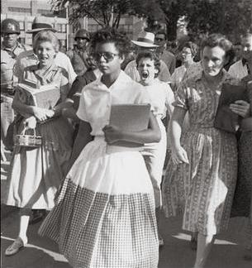[Elizabeth Eckford](https://en.wikipedia.org/wiki/Elizabeth_Eckford) attempting to enter [Little Rock School](https://en.wikipedia.org/wiki/Central_High_School_(Little_Rock)) on 4th September, 1957.

**Little Rock Crisis, 1957**

**harassed prevent harsh graduated attend**

A crisis erupted in [Little Rock, Arkansas](https://en.wikipedia.org/wiki/Little_Rock,_Arkansas), when [Governor of Arkansas](https://en.wikipedia.org/wiki/Governor_of_Arkansas) [Orval Faubus](https://en.wikipedia.org/wiki/Orval_Faubus" \o "Orval Faubus) called out the [National Guard](https://en.wikipedia.org/wiki/National_Guard_of_the_United_States) on September 4 to 1) __________ entry to the [nine African-American students](https://en.wikipedia.org/wiki/Little_Rock_Nine) who had been chosen to 2) _________ Central High because of their excellent grades.

On the first day of school, 15-year-old [Elizabeth Eckford](https://en.wikipedia.org/wiki/Elizabeth_Eckford) was the only one of the nine students who showed up because she did not receive the phone call about the danger of going to school. A photo was taken of Eckford being 3) _________ by white protesters outside the school, and the police had to take her away in a patrol car for her protection.

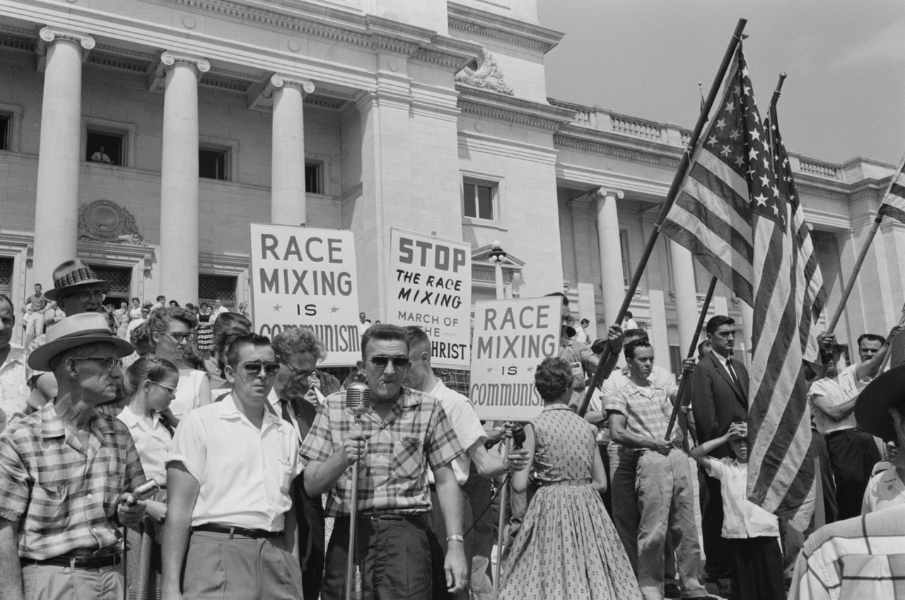

White parents rally against integrating Little Rock's schools

After action taken by President Eisenhower, the students eventually attended high school under   
4) __________ conditions. Although federal troops escorted the students between classes, the students were teased and even attacked by white students when the soldiers were not around. Only [Ernest Green](https://en.wikipedia.org/wiki/Ernest_Green) of the Little Rock Nine   
5) __________ from Central High School.

**Source: Wikipedia**