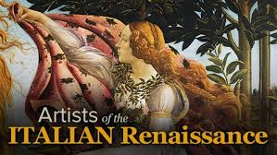

**PRE-CLASS**

Activity 1

Blog: <http://aroreta.blogspot.com/>

A happy thinklink user

Have a close look at the digital picture. What do you think this text will be about?

After having read it. What do you think this text is about?

How is the information organized?

Take notes to tell the class what you have learnt about The Renaissance.

Activity 2

Blog: <http://aroreta.blogspot.com/>

Watch the videos about five artists (Leonardo Da Vinci, Michelangelo, Sandro Botticelli, Raphael και Andrea Del Verrocchio) from the Renaissance period. Take notes in English or Greek and use wordart to write the most important words or expressions for each one.

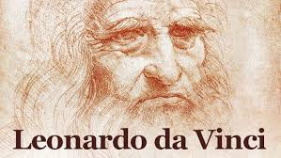

**IN-CLASS** 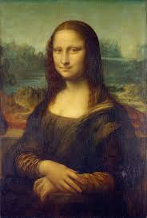

Activity 1

In groups of three or four using google drive

Imagine that you are a tour guide of a museum and you have to say the most important things related to the Renaissance. What would you say? Compare the notes you have taken with your classmates and make a presentation together.

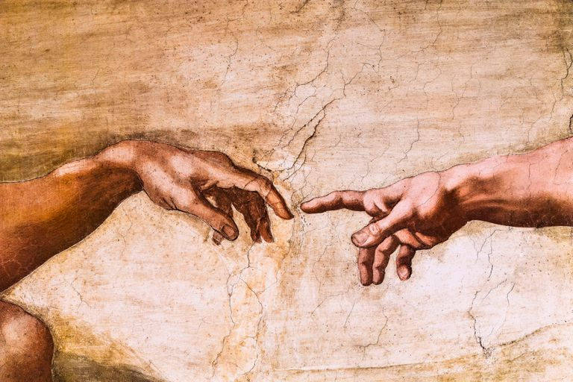

Activity 2

Read the five texts about Leonardo Da Vinci, Michelangelo, Sandro Botticelli, Raphael και Andrea Del Verrocchio (Coursebook).

Find any unknown words. Which are the words you already know from last year? (Do you remember the unit related to art?)

Use the following link <https://translate.google.gr/?hl=el#view=home&op=translate&sl=en&tl=el&text=bo>

to find the meaning of the new words, as well as synonyms.

Use padlet for the new words that you will be asked to use in an activity later on.

Activity 3

Choose one artist from the Renaissance period.

In groups of three or four (using google drive) compare the information you got from the book and the video. Which one was the most informative? Do we know anything about the writers? Are they trustworthy? Write down notes because you will use them for homework.

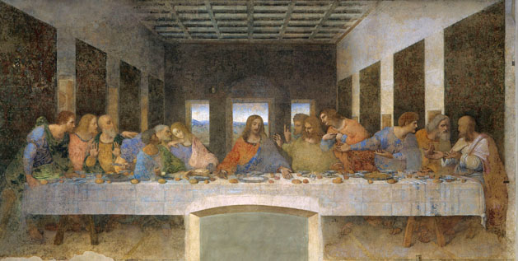

**AFTER-CLASS**

Activity 1

Use google drive. Make a power point presentation about an artist of the Renaissance period using your findings of activity 3. Upload your presentation.