*Why did Van Gogh paint so many portraits?*

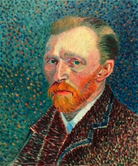

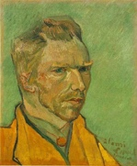

How many portraits are there in the Van Gogh museum in Amsterdam?

_______________________________________________________________

How many portraits did he actually create?

_______________________________________________________________Why did Vincent create all these portraits?

_______________________________________________________________Did Vincent want to sell his portraits?

_______________________________________________________________Does he look the same in all the portraits?

_______________________________________________________________What proves that he used his portraits to practice?

_______________________________________________________________When were these two portraits made?

_______________________________________________________________Why did he use the complementary pairs of colors?

_______________________________________________________________What was he mostly interested in?

_______________________________________________________________Which is his most accurate portrait?

_______________________________________________________________