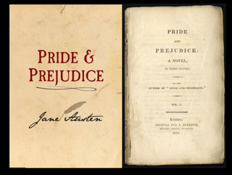
Pride and Prejudice Reading
pages 82-83 Questions

A.
1. Where do the Bennet family live?
____________________________________________________________________
2. Who seems to be a person who doesn’t keep his/her mouth shut?
____________________________________________________________________
3. What does the novel’s opening sentence: “It is a truth……want of a wife” mean?
____________________________________________________________________
4. What do the Bennets do to come in contact with Mr. Bingley?
____________________________________________________________________
5. Why do they do so?
____________________________________________________________________

B.
6. Who does Mr. Bingley fall in love? How does he characterize her?
____________________________________________________________________
7. What is Darcy’s original opinion of Elizabeth?
____________________________________________________________________
8. How does Elizabeth feel about Darcy?
____________________________________________________________________
9. What is the neighbourhood’s opinion of Darcy?
____________________________________________________________________
10. What is the neighbourhood’s opinion of Mr. Bingley?
____________________________________________________________________

C.
11. What is Mr. Bingley like as a person?
____________________________________________________________________
12. What is Darcy like as a person ?
____________________________________________________________________

D.
13. Why do you think Jane hides her feelings for Mr. Bingley?
____________________________________________________________________

E.
14. Does Darcy continue rejecting Elizabeth?
____________________________________________________________________
15. What does he say about her?
____________________________________________________________________

F.
16. Is Miss Bingley interested in Darcy? What does she do to attract him?
____________________________________________________________________
17. Why do you think Miss Bingley and Elizabeth try find something in Darcy’s character to make fun of?
____________________________________________________________________
18. “My good opinion once lost is lost forever”. What does Darcy mean?\
____________________________________________________________________
19. Why do you think Elizabeth want to leave and go back home?
____________________________________________________________________

G.
20. Why do you think Miss Bingley compliments upon Darcy?
____________________________________________________________________
21. Why do Elizabeth and Darcy argue that evening?
____________________________________________________________________
22. What does Darcy mean when he says “Were it not for the inferiority of her connections, he should be in some danger.”?
____________________________________________________________________
23. Why does Miss Bingley make fun of Elizabeth’s family ?
____________________________________________________________________

