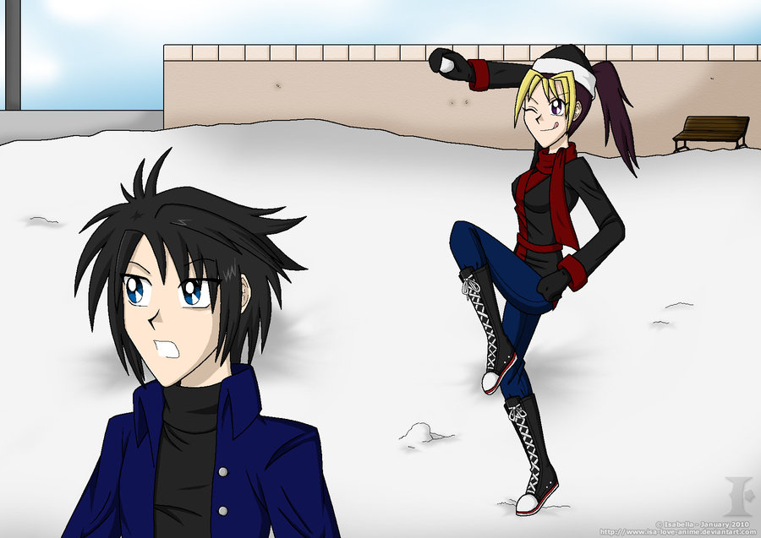
Όνομα:........................
Σου έχω γράψει κάποιους αριθμούς. Μάντεψε την σκέψη μου και γράψε αυτούς που σου έχω κρύψει!!

Ανεβαίνω 2

2, 4, ..........., ..........., ..........., ..........., ..........., 16, .........., ..........., ............, ............ .

3, 6, 9, ..........., ..........., ..........., ..........., ..........., .........., ..........., ............, ............ .

27, 25, ..........., ..........., ..........., ..........., ..........., .........., ..........., ............, ............ .

62, 65, ..........., ..........., ..........., ..........., ..........., .........., ..........., ............, ............ .

42, 46, ..........., ..........., ..........., ..........., ..........., .........., ..........., ............, ............ .

92, 88, ..........., ..........., ..........., ..........., ..........., .........., ..........., ............, ............ .

10, 20, ..........., ..........., ..........., ..........., ..........., .........., ..........., ..........., 110, ........... .

20, 40, ..........., ..........., ..........., 120, ..........., 160, .........., 200, ............, ............ .

85, 80, ..........., ..........., ..........., ..........., ..........., .........., ..........., ............, ............ .

27, 32, ..........., ..........., ..........., ..........., ..........., .........., ..........., ............, ............ .

15, 30, ..........., ..........., ..........., ..........., 105, .......... .

