MODAL VERBS
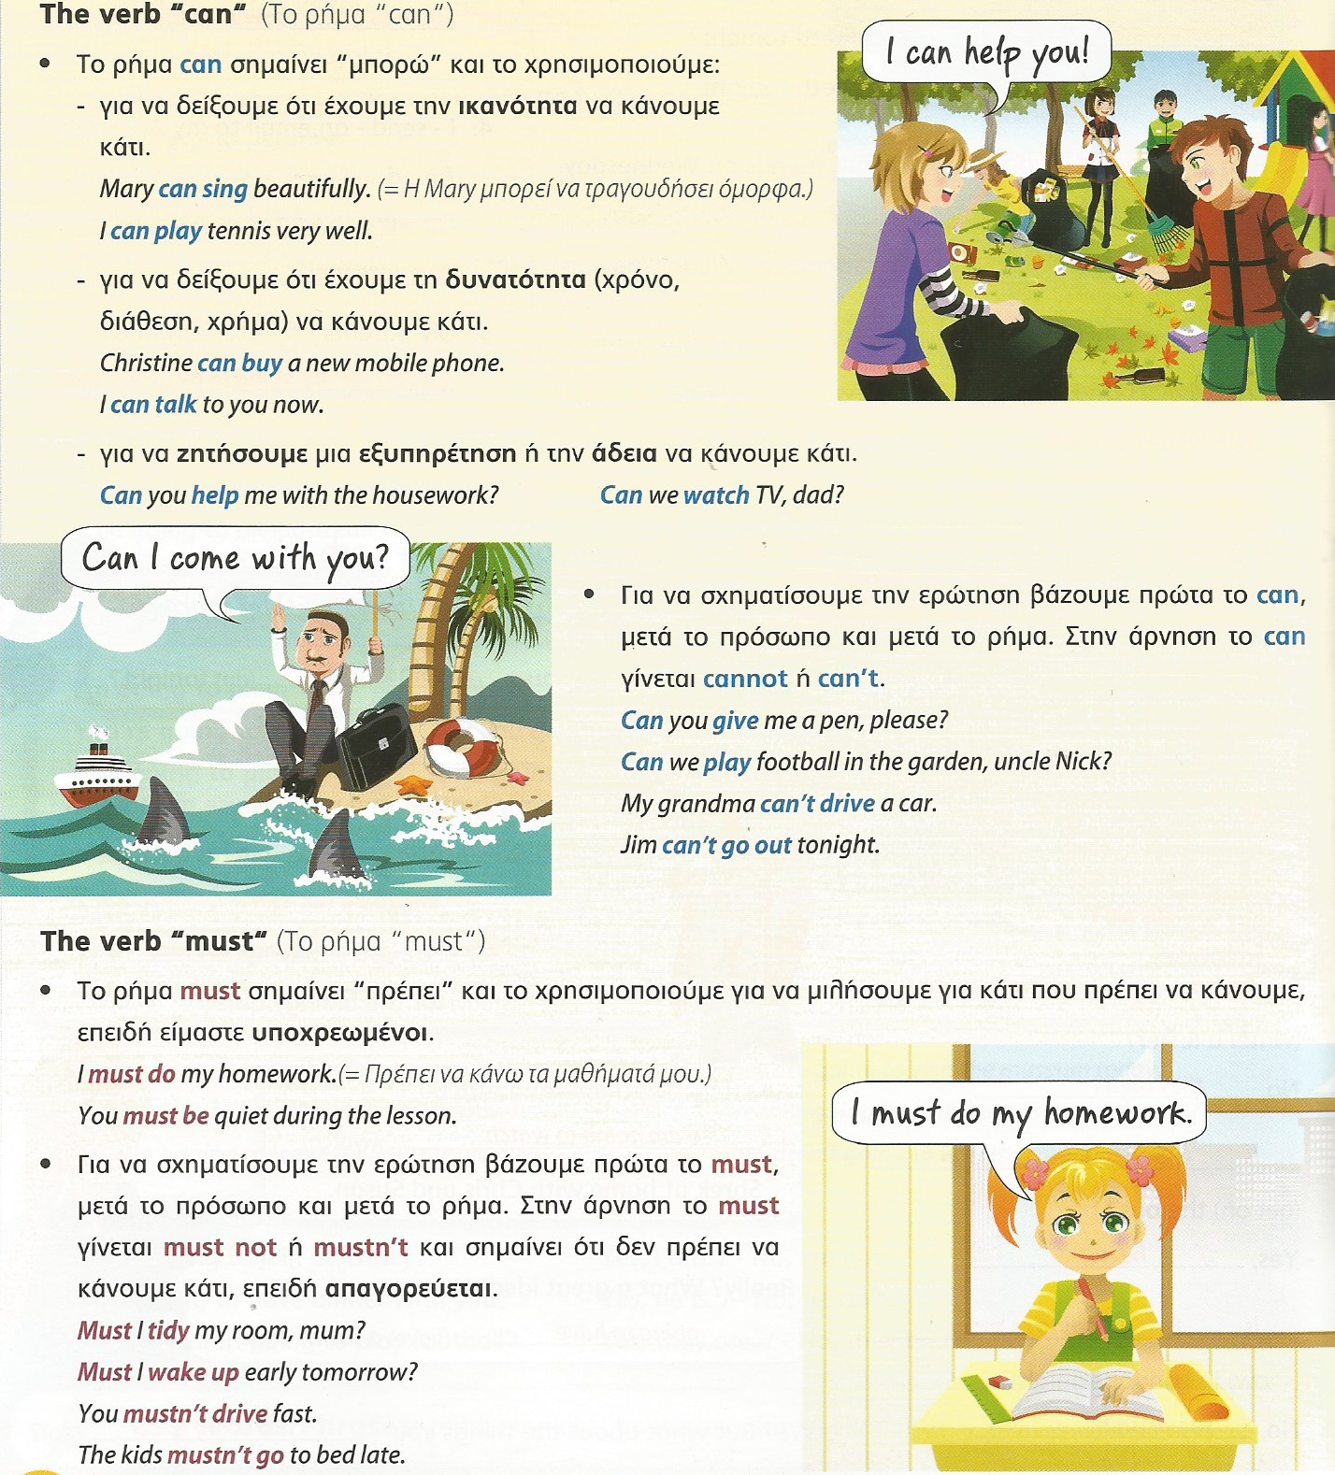

EXERCISE 1
Fill in the text with can/ can’t/ must/ mustn’t.

Every day I ________ wake up at 7:00 and I ________ take the bus to school at 8:00. After school, I _________ do my homework. I _________ watch TV or go out. At night, I __________ go to bed early.
But then the weekend comes and I ________ relax. I _________ go out with my friends or we __________ ride our bikes but I __________ stay out after 11:00…. Weekends are great!

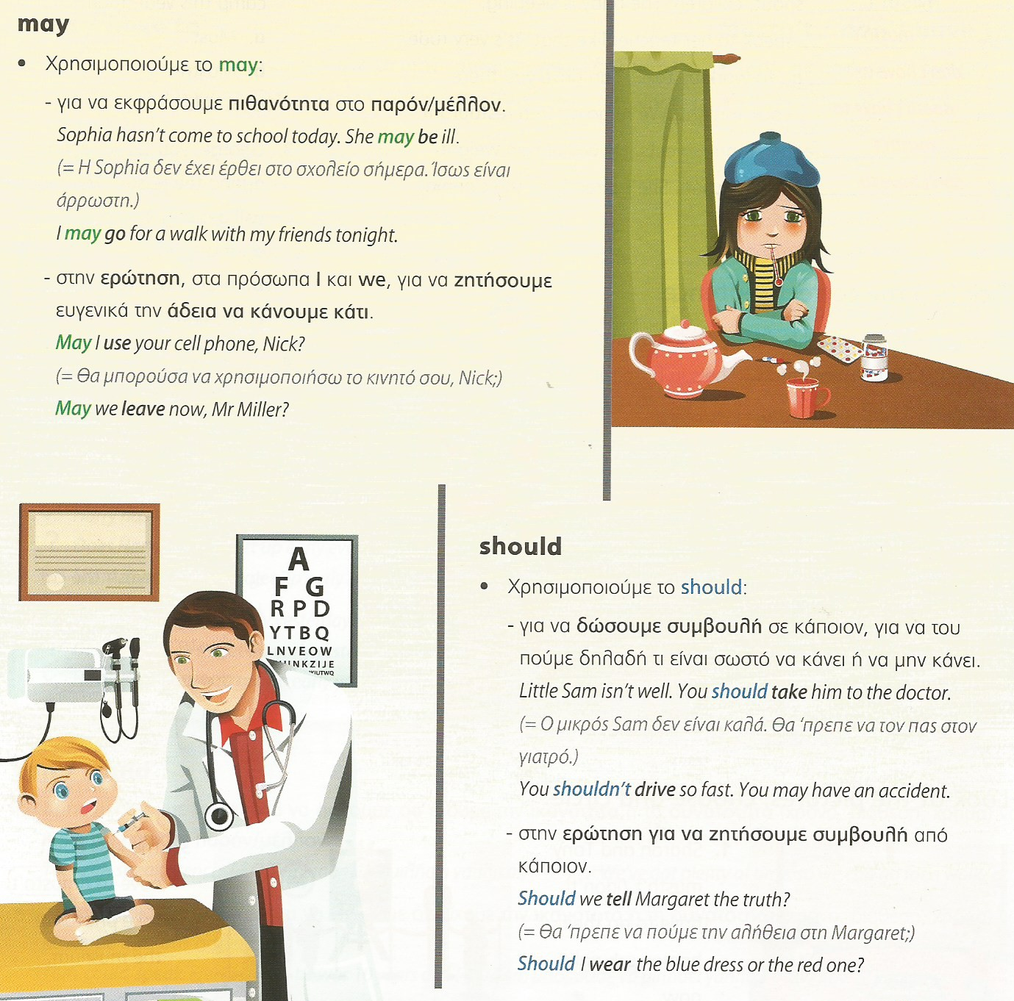

EXERCISE 2
Fill in the text with may / should / shouldn’t.
