DESCRIBE YOUR BEST FRIEND
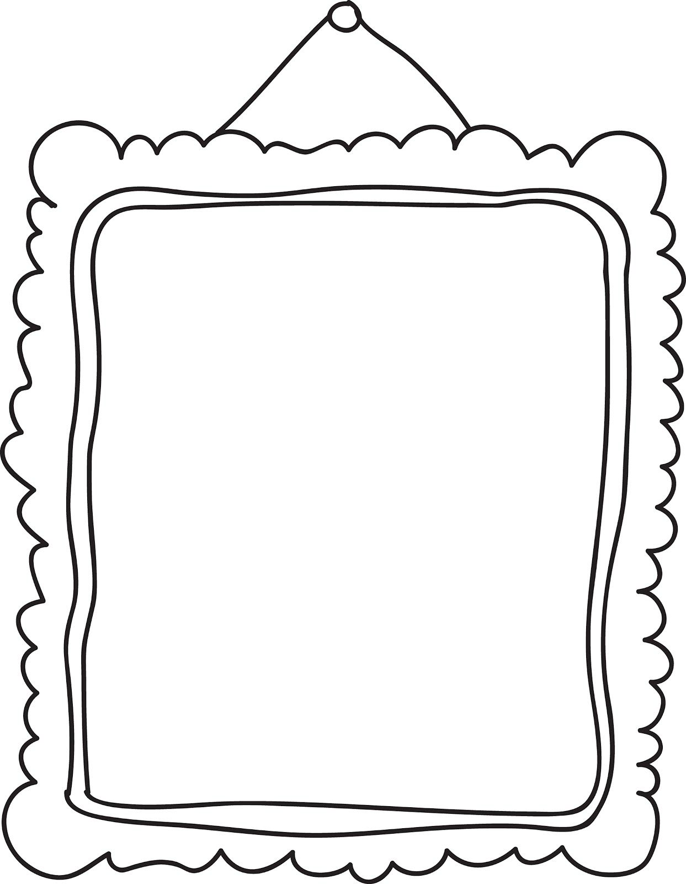
Use the information from the videos and the activities to describe your best friend. Follow the plan below.

Paragraph 1: General information
What’s his/her name?
How old is he/she?
Where & when did you meet?
Paragraph 2: Physical appearance
What is his/her build?
What is his/her hair like?
What are his/her eyes like?
Paragraph 3: Personality
What are his/her hobbies?
What can he/she do well?
What kind of person is he/she?
Paragraph 4: Your opinion
What do you like about your best friend?

Write your text here in Word form.

