PRESENT SIMPLE & CONTINUOUS
6th GRADE
ACTIVITY 1
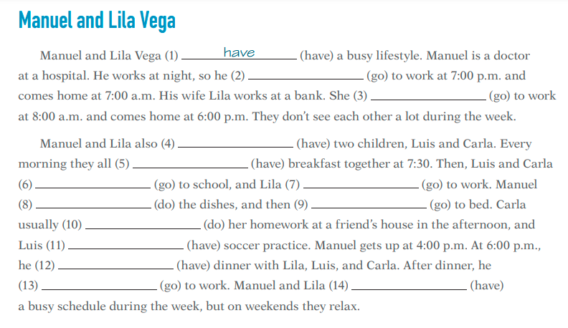
Put the verbs in the Present Simple.

ACTIVITY 2
Put the verbs in the Present Continuous.
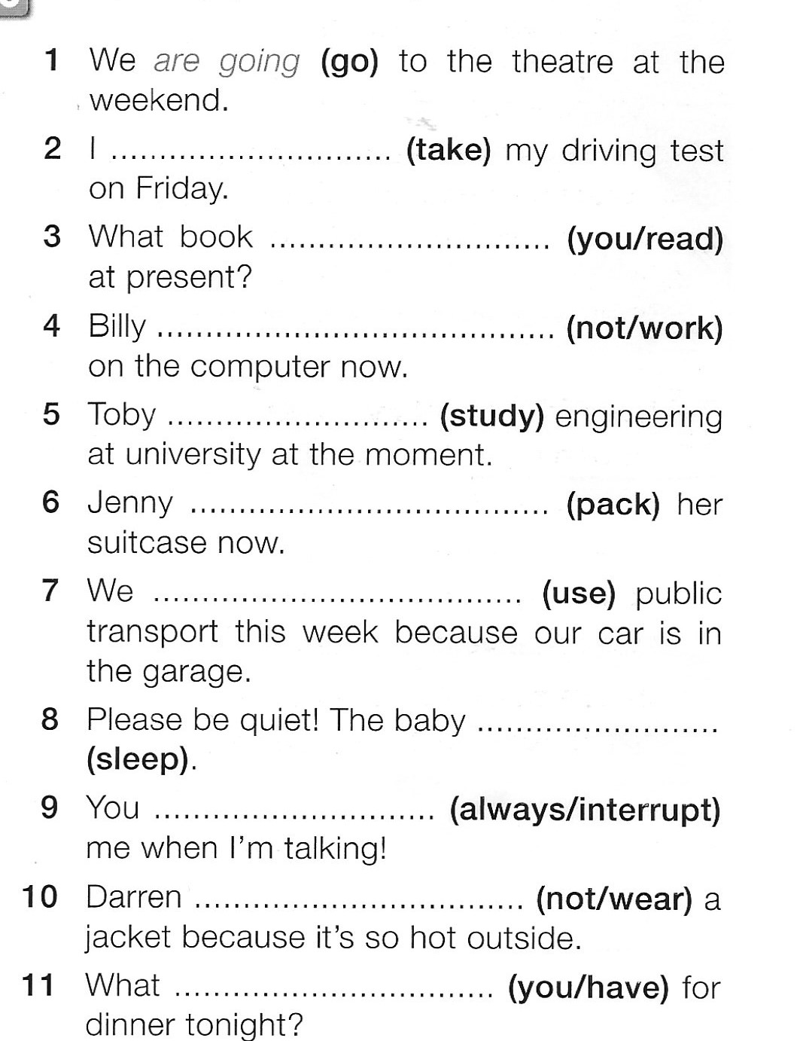

ACTIVITY 3
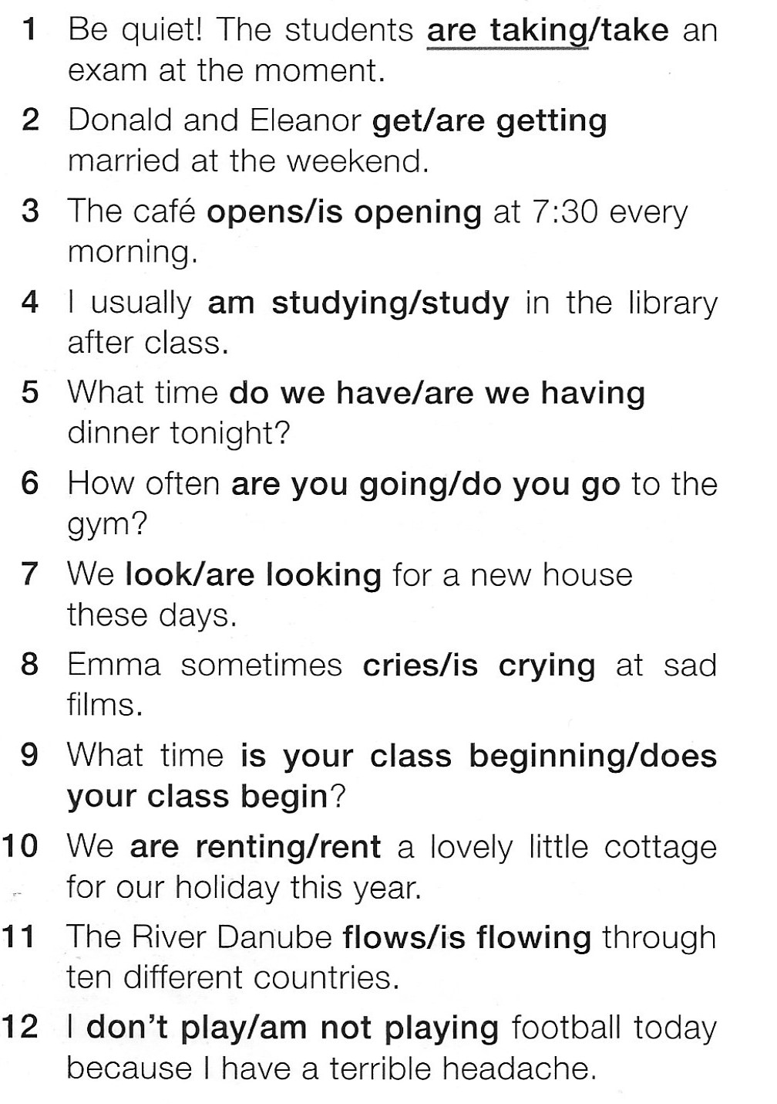
Underline the correct verb.

ACTIVITY 4
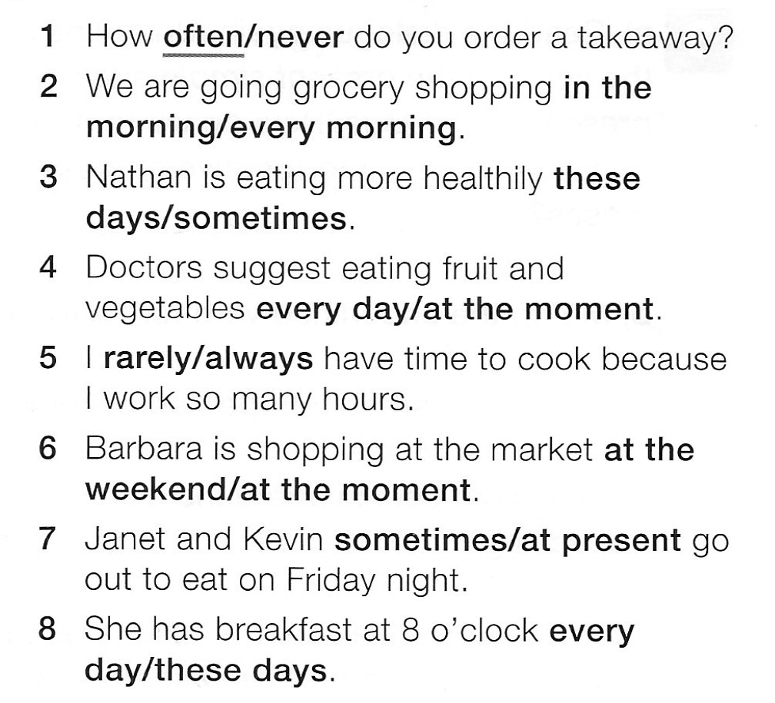
Choose the correct time expression.

ACTIVITY 5
Choose the correct option, A, B or C.
