Sing for the climate!
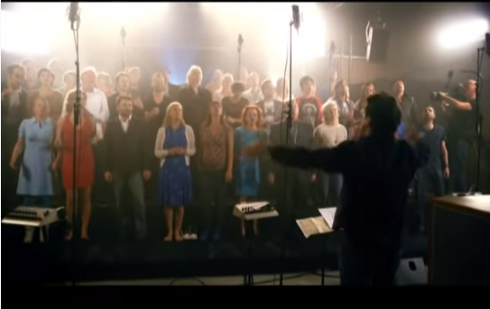
Watch the video at https://www.youtube.com/watch?v=c7V1qLLsn7M&t=3s

Complete the gaps of the song with the words:
greener now future fast better wake start more eyes right need solve problem get cleaner waiting
We need to ____________ up.
We need to wise up.
We need to open our ____________
And do it ____________ ____________ ____________ (same word 3 times)
We need to build a ____________ future.
And we need to ____________ right now.
We’re on a planet
That has a ____________
We’ve got to ____________ it, get involved.
And do it now now now
We need to build a better ____________
And we need to start ____________ now.
Make it ____________
Make it ____________
Make it last, make it ____________
And do it now now now
We need to build a better future
And we need to start right now.
No point in ____________
Or hesitating
We must ____________ wise, take no ____________ lies.
And do it now now now
We ____________ to build a better future
And we need to start right now.

