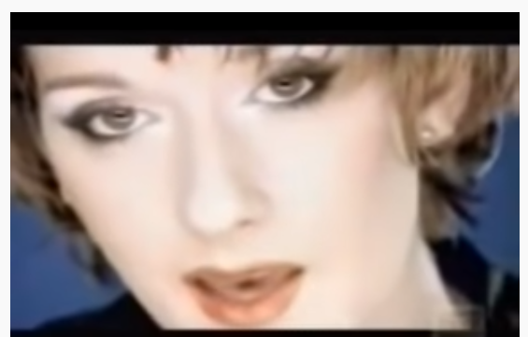
BECAUSE YOU LOVED ME (Celine Dion, 1996)
- Watch the song at https://safeYouTube.net/w/thO7
- Complete the sentences with the Past Simple of the verbs.

For all those times you __________ by me (stand)
For all the truth that you _________ me see (make)
For all the joy you __________ to my life (bring)
For all the wrong that you __________ right (make)
For every dream you _________ come true (make)
For all the love I ___________ in you (find)
I'll be forever thankful, baby
You're the one who ________ me up (hold)
Never let me fall
You're the one who _________ me through, through it all (see)

You ________ my strength when I was weak (be)
You ________ my voice when I couldn't speak (be)
You ________ my eyes when I couldn't see (be)
You ___________ the best there was in me (see)
__________ me up when I couldn't reach (lift)
You _________ me faith 'cause you ________ (give, believe)
I'm everything I am
Because you ________ me (love)

You ______ me wings and _________ me fly (give, make)
You __________ my hand, I could touch the sky (touch)
I __________ my faith, you _________ it back to me (lose, give)
You __________ no star was out of reach (say)
You __________ by me and I ________ tall. (stand, stand)
I _________ your love, I ________ it all! (have, have)
I’m grateful for each day you ______________ me (give)
Maybe I don’t know that much

But I know this much is true
I was blessed because I was loved by you!

You _______ always there for me (be)
The tender wind that __________ me (carry)
A light in the dark shining your love into my life
You've been my inspiration
Through the lies you ____________ the truth (be)
My world is a better place because of you.

