18/5/2020 Class 5
Problems and suggestions (=προτάσεις)
Στα 2 τελευταία online μαθήματα, με τα παιδιά μιλήσαμε για το πώς λέμε την γνώμη μας και πώς κάνουμε προτάσεις/ιδέες. Ο παρακάτω πίνακας είναι από το βιβλίο, σελίδα 40.
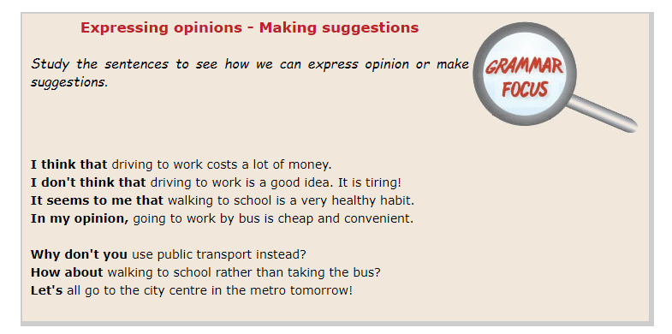
ΕΡΓΑΣΙΑ
You are the new Mayor in a city. People have a lot of problems and they want your suggestions! Use the phrases in the table above to make some suggestions!
(Κάνε προτάσεις στα προβλήματα των πολιτών! Είσαι ο νέος τους Δήμαρχος! Χρησιμοποίησε τις 3 φράσεις – δες το παράδειγμα με όλες τις φράσεις)
- I think that we don’t recycle!
Why don’t you put recycling bins in all schools?
How about putting recycling bins in all streets?
Let’s talk about recycling at schools.
- We can’t do any sports in this city!
-
-
- I think that there aren’t many parks!
-
-
- I can’t ride my bike outside my garden! I’m afraid.
-
-
- The air is not clean!
-
-
- There is a lot of rubbish on the beach!
-
-
- There is a lot of rubbish in the streets.
-
-
- There are a lot of cars in the streets.
-
-
- There aren’t any places for old people in the city. What ca they do in their free time?
-
-
10. There are no places for young people and children. What can they do in their free time?
-
-

