ACTIVITY 1
Complete the missing letters.
A a | B b | _______ | D d | ______ | F f
______ | H h | I i | ______ | K k | ______
M m | ______ | O o | P p | ______ | R r
S s | ______ | U u | V v | ______ | X x
______ | Z z
ACTIVITY 2
a e i o u
Write and join the words with the pictures . Use colours.

c__mp__t__r  w__nd__w  __mbr__ll__  b__ __r  l__z__rd |   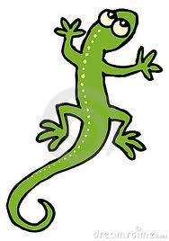  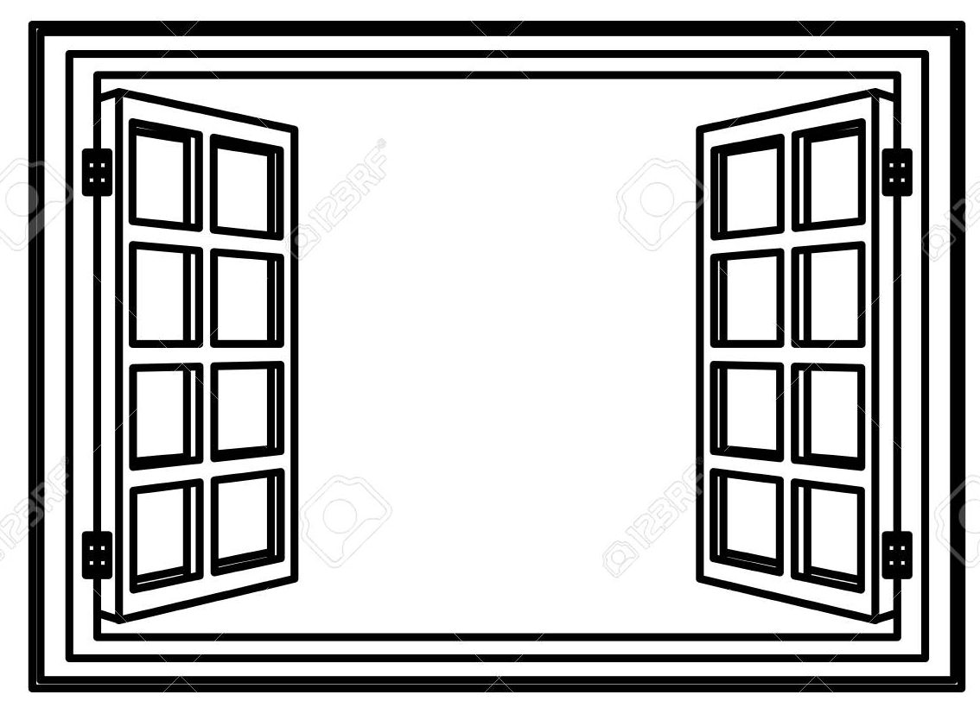  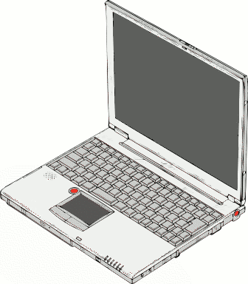  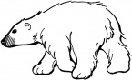  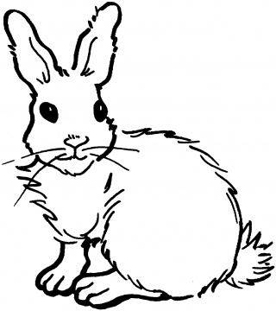  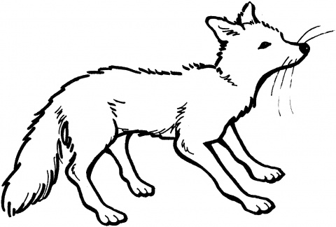  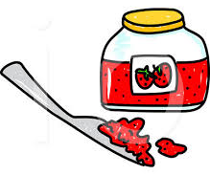  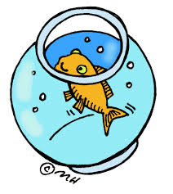  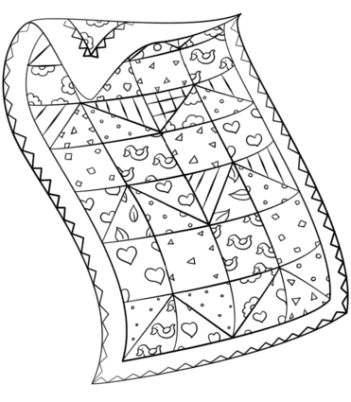 | r__ bb__t  j__m  q__ __lt  f__shb__wl  f__x

ACTIVITY 3
Complete the first letter.
__ ndian | __ gg | __ ion | __ ave
__ angaroo | __ ish | __ onkey | __ oghurt
__ og | __ ar | __ est | __ iger

ACTIVITY 4
Write the words in capital letters.
hare | ____________________ | violet | ____________________
penguin | ____________________ | nut | ____________________
gate | ____________________ | ball | ____________________
clock | ____________________ | octopus | ____________________
ACTIVITY 5
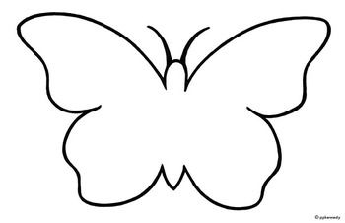
Match the letters. Use colours.
