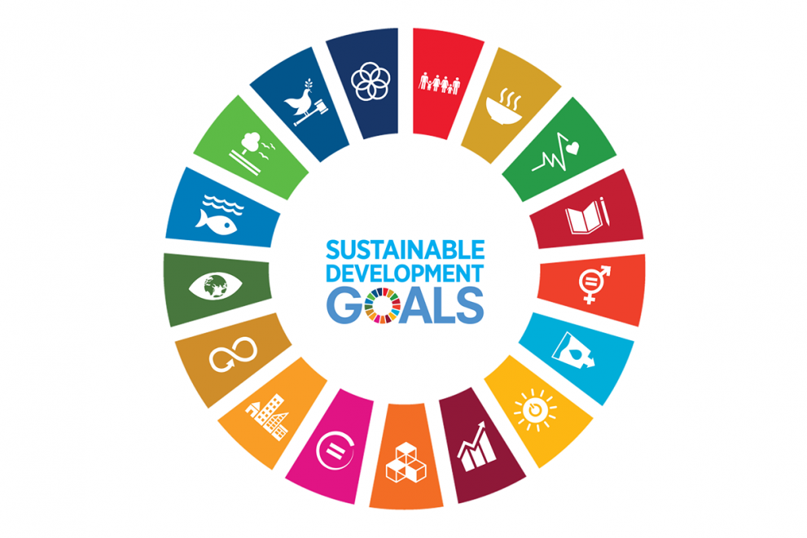
Poster Ideas
The United Nations
Sustainable Development 17 Goals (SDGs)
(17 Στόχοι Βιώσιμης Ανάπτυξης)

- Goal 1 (No Poverty) Draw a happy family with food, shelter, and education.
- Goal 2 (Zero Hunger) Draw different healthy foods from around the world.\
- Goal 3 (Good Health and Well-being) Use images of children playing, people exercising, or a smiling doctor/nurse.
- Goal 4 (Quality Education): Show kids in school, reading books, or using computers.
- Goal 5 (Gender Equality) Illustrate boys and girls learning, playing, or working together equally.
- Goal 6 (Clean Water and Sanitation): Use blue colors to show a clean river, lake, or happy kids drinking water.
- Goal 7 (Affordable and Clean Energy): Draw wind turbines, solar panels, or light bulbs with eco-friendly labels.
- Goal 8 (Decent Work and Economic Growth): Illustrate different professions to show that everyone has the right to work in a safe, fair environment.
- Goal 9 (Industry and Innovation): Focus on technology with images like bridges, trains, or scientists working.
- Goal 10 (Reduced Inequalities): Show diverse people of different backgrounds smiling or helping each other to represent equality.
- Goal 11 (Sustainable Cities and Communities): Draw a green, clean city with parks, bike paths, and eco-friendly buildings.
- Goal 12 (Responsible Consumption and Production): Illustrate recycling, reducing waste, or eco-friendly shopping habits.
- Goal 13 (Climate Action): Use green and blue colors to show a healthy planet and actions that help prevent climate change, like planting trees.
- Goal 14 (Life Below Water): Draw a clean ocean with happy marine life, like fish, turtles, and coral reefs.
- Goal 15 (Life on Land): Show animals in a forest or jungle setting with a slogan about protecting nature.
- Goal 16 (Peace and Justice): Illustrate children from different backgrounds holding hands around a globe.
- Goal 17 (Partnerships for the Goals): Draw different countries and groups working together, with linked hands or puzzle pieces.

