**Unit 2**

**A refugee’s Dreamland**

**Page 21**

**Task B**

Try your luck by attempting to successfully escape Syria’s war zone….

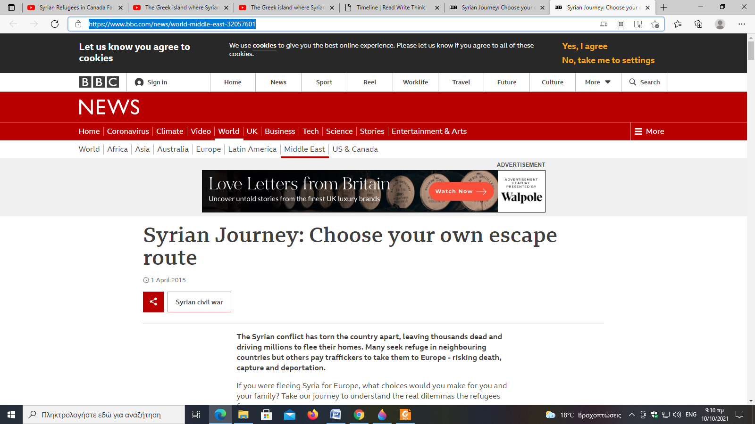

**Click on the following link and see if you manage to reach safety …..**

[Syrian Journey: Choose your own escape route - BBC News](https://www.bbc.com/news/world-middle-east-32057601)

**Don’t forget!**

**You will be asked to report the outcome of your journey in class ….**

**Good Luck!!!**

**Hope you and your family reach your destination safely…**