**UNIT 2**

**A Refugee’s Dreamland**

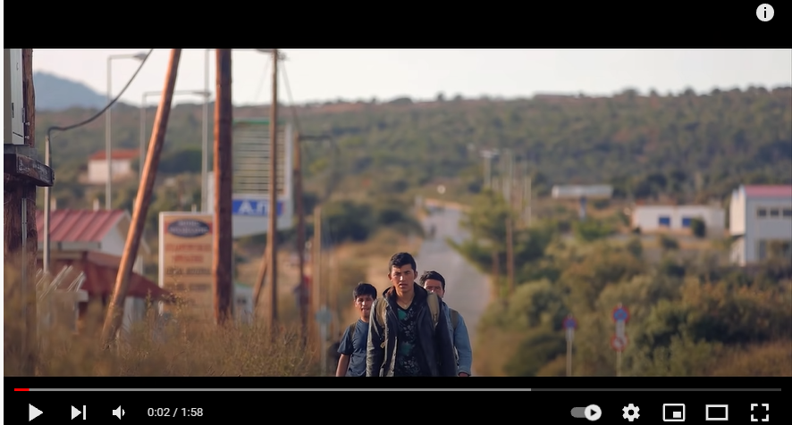

**Page: 14**

**Click** on the following link to watch the video…

[Syrian Refugees: A Human Crisis Revealed in a Powerful Short Film | Short Film Showcase - YouTube](https://www.youtube.com/watch?v=hiujzFNgHcE)

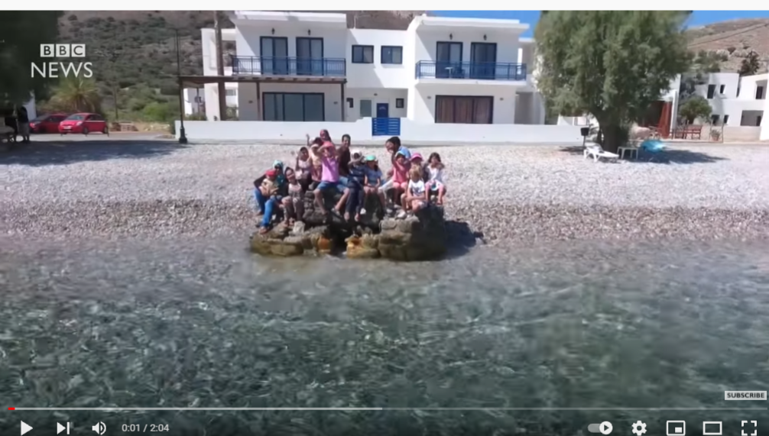

**Page: 15 Follow the link below……**

[The Greek island where Syrian refugees are welcome - BBC News - YouTube](https://www.youtube.com/watch?v=pwa9KPxbZWQ)