Pride and prejudice

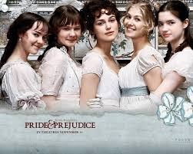

The story is about the Bennet family. Mr and Mrs Bennet have five lovely daughters: Jane, Elizabeth, Mary, Catherine, Lydia.



Two young men, Bingley and Darcy, come to stay in the neighbourhood.

Bingley falls in love with Jane.

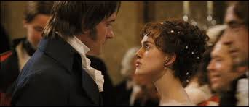

Elizabeth, intelligent and witty, takes a dislike to mr Darcy because he is cold and proud.



Mr Darcy is in love with Elizabeth, then he proposes to her and she refuses to him.

Some months later Elizabeth meets mr Darcy by accident and falls in love with him.

Darcy helps Elizabeth when her sister Lydia run away from home.

The story ends happily, with the marriage of Elizabeth to Darcy and Jane to Bingley.