**Media Studies: Newspapers**

**Broadsheet:** A ‘quality’ newspaper with serious and in-depth reporting on a wide range of important issues. It is A2 size. It uses formal language and tries to give the facts without exaggerating.

**Tabloid:** Reports mostly on scandals, gossip and celebrities, in a sensational style. It is A3 siza, which is half the size of a broadsheet. It uses simple, exaggerated language and slang.

**Front pages:** The first part of the newspaper that you see is the front page. This has to be eye-catching to convince you to buy the paper. Newspapers use different tricks to attract our attention. You can tell the difference between a tabloid and a broadsheet at a glance.

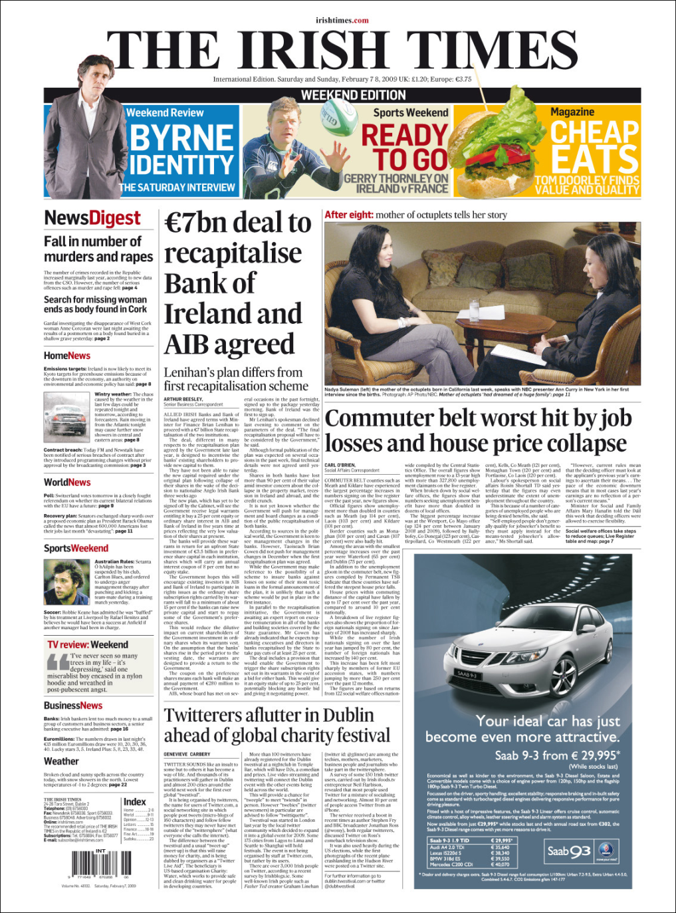**Broadsheet**

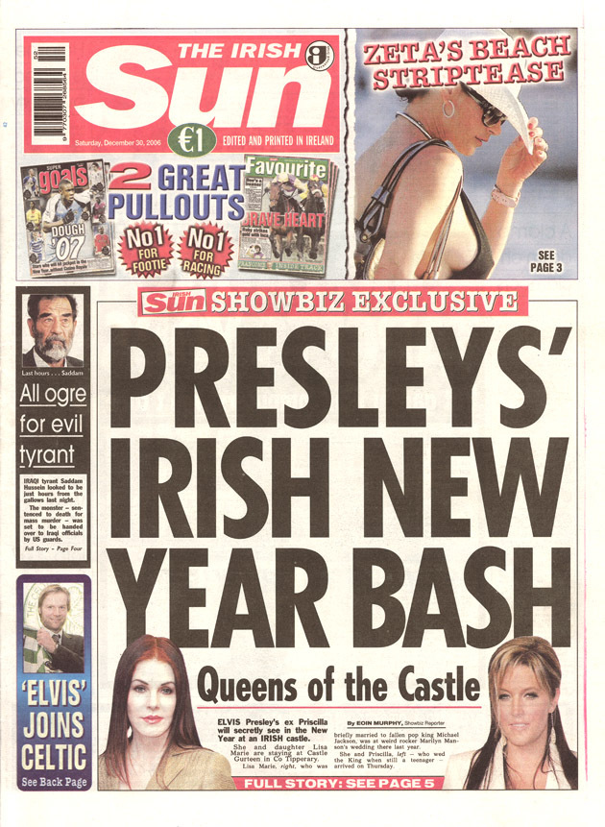**Tabloid**

**Headlines:** Tell you what a newspaper story is about. *Broadsheets* use informative, serious language. For example, “Young Man shot dead at his home”. Tabloids use sensational and exaggerated language. For example, “Frantic hunt for lone knife raider”. Tabloids also use **puns** and **alliteration** to make their headlines eye-catching.

**Puns:** When people play with words that sound similar or that mean the same thing, in order to be funny, it is called a ‘pun’. For example:

“Tiger admits: I’m a Cheetah!” “Britney SHEARS”

**Alliteration:** Headlines often repeat the same letter to make them sound powerful. For example:

“Tax Hike Horror” “Minister Blames Bad Budget”

**Stylistic Features**

|  |  |
| --- | --- |
| **Features of Broadsheets** | **Features of Tabloids** |
| 1) Layout and Content:  Cover important global and national stories. Cover stories on politics, finance and current affairs.  2) Headlines:  Informative, factual, serious language, black print on white.  3) Reports and Articles:  Highly researched, factual details, neutral and unbiased, few quotations,  few photographs, small print. | 1) Layout and Content:  Cover sensational new, cover stories about scandals, gossip, celebrities and sport.  2) Headlines:  Dramatic, exaggerated, use of slang, bold colour and print.  3) Reports and Articles:  Some research, less factual details, more speculation, obvious bias, many quotations, large eye-catching photographs, large print. |

Writing Exercise

Compose a headline, write a report (tabloid or broadsheet) and lay out a front page article for one of the following news items:

* An important building, local or national, has been destroyed by a fire.
* An extremely valuable item has been stolen.
* Freak weather disrupts the country.
* An assassination attempt on an important public figure.
* A major sporting event

When writing your report, you must use the **INVERTED PYRAMID:**

**Main Facts (What, Who, Where, When, Why, How)**

**Background Information**

**Analysis**

**Quotes**

**Pairwork: Newspapers**

Work in groups of two to discuss two reports on the same story (one tabloid, one broadsheet)

1. **WHAT** happened?

2. **WHO** was involved?

3. **WHERE** did it happen?

4. **WHY** did it happen?

5. **HOW** did it happen?

6. What differences can you see in the ways that different papers handle the story? List all of the differences that you can see (the print used, the information that we get, photographic evidence?)

7. Does one of the reports have information that the other does not have? If so, what kind of information is it and from where might the paper have got it?

8. Can you explain why different papers have tackled this story in different ways?

9. Can you find any of these elements in either story:

1. an eyewitness account?
2. an expert opinion?
3. a brief summary of events?
4. historical background?
5. reaction from public figures?