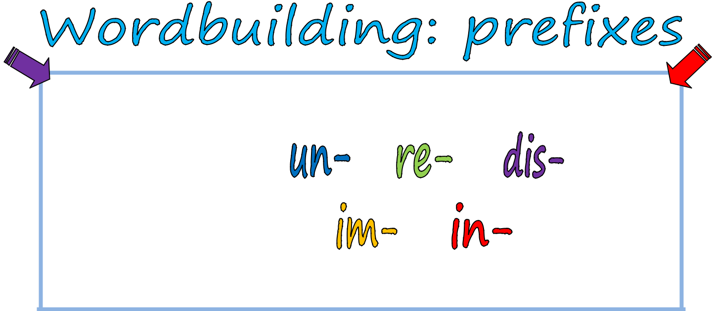
dis-, in-, im-, re-, un- are the most common prefixes of the English language.

dis- means not or opposite of

in- & im- mean in

re- means again

un- means not

PS.: UN- can go before any letters. IM is used before letters m and p –other than that IN is used.

Write the right prefix on the lines:

_____able | _____confortable | _____certain | _____like | _____happy
_____secure | _____invited | _____open | _____ adjust _____known
_____assure | _____habit | _____connect | _____ability | _____agree
_____like | _____trust | _____turn | _____fresh | _____store
_____polite | _____possible | _____guise | _____formal | _____patient


Now use some of the words in the sentences:

- The birthday party was very __________. 2. Boy, was he _________ when he asked for help! 3. The plants that grow here are very __________ the plants where I live. 4. He was __________ to solve the problem. 5. Everybody wants him to __________ to his job.

- I feel shy and __________ around strangers. 7. He tried to __________ his voice on the phone but I could tell it was him. 8. People have grown __________ with the numerous delays. 9. Now you must __________ the hose from the faucet. 10. You look __________

in that chair. Do you want another one? 11. I am sorry but the restaurant is closed. We will

__________ tonight at 9 pm. 12. Several species of birds _________ the island. 13. I am not sure of the address. Could you __________ your memory? 14. Much is _________

about his early life in America. 15. We don’t look eye to eye on the matter. Actually we

________ very much. 16. Mary has learned to keep a positive attitude about her

__________. 17. The crew is trying to __________ the old house to its original condition. 18. The heavy rain made it ____________ to see the dark road. 19. I was annoyed that he brought three ____________ guests to my party. 20. It is a very

___________ situation. I wish I could do something to change it. 21. The children need to

___________ to the new school. 22. They generally __________ dentists and doctors.

ISLCOLLECTIVE.COM

