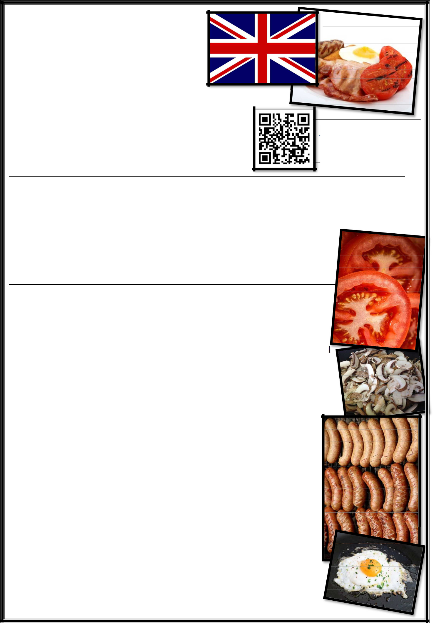
English

Culture
Listening Comprehension

Vocabulary

The English Breakfast
Name |  |  |  |  | https://youtu.be
Name |  |  |  |  |  | /vi3_sALgSsk
Date

Instructions
- First, read through all the questions.
- Then, Watch the video on The English Breakfast.

- Answer ALL the questions.
- Click on the LINK ABOVE or SCAN the QR CODE to gain access to the video.
- You may stop or rewatch the video as needed.

The English Breakfast

- Underline the correct answer.

1.1. The English Breakfast is described as an iconic part of British culture and cuisine.
Iconic, in this context, means …
- that the English Breakfast is famous.

- that the English Breakfast is regarded as a representative symbol of English cuisine.
- that the English Breakfast is delicious and everyone should try it.

1.2. The English Breakfast is also called a …
- mash-up.

- meet-up.
- fry-up.

1.3. An English Breakfast is usually served as …

- lunch or dinner.
- breakfast or lunch.
- breakfast or brunch.

1.4. The English Breakfast is described as a hearty meal. A hearty meal is …

- a meal that is made up of many different components.
- a meal that is large and satisfying.
- a meal with a lot of different flavours.

ISLCOLLECTIVE.COM

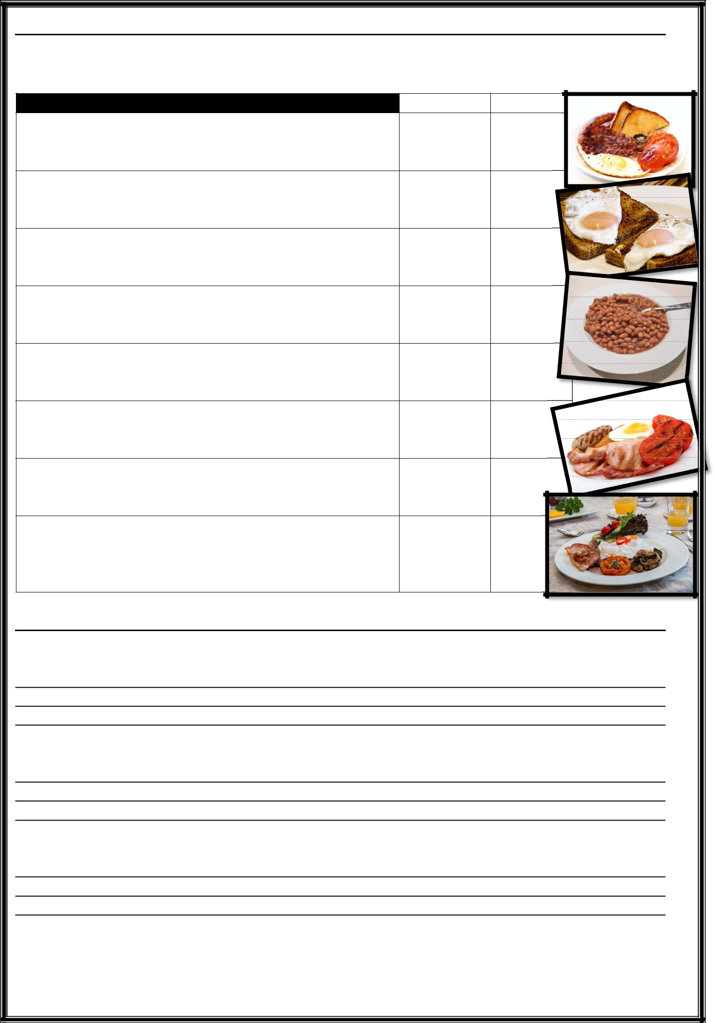
- TRUE or FALSE
  - Indicate whether the following statements are TRUE or FALSE.

  - If a statement is FALSE, underline the incorrect word or phrase and correct it.

 | TRUE | FALSE
2.1. | Bacon is grilled and served in rashers.
2.2. | You can only have pork sausages with an
English Breakfast.
2.3. | Black pudding is a type of blood sausage
which is also served with other breakfast foods.
2.4. | Mushrooms are never fried.
2.5. | Eggs are typically served scrambled.
2.6. | Tomatoes are typically served charred and
are spiced with salt and pepper.
2.7. | Toast is always served with butter and jam.
2.8. | Baked beans in tomato sauce are usually
optional.

- Answer the following questions in FULL sentences.

3.1. What are two regional differences from the standard English breakfast?

3.2. What are kippers?

3.3. Why would kippers be popular in coastal regions?

ISLCOLLECTIVE.COM

- Label the different components of the English Breakfast.
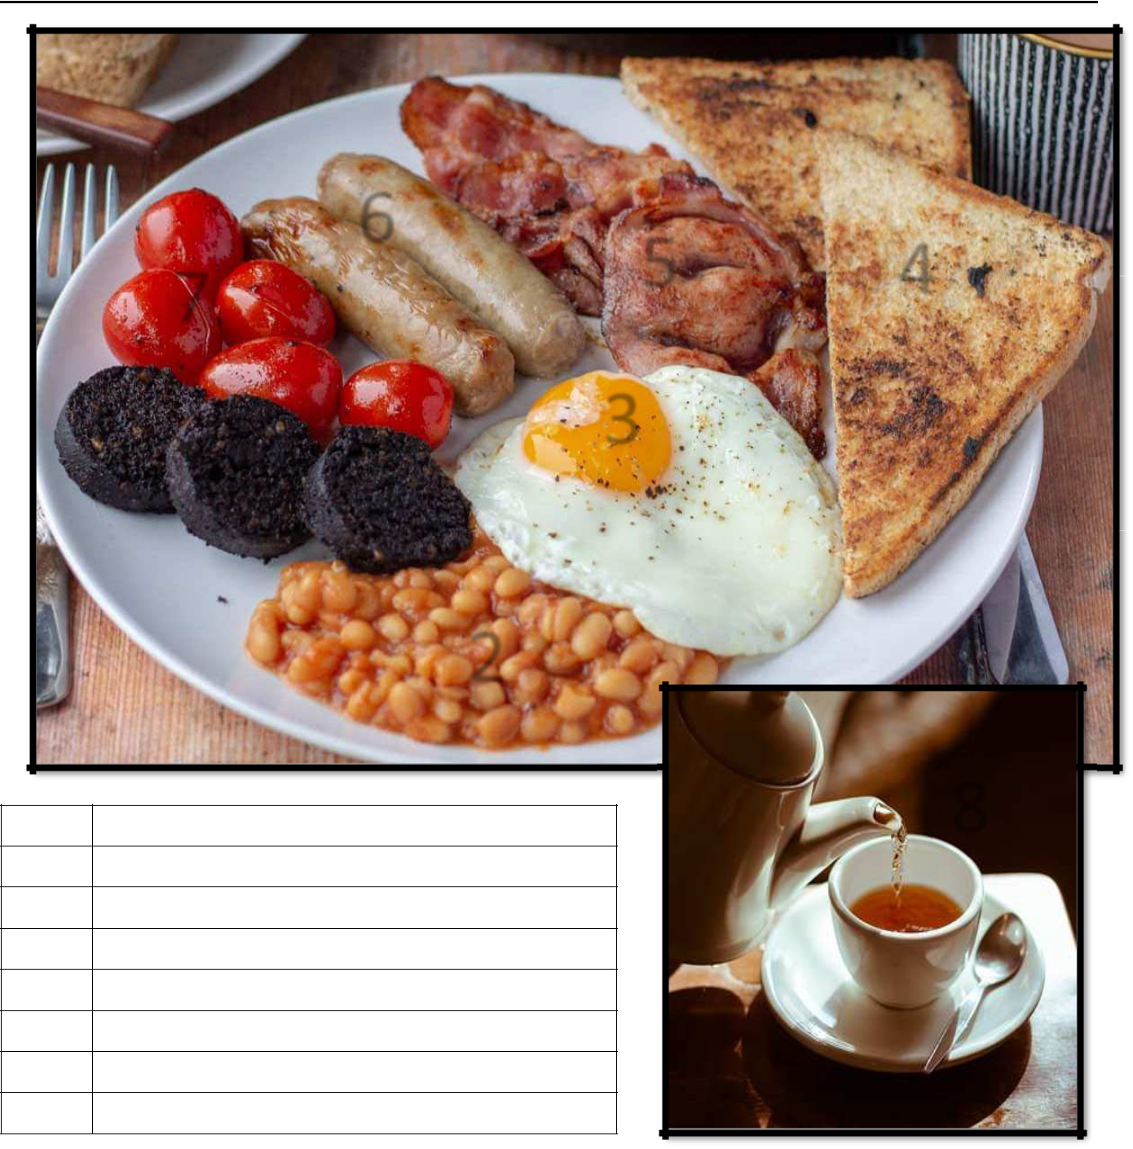

6
₇ 5 4

1

3

1

2

3

4

5

6

7

8

2
2

8

- What do you think?

  - Have you ever had an English Breakfast?

  - What do you like or dislike about the English Breakfast?
  - Do you prefer a large or small breakfast?

ISLCOLLECTIVE.CO

