Present Simple AM/IS/ARE+ Past Participle

Past Simple
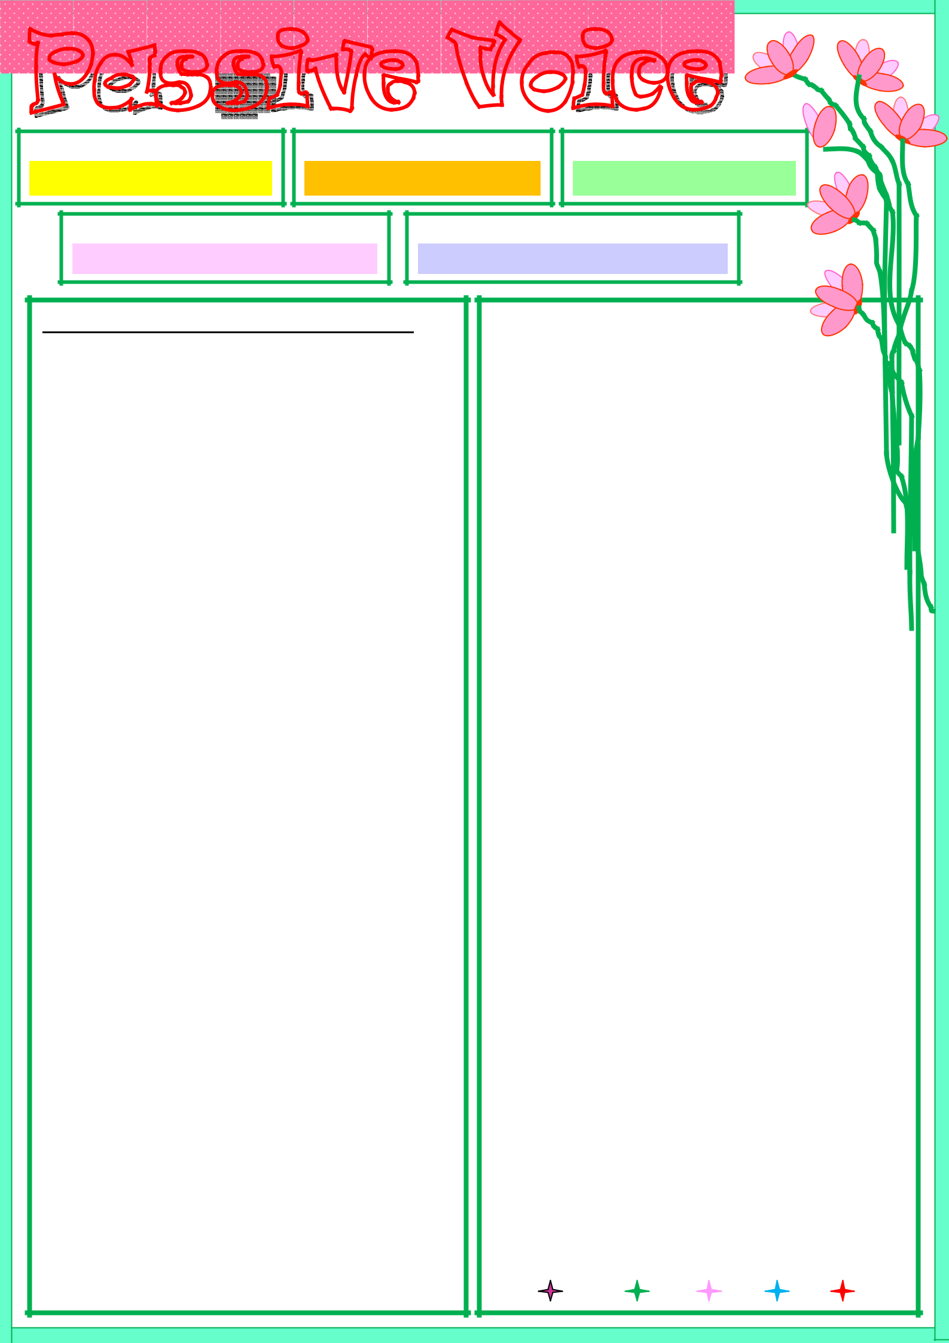
WAS/WERE + Past Participle

Future Simple  WILL +BE+ Past Participle

Present Continuous

AM/IS/ARE+ BEING + Past Participle

Present Perfect

HAVE/HAS+ BEEN+ Past Participle

Rewrite the sentences in Passive Voice:

1. I clean my room every day.
______________________________

2. Tom bought a nice present yesterday.

______________________________
3. Ann will sing a beautiful song.

______________________________

- Ben repaired my computer yesterday.
______________________________

- My sister is making a tasty cake now.

______________________________

- We have bought tickets to the concert.
______________________________

- Helen teaches French at school.

______________________________
- They grow strawberries every year.

______________________________

- Tim sent an SMS to his friend.
______________________________

- She has written a test today.

______________________________
- They visited that museum yesterday.

______________________________

- I am watching a football match now.
______________________________

- Pam has found the keys in the table.

______________________________
- Mona is washing the clothes now.

______________________________

- You have made a lot of mistakes.
______________________________

- Bill will bring sandwiches.

______________________________
- They attend lectures every day.

______________________________

- We are meeting the relatives now.
______________________________

19. He will copy this text.

_______________________________
- He has bought a new car.

_______________________________

- We are playing volley-ball now.
_______________________________

- Our teacher explained the rule.

_______________________________
- She translates the texts every day.

_______________________________

- She is watching a comedy film now.

_______________________________
- He put the candle on the table.

_______________________________

- Pam has bought a new ring recently.
_______________________________

- He will correct the mistakes.

_______________________________
- I have got a beautiful present.

_______________________________

- The cat dropped the vase yesterday.
_______________________________

- I am playing the piano now.

_______________________________
- He has turned off the TV set.

_______________________________

- We receive e-mails every day.
_______________________________

- Nick is eating an ice-cream now.

_______________________________
- She will lend money to her friend.

_______________________________

- I visit Paris every year.
_______________________________

- He has already prepared the report.

_______________________________

ISLCOLLECTIVE.COM

ISLCOLLECTIVE.COM

