INTEGRATED SKILLS TEACHER’S NOTES


WORKSHEET

Topics: Museums by Adrian Tennant

LEAD-IN

Look at these photos. What does each one show?
  - 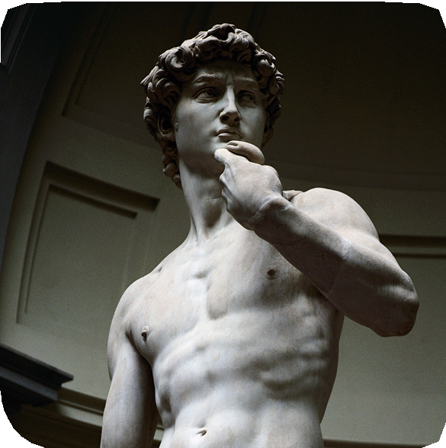
Image:Corbis
- Discuss the questions below.

  - How often do you go to a museum or art gallery?
  - When was the last time you went?
  - What type of museum or art gallery was it?

READING 1: TITLES

Read the titles below. What kind of museum or art gallery do you think each one is about?

INTEGRATED SKILLS WORKSHEET

1.
WAITING, WALKING AND A BIT OF CANVAS

2.
YOU DON’T HAVE TO BE ABLE TO PAINT!
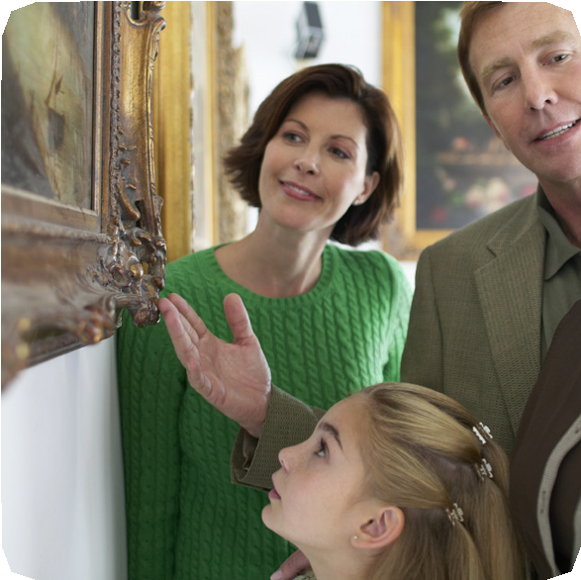2.
Image: Corbis

3.
A Trip Back In Time

4.
ANY SKELETONS IN YOUR CUPBOARD?

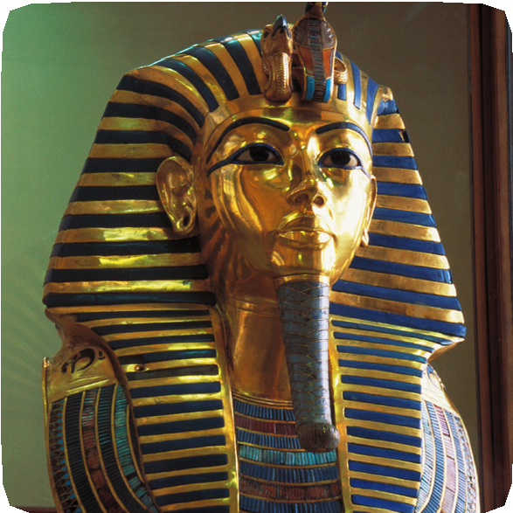3. 5.
Image: Pixtal
More Than Just A Sharp Fence!

  - 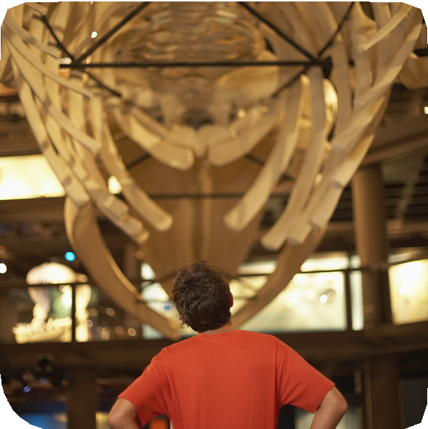
Image: Corbis

WORKSHEET

Topics: Museums by Adrian Tennant

READING 2: REVIEWS

Read the online reviews of five different museums and art galleries. Match the titles from the previous exercise to each one.

A.
When I told my wife I was taking our
seven-year-old son Jake to a museum she said ‘Good luck!’ but it was great. We walked into the museum and the first thing he saw was a big
skeleton of a dinosaur. He enjoyed every minute of the visit and asked me lots of questions. Fantastic.

B.
What a strange museum! The only thing on display is barbed wire. Why would anyone be interested in the stuff you
find on fences? Of course, the museum
is in the US – where else would it be?
But, I learnt some interesting facts. Did
you know there are more than 2,000
types of barbed wire?
C.

I went to the Louvre with great expectations but was quite disappointed. Everyone goes there to see the Mona Lisa, but it’s so small! Also, I was amazed by the queues to get in – it took almost two hours and it was raining!
- Read the reviews again and answer the questions.

- Which places were good for children?
- In which country is the Museum of Barbed Wire?
- What was reviewer C’s opinion of the Mona Lisa?
- What was the first thing Jake saw?

WORKING WITH THE LANGUAGE
Some verbs are always followed by the same preposition – these are known as ‘dependent’ prepositions.

- Here are some examples from the reviews.
Try to complete the sentences with a preposition from the box but don’t look back at the texts.
Be careful! There are two extra prepositions.
at
by
from
in
to

- Why would anyone be interested the stuff …?
- I was amazed the queues …
- It’s dedicated bad art!

Make sentences of your own using the three prepositions used in the exercise above.

INTEGRATED SKILLS WORKSHEET
D.
What an amazing museum. It’s like stepping back 1,000 years. The video and audio displays are fantastic and give you so much information. The
highlight for my two young boys was coming face-to-face with
a ‘real’ Viking – at least they thought he was real!

E.
Do you like good art? Well, this museum might just make you think again. It’s dedicated to bad art! All the art here is terrible but that is deliberate. My kids loved it. They walked around saying “I could do better than that!”

INTEGRATED SKILLS WORKSHEET

WORKSHEET

Topics: Museums by Adrian Tennant

WORKING WITH VOCABULARY
Focus 1: Meaning

Find words and phrases in the reviews that match
the definitions below.

- the set of bones that supports a human or animal body
- very good / great
- in a particular place so that people can see it easily
- objects or things
- belief or hope that something will be good
- the most exciting, impressive or interesting part of something
- intended and not done by chance or accident

LISTENING

Listen to a boy talking about one of the museums or art galleries and answer the questions below.

- Which museum is he talking about?
- What are the differences between what he says and the review?

SPEAKING

Discuss the questions below in groups.

- Which of these museums or art galleries would you like to visit? Why?
- What’s the most interesting museum or art gallery you have visited?
- How much would you pay to go to an art gallery or a museum?

PROJECT
Write a review of a museum or art gallery that you have visited in the past.

