



INVERSION  AUXILIARY VERB + SUBJECT + MAIN VERB

We use Inversion for emphasis in formal and written English

 when the following words and expressions are at the beginning of a sentence:



- Seldom➢ Scarcely (ever) …… when ➢ Only in this way
➢ Rarely | ➢ Hardly (ever) …… when | ➢ Only then
➢ Never | ➢ No sooner ….. than | ➢ In no way
➢ Never before ➢ Not only…... but also |  | ➢ On no account
➢ Little | ➢ Not even once | ➢ On no occasion
➢ Barely | ➢ Nowhere | ➢ In/ Under no circumstances

- Rarely do we go out in winter.

  - No sooner had the Browns got in their house than they realized that someone had broken into.
  - Under no circumstances should you sign this contract.



NOTE: After Not until, Not since, Only when, Only if, Only after,

Only by, the inversion comes in the main clause.

- Not until I had reached the office did I remember that I had left the kitchen window open.

- Only after she had left the supermarket did she realize that she hadn’t bought any cheese.

ISLCOLLECTIVE.COM

 after so and such (a/ an) when the are at the beginning of a sentence, to express result:

☞

☞

So tired did he feel that he fell asleep at his desk.

Such a lovely day was it that we had lunch in the garden.

after so, neither/ nor when they are at the beginning of a sentence, to express agreement:

- “ I love comedies. ” “ So do we. ”
  - “ He isn’t coming to the party. “ Neither/ Nor am I. ”

with should, were, had at the beginning of conditional sentences when if is omitted:

- Should you finish the project today, e mail it to me. (Type 1)
- Were I you, I would confess. (Type 2)
- Had I seen John, I would have told him. (Type 3)

with here and there when they are at the beginning of a sentence:

- Here comes the bride !
- There goes the bus !

ISLCOLLECTIVE.COM

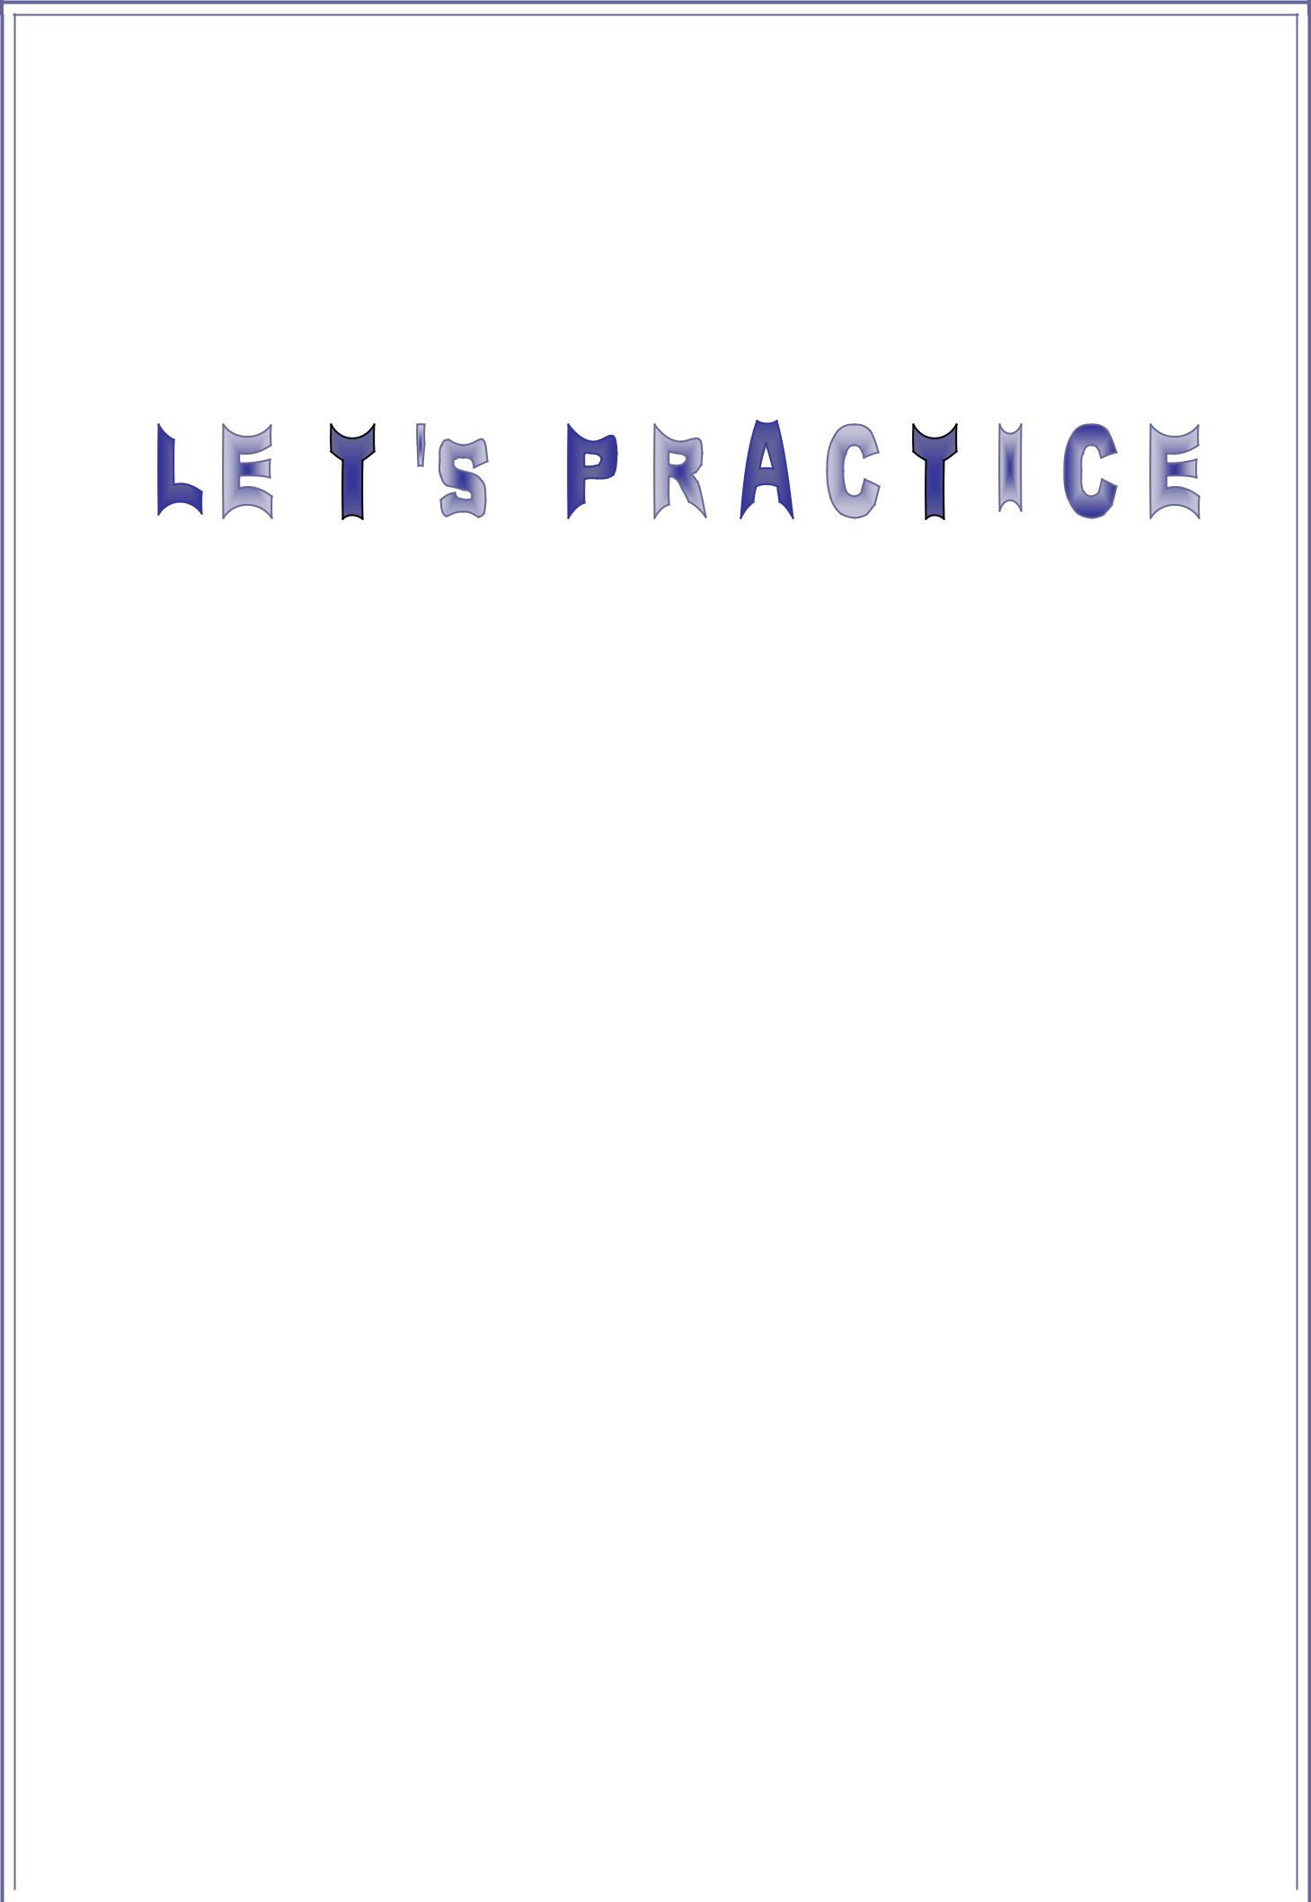

Complete the second sentence so that it has a similar meaning to the first.

 | 1 - We had never seen such an outstanding performance before.
 |  | Never ________________________________________________________________
 | 2 | - As soon as I left home it started raining.
 |  | No sooner ____________________________________________________________
 | 3 | - My husband doesn’t often read magazines.
 |  | Rarely _______________________________________________________________
 | 4 | - She didn’t speak to him until he apologized to her.
 |  | Not until _____________________________________________________________
 | 5 | - You won’t finish this project today unless you start working on it now.
 |  | Only if _______________________________________________________________
 | 6 | - They had no idea what damage they would cause.
 |  | Little ________________________________________________________________
 | 7 | - This rare species of bird doesn’t live anywhere else in the world.
 |  | Nowhere _____________________________________________________________
 | 8 | - My sister is such a bright student that she’s got straight As.
 |  | Such ________________________________________________________________
 | 9 | - You must not open this letter under no circumstances.
 |  | Under no circumstances ________________________________________________
 | 10 - He fell asleep after I had read him a story.
 |  | Only after ____________________________________________________________
 | 11 - I lost my passport as well as my credit card.
 |  | Not only _____________________________________________________________
 | 12 - You aren’t allowed to purchase alcohol until you are eighteen.
 |  | Not until ____________________________________________________________
 | 13 - They will watch the film and then they will be able to form an opinion.
 |  | Only when __________________________________________________________
 | 14 - They didn’t recognize me until I took off my mask.
 |  | Only when __________________________________________________________
 | 15 - We hadn’t seen such interesting museums since we went to Italy.
 |  | Not since ____________________________________________________________
 | 16 - She’s a successful politician as well as a devoted mother.
 |  | Not only _____________________________________________________________
 | 17 - The little girl got so scared that she screamed. |  | ISLCOLLECTIVE.COM

So __________________________________________________________________

18 - I wouldn’t go out with my boss in any way.

In no way ____________________________________________________________

19 - The dog attacked him as soon as he walked in.

No sooner ____________________________________________________________

20 - If you see Mary, tell her to call me.

Should _______________________________________________________________

ISLCOLLECTIVE.COM

