**Mummy of Pharaoh Ramesses II Issued a Passport to Travel to France**

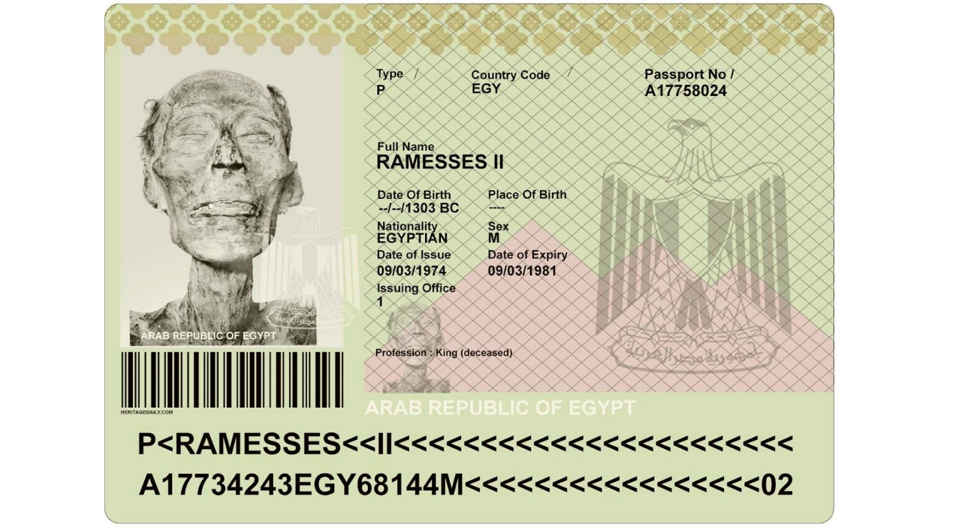

Ramesses II is often called one the greatest pharaohs of ancient Egypt. He reigned for over 60 years and accomplished much during his lifetime. His achievements were not matched by the pharaohs who preceded or succeeded him. Even after death, Ramesses II continued to be unique. 3000 years after Ramesses II died he became the only mummy with a passport issued by a modern government.

Who Was Ramesses II?

Ramesses II (Ramses II) was a pharaoh of the Nineteenth Dynasty, the second dynasty of ancient Egypt’s New Kingdom. He was born around 1302 BC, and succeeded his father, Seti I, in his late teens or early 20s. Ramesses II reigned for a total of 66 years, making him one of the longest reigning pharaohs in the history of ancient Egypt. He outlived many of the children he fathered. Incidentally, this record was surpassed only by Pepi II, a pharaoh of the Old Kingdom who is recorded to have reigned for 94 years.

Apart from his long reign, Ramesses II is notable also for various achievements during his lifetime. For instance, he campaigned successfully against the enemies of Egypt, including the Hittites in Anatolia and the Nubians to the south of Egypt. Additionally, Ramesses II constructed many remarkable monuments that have survived till this day. Amongst the best-known of these are Abu Simbel and the Ramesseum.

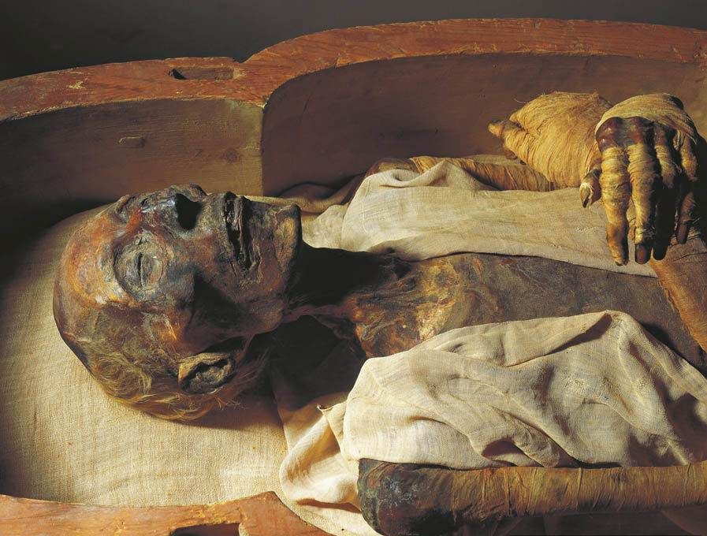

## Moving the Mummy

Like many of the New Kingdom pharaohs, Ramesses II was buried in the Valley of the Kings, on the west bank of the Nile, across from Thebes. Initially, the pharaoh was buried in the tomb now designated as KV7. Sometime later, however, the mummy of the pharaoh was transferred by Egyptian priests to the mummy cache of Deir el-Bahri, where it remained until its discovery in 1881.

The mummy of Ramesses II was placed in the Egyptian Museum in Cairo in 1885. In 1974, Egyptologists working for the museum realized that the pharaoh’s mummy was deteriorating at an alarming rate, and decided to have it sent to France for an examination. Apparently, under Egyptian law, even dead individuals are required to have the proper documents before they are allowed to leave the country. It has also been claimed that with these documents would provide the pharaoh with the legal protection required to ensure his safe return to the country. It may have been feared that once in France, the mummy of the pharaoh would not be allowed to leave.

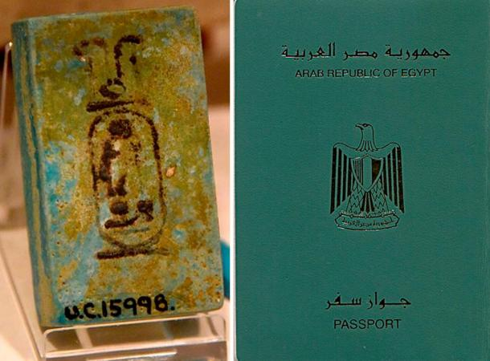

## The Pharaoh Gets a Passport

In any case, Ramesses II was issued a passport by the Egyptian government, and was the first (and probably the last) mummy to receive one. Apart from having a photo of Ramesses II’s face, the passport is also notable for listing the occupation of the ancient Egyptian pharaoh as ‘King (deceased)’. The mummy of Ramesses II left Egypt in 1976, and when it arrived in France, it was received at the Paris–Le Bourget Airport with the full military honors befitting a king.

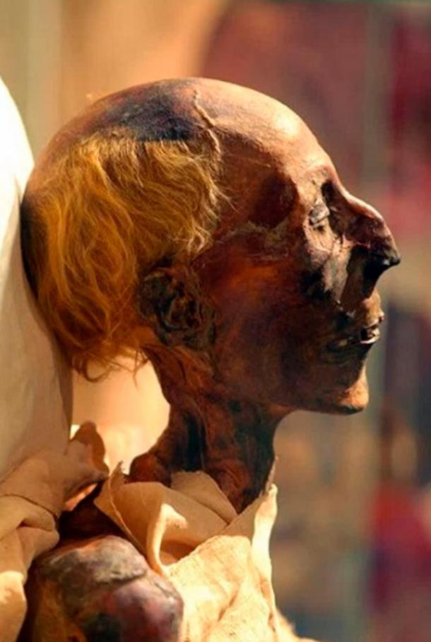

A mock up for the only mummy with a passport. Ramesses II ( Public Domain ) on an example of an Egyptian Passport Bio Page. ( Public Domain )

The mummy was then transported to the Paris Ethnological Museum, where it was examined. The researchers discovered that the deterioration of the mummy was caused by a fungal infection, and it was given the appropriate treatment to avoid total decay.

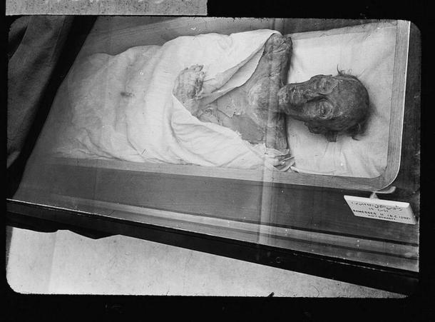

After the treatment, further examinations were carried out on the mummy. It was found that the pharaoh was about 1.7 meters (5 feet 7 inches) tall, had fair skin and red hair. In addition, some of the maladies the pharaoh suffered from were identified. For instance, it was reported that he was suffering from arthritis, as well as a tooth abscess. Moreover, it seems that Ramesses II also had ankylosing spondylitis, a long-term inflammation of the joints of the spine, which would have made him walk with a hunched back during his later years.

<https://cryptolozi.com/mummy-of-pharaoh-ramesses-ii-issued-a-passport-to-travel-to-france/?fbclid=IwAR1w9LO6A128JQfJeZRiE3K9Kj_7TAFYMPkLEKq-rrmkp1buAK6ZtWTAC8M>