Μήκος Κύκλου

1) <https://www.geogebra.org/m/rftkkssk>

2) <https://www.geogebra.org/m/WcRnJpax>

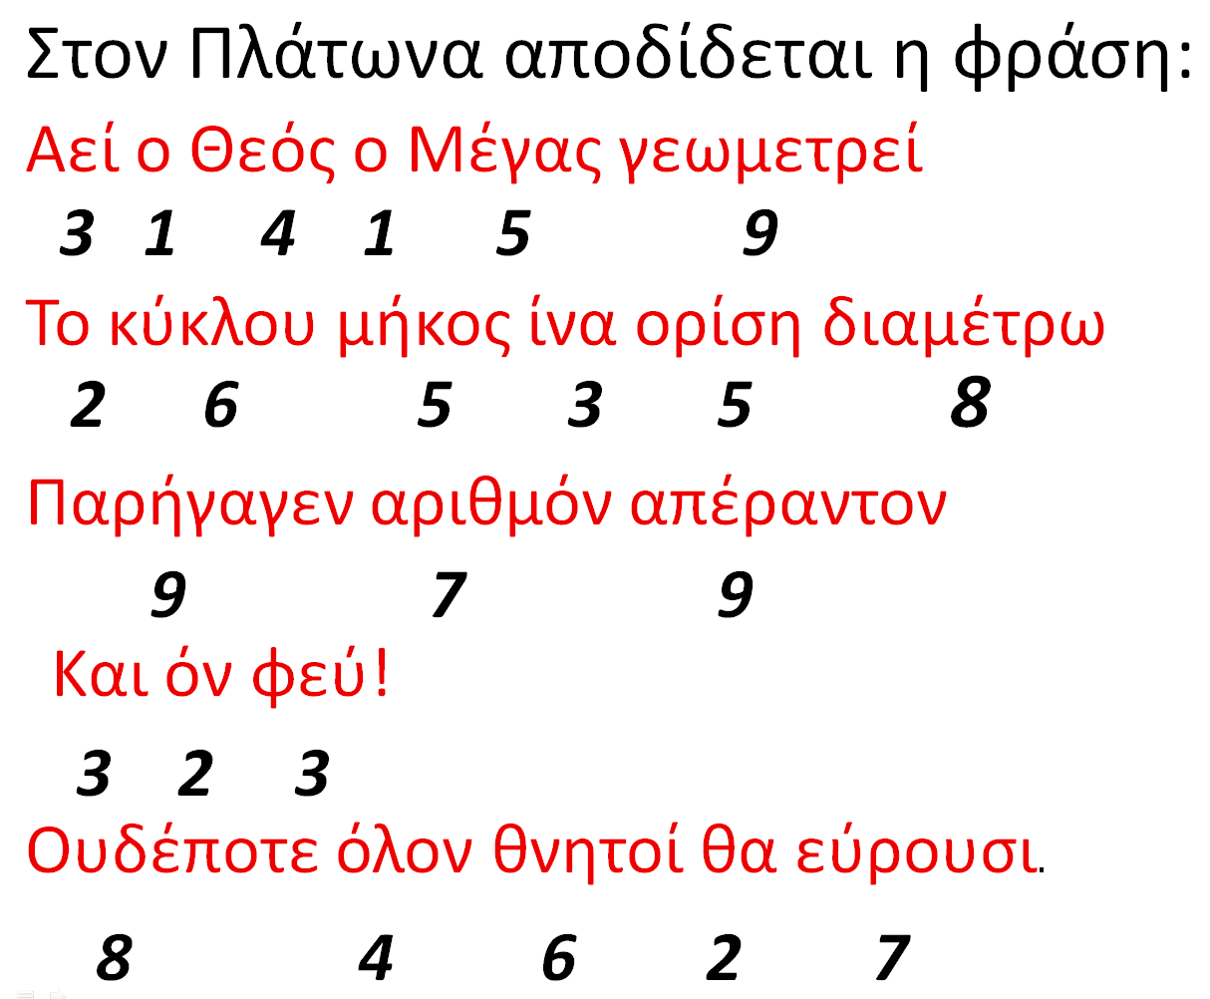3) <https://www.geogebra.org/m/b7BS4Tmn>

π = 3,1415926535897932384627……….