, Platon School Model United Nations *{ 1)*

PSeftlUN

-------- ::

I , I,

WORLD SCHOO1L ... ,,.,.,,,,,'



**Platen School MUN**



**Delegate Manual**

The 6th Annual Session of PS-MUN Conference



--;..---

Dear delegates, in this manual you will find the essential information of the rules of procedure that will help you initiate your knowledge and be your guide for this conference. We expect to see well prepared delegates, ready to participate actively in the debates with full with capacity of the topics at hand.

What should delegates do before the Conference?

In preparation for this year’s Conference, we advise you to work comprehensively and have all the required work done by early March. With this manual as a guideline you will prepare everything in detail concerning every possible aspect of your topic.

Select delegation and Committee

Before you can participate in a MUN Conference, you should read all the topics of the agenda and think of which Committee best suits your interests. In PS-MUN we have 5

General Assembly Committees and 5 Specialized Agencies (or Non-GA Committees). You should contact your MUN Director/Advisor and inform him/her about your decision concerning the Committee you chose.

Research

In your research there are some questions you need to cover:

1. What is my topic about?

2. Which country do I represent?

3. What has my country got to do with the topic?

4. What is my country’s policy on the topic?

5. What are the different aspects?

6. Recent events relevant to the topic?

All these questions are of extreme importance for your preparation for this

Conference.

All these questions are of extreme importance for your preparation for the

Conference. Here are some tips for your preparation:

Sources for researching a Delegation

• CIA: The World Fact Book https://[www.cia.gov/library/publications/the-world-factbook/](http://www.cia.gov/library/publications/the-world-factbook/)

• U.S. Department of State<http://www.state.gov/r/pa/ei/bgn/index.htm>

• United Nations Website<http://www.un.org/>

• UN Systems: UN Organisations<http://www.unsceb.org/directory>

• BBC Country Profiles

<http://news.bbc.co.uk/2/hi/africa/country_profiles><http://news.bbc.co.uk/2/hi/americas/country_profiles><http://news.bbc.co.uk/2/hi/asia-pacific/country_profiles><http://news.bbc.co.uk/2/hi/south_asia/country_profiles><http://news.bbc.co.uk/2/hi/middle_east/country_profiles><http://news.bbc.co.uk/2/hi/europe/country_profiles>

• Contacting your Embassy<http://www.embassyworld.com/>

Sources for researching an issue

• BBC News [http://www.bbc.co.uk](http://www.bbc.co.uk/)

• Global Policy Forum<http://www.globalpolicy.org/>

• Britannica Encyclopedia<http://www.britannica.com/>

• UN Documents<http://www.un.org/en/documents/>

• PS-MUN Study Guides

• Research links provided on our website

• Keep up-to-date through news websites (e.g. BBC, Reuters)

• Search any key word in an online-searching machine (e.g. Google, Bing)

Policy Statement

The policy statement is a short speech which briefly and clearly explains the policies of a country/organization with respect to the issues dealt at the Conference. There are 2 important reasons for drawing up this document: a) you can focus on the exact points of view of your country/organization, b) the policy statement can server as a reference document during the Conference and thus may provide an excellent tool in the lobbying process, c) they may also server as the basis for the opening speech in the Committee.

The policy statement must not exceed the time length of one-minute (about 1 paragraph). All policy statements shall be entertained at the begging of lobbying session.

A policy statement sets out to answer three basic questions:

• What is the background of your country’s point of view in the issue?

• What is your country’s current position on the issue?

• What does it hope to achieve in relation to the issue?

***Policy Statement***

*Topic: Ensuring global accessibility to medication and treatment*

*Proposed by: Burkina Faso*

*Burkina Faso’s position on the issue of the global accessibility to medication and treatment is that traditional medicine will always remain an important source of health care for the majority of the population since traditional medicine is part of African sociocultural foundations. In 1983, the Government encouraged the formation of associations of traditional medicine practitioners as well as pharmacopoeia units within decentralized sanitary structures of the health system. Moreover, under colonialism, traditional medical practices were outlawed as harmful and dangerous. Only after independence did the Government promote traditional medicine and begin to restore esteem to traditional medical practices. Last but not least the “Burkinabe” system is based on a rationalized supply structure combined with policy to promote generic medicines.*

Draft Resolution

After having read the study guide, conducted the research on your country/organization, written your policy statement, you have to write a draft resolution.

The draft resolution is a document which includes proposed measures in order to solve the issue. You have to acknowledge facts and measures already taken and propose new. The resolution has a very specific format which you must follow:

**FORUM:** (your Committee, e.g. Legal Committee)

**QUESTION OF:** (the topic, e.g. Human Cloning)

**SUBMITTED BY:** (your country, e.g. United States of America)

Pre-ambulatory clauses

These clauses are the introduction of the resolution. They contain the background and the argumentation to the issue you have chosen (such as historic background, past UN resolutions, etc). Each clause begins with a pre-ambulatory phrase and ends with a comma. These clauses do not take any action, since they are not debatable.

Operative clauses

Those are your suggested solutions and the measures that should be taken. Each operative clause should be numbered, and should end with a semi-colon (;). The last operative clause should be followed by a period (.).Don’t forget that those solutions must be similar to your country’s policy.

***On ce yo u w rite the resol ution , sav e th e do cument on a USB sti ck and pri nt i t or***

***send i t to yo ur A dv i sor vi a e -mai l . Don ’t forget to bri ng the USB to th e Con ference.***

Below you will find: a) 1 sample resolution with the appropriate format/heading/pre- ambulatory & operative clauses, b) a table with some pre-ambulatory & operative clauses

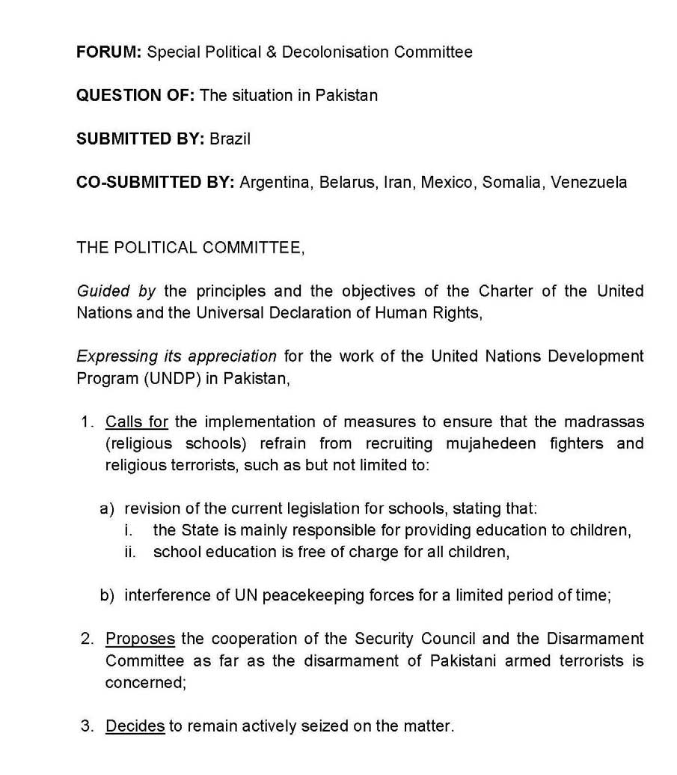

Sample Resolution

***Heading***

In upper case Font: **Arial, Bold** Size: 12

***Pre-amb clauses*** Font: *Arial, Italic* Size: 12

***Operative clauses***

Font: Arial,

Underline Size: 12

Each operative

clause must be

numbered

N otes & T ip s

• All perambulatory clauses must end in commas (,)

• All operative clauses must end in semi-colons (;)

• All operative clauses must be underlined and numbered

• Sub-operative clauses must be lettered; sub-sub operatives clauses must be in

Roman Numerals

• Leave 5 lines space between pre-ambulatory clauses and 1 line between every operative clause

All acronyms must be fully written out before appearing in the abbreviated form;

you only need to write them out once, and then refer to the abbreviated form

Resolution – Pre-ambulatory/Operative clauses

Pre-ambulatory clauses

|  |  |  |
| --- | --- | --- |
| Acknowledging | Expecting | Noting with appreciation |
| Affirming Expressing its appreciation Noting with approval | | |
| Alarmed by Expressing its satisfaction Noting with deep concern | | |
| Approving Fulfilling Noting with regret | | |
| Aware of Fully alarmed Noting with satisfaction | | |
| Believing Fully aware Observing | | |
| Bearing in mid Fully believing Pointing out | | |
| Confident Further deploring Reaffirming | | |
| Congratulating Further recalling Realizing | | |
| Convinced Guided by Recalling | | |
| Declaring Having adopted Recognising | | |
| Deeply concerned Having considered Referring | | |
| Deeply conscious Having devoted attention Reminding | | |
| Deeply disturbed Having examined Seeking | | |
| Deeply regretting Having received Taking into account | | |
| Deploring Having studied Taking into consideration | | |
| Desiring Keeping in mind Viewing with appreciation | | |
| Emphasizing Noting further Welcoming | | |

Operatives clauses

rms **ondemns ges**

|  |  |  |
| --- | --- | --- |
| Accepts | Deplores | Requests |
| Affirms Designates Resolves | | |
| Approves Encourages Seeks | | |
| Asks Endorses Strongly affi | | |
| Authorizes Expresses its satisfaction **Strongly c** | | |
| Calls for Expresses its hope **Strongly ur** | | |
| Calls upon Further recommends Suggests | | |
| **Condemns** Hopes Supports | | |
| Congratulates Invites Trusts | | |
| Confirms Proclaims Transmits | | |
| **Decides** Proposes Urges | | |
| **Declares accordingly** Recommends | | |
| **Demands** Regrets | | |

• Any of these clauses can be reused by adding “further” or “deeply” in front of it

• All operatives clauses in **bold** can on ly be used by the Security Council

What should delegates do during the Conference?

Lobbying

Lobbying is one of the most important components of a MUN Conference, since it is the main process through which draft resolutions are crafted and merged. In the PS- MUN, lobbying for the Committees of the General Assembly, the ECOSOC, the Security Council and the Special Conference will take place on the first & second day of the Conference. This process will be an opportunity for the delegates to have an understanding of where they stand with respect to the positions of other delegates.

Once you come in your Committee, you find the seat with your country’s name, you take out your placard and wait until the Chairs start the Roll Call. When they say your country’s name, be ready to respond by raising your placard and saying Present. You will also do this during voting procedures. Once they finish with the Roll Call, the chairs present themselves and split the house and time to prepare the topics. That’s when you will have to form your alliances by persuading other delegates that your clauses are useful and include as many as possible in the final resolution and also try to be the main-submitter. After you have written your draft resolution, you bring it to the expert chair on the topic who will have to correct any policy mistakes. Afterwards, you have to take it to the computer lab in a digital form (remember the USB stick), print it and get a D-number by the computer staff. Then the resolution will be send to the Approval Panel again for an A-number (if contains no grammar/spelling mistakes). The resolution then is ready to be debated.

Debate

Open Debate (speeches are either in favour or against) is the mode followed in PS- MUN when debating resolutions. However, when debating amendments the debate mode is closed debate (separate time for speakers in favour and speakers against).

Speeches

• Speeches addressed the House, may be in favour, against or neutral (e.g.

Point of Information). They should not exceed 1-minute length and should by any mean the diplomatic courtesy.

• Speakers should refrain from using the first or second person (“I”, “you”) as it is not formal. Instead, we encourage you to use the third person.

Points & Motions

Points during debate may NOT interrupt a speaker except for a Point of Personal Privilege, which refers to audibility. Delegates may not just immediately state their point, they must wait until the chair recognizes a Point.

Example: “Point of Information to the Chair”. “There has been a point of Information in the house, could the delegate please raise and states his point”. “Is the Chair aware…”

Points

Point of Personal Privilege

• Refers to the comfort and well-being of the delegate

• May only interrupt a speaker if it refers to audibility

• May not refer to the content of a speech

• Is not debatable

• Does not require a second

Example: “Could the windows please be opened? It is very hot in here.”

Point of Parliamentary Inquiry

• Point of information to the chair concerning Rules of Procedures

• May NOT interrupt a speaker

• Don’t simply overrule them because they are unknown

Example: “Could the Chair please explain to the house what is meant by Open debate?”-be aware of the fact that delegates can create their own points, but that is not allowed. They can also accidentally use a different wording.

Point of Information to the Speaker

• Always remain standing when the speaker is replying to your Point of

Information

• A question directed to the delegate having the floor, and who has indicated that he/she is willing to yield to points of information

• Speaker asking the Point of Information may only speak if recognised by Chair

• Must be formulated in the form of a question, i.e. “Is the speaker aware of the fact that…” A short introductory statement may precede the question

• Be fair and treat all delegates equally when recognising points of information to a speaker

Example: “Could the honourable delegate, as she is the main submitter of this resolution, please explain to the house what she implies with clause 3?”

Point of Information to the Chair

• A question to the chair

• May NOT interrupt a speaker

• Question referring to anything that does not fall under the category of Point of Parliamentary Enquiry, Point of Order or Point of Personal Privilege

• Chair to answer clearly and swiftly and move on with business

Example: “At what time do we adjourn for lunch?”

• ALSO: Question asking for a statement by the Chair or clarification on an issue

Example: “Could the Chair please explain to the house, whether the Darfur Liberation Army has signed the Darfur Peace Agreement?”–be aware, however, as some delegates might use this in order to get their opinion across.

• The respective Chair should hold a short statement and swiftly move on with business

Point of Order

• Delegates use this motion when they want to bring the Chair’s attention to a speaker’s or another delegate’s mistake or violation of parliamentary procedure, i.e. if the chair makes an error in the order of debate or in the setting/observing of debate time

• May NOT interrupt a speaker

• Is not debatable

• Can only refer to something that just happened, direct reference, otherwise call it “out of order”

• If used by delegate simply to cause disorder, again call it “out of order”

• Take your time to explain your decision clearly so that all delegates understand your arguments.

Example: “Is it in order for the delegate to yield the floor to another delegation since the floor was previously yielded to him by Saudi Arabia?”

Right of reply

• This is a short statement to a Speech by a delegate who has the floor

• Entertained only in opening speeches by Student Ambassadors

Motions

Motion to approach the Chairs

• When you want to speak to the Chair

Motion to move to the previous question

• Calls for the closure of debate and a vote to be taken on the motion

(resolution/amendment) pending

• When discussing an amendment, in time in favor, this motion means to move to time against the amendment

• May be moved by the Chair or a delegate, may not interrupt a speaker

• Requires a “second” by the house, and is quickly voted upon if an objection is voiced

• May be overruled by Chair if time needs to be filled

• Although delegates like to say “Motion to move directly into voting procedure” the correct expression is “Motion to move to the previous question”. Remind the delegates of this new wording

• Chair needs to ask for objections

Motion to extend debate time

• At the chairs’ discretion/ not debatable

• Needs a second, if proposed by the house

• Needs a simple majority or a ruling by the chair to be adopted (e.g. due to lack of time or a guest speaker)

Motion to follow up

It is used when a delegate wishes the speaker to clarify or elaborate on the answer to the point of information just proposed by the same delegate. A motion to follow up should NOT be used to ask an entirely different question, and the chair must object to one as such.

Motion to divide the House

It is used when the majority of the final vote on a much-disputed issue comes to a tie to be considered conclusive. The house is then asked to vote again, but this time, with no abstentions allowed.

Motion to reconsider a resolution

(This motion will be entertained only in the Specialized Agencies)

• Calls for a re-debate and a re-vote of a resolution that has already been discussed (adopted)

• Done at the end of all other business

• Only necessary if no other draft resolutions on the issue are present

• Needs 2/3 majority (abstentions are not in order)

• Not debatable

Rules of Procedure

Rule 1

English is the official and working language of this Conference. This rule also applies to the General Assembly, the session in the Committees and all the school premises. Delegates are to speak with civility.

Rule 2

For the Conference to achieve its purpose during the Opening Speeches, the General Assembly and during the sessions in the Committees, all mobile phones and electronic devices must be switched off. Laptops are allowed during lobbying. No smoking is allowed on the premises. The conference is formal, so formal business style dress is required. Open- necked shirts, T-shirts, jeans, denim or cloth jackets, extremely high heels, trainers etc. will not be permitted.

Rule 3

The Official Opening Ceremony, the Official Closing Ceremony and the General Assembly shall be supervised by the Secretariat.

Rule 4

All resolutions shall be checked and approved by the authorized Approval Panel. The Chairpersons will decide which resolutions of the General Assembly Committees will be discussed in the General Assembly.

Rule 5

During all voting procedures in the Committees the guests may stay in the room, the members of Admin Staff must take their place for the voting

procedure and the members of the

Security Staff must seal the doors.

Rule 6

No delegate can obtain the floor until the Chairpersons or President has opened the floor and given them permission to do so. This rule also applies to the General Assembly.

Rule 7

The Chairpersons of each Committee set debate time for the subjects

which if necessary, can be extended.

Rule 8

Each country represented shall only have one vote per voting procedure; NGOs are not allowed to vote.

Rule 9

If any delegate finds that it is impossible for them to attend their Committees for any reason they must inform their Chairpersons and their Advisor.

Rule 10

All amendments shall be submitted during the Committee sessions on the official amendment sheet. Abstentions will be allowed on both resolutions and amendments. On procedural matters (motions) abstentions are not allowed.

Rule 11

During the voting procedure delegates raise their placard, to vote in favor of, against or abstain. However, when the motion to divide the house is entertained, abstentions will not be allowed.

Rule 12

No motion or point can interrupt the speaker, except for the point of personal privilege when it refers to audibility problems. The point of order can only interrupt the voting procedure.

Rule 13

No resolution can contain financial amounts but can refer to possible financial resources without specifications of exact amounts.

Rule 14

No delegate has the right to question the authority of the United Nations. The decisions of the Secretariat and the Chairpersons are final.

Rule 15

The Chairperson decides when the proposals that refer to amendments shall be discussed. The amendment is entertained after the floor has been yielded by the Chairperson to the submitter.

Rule 16

If the Committee votes come to a tie then the proposal will be rejected.

Rule 17

The Secretariat reserves the right to ban any participant failing to adhere

to the rules of the Conference.

Amendments

Amendment of First Degree

• An amendment is only in order if it is submitted to the Chair on the official Amendment Sheet before the delegate obtain the floor, and must be easily legible

• Delegate moves the amendment, but the Chair reads it out slowly and clearly for all delegates to note down

• Only one amendment per amendment sheet will be in order

• Delegations can vote for, against or abstain an Amendment

Amendment of Second Degree

• Can only be submitted in time against the Amendment of the First Degree, and debate on this amendment does not count as time against the Amendment of the First Degree

• Same procedure as for normal amendments

• Debate on the Amendment of the First Degree will always be continued, whether the Amendment of the Second Degree passes or fails

Voting

• Only member states of the UN may exercise a vote right. No NGO is allowed to vote, on either amendments or resolutions

• Delegates voting on a resolution or an amendment may vote in favour, against or abstain

• Delegates and NGOs voting on procedural matters, may only vote in favour or against

• During voting procedure, all points and motions are out of order, except the

Point of Order

• A resolution will pass if the number for exceeds the number against, regardless of the number of abstentions; i.e. abstentions do not count either for or against the adoption of a resolution;

• A resolution or an amendment with a tied vote fails. Close votes should be followed, upon request through the motion to divide the house (note that abstentions are out of order).

• There are NO informal votes at PS-MUN; all votes are real and count!

• Clapping is only allowed when a resolution passes

Dress Code

*M en:*

✓ A suit, a pair of trousers

✓ A shirt and a jacket

✓ A tie

✓ Dark formal shoes

× Casual dress (jeans)

× Sneakers (all-stars/vans)

MUN Vocabulary

Abstain

When debate time elapses, delegates are to vote on the resolution or an amendment. Delegates who wish to abstain are those who do not support the resolution or clause and also do not oppose it.

Ad Hoc

Ad Hoc refers to committees like the Security Council, where resolutions are not pre-written and then debated, but instead, clauses are submitted by delegates and together the Committee debates the clause and makes amendments to improve the clause.

Adjourn

When the debate session adjourns, it means that session time has ended. The Chair/President announces to delegates that the committee will be

*Women:*

✓ A long skirt, a long dress

✓ A pair of trousers

✓ A blouse

✓ Formal shoes

× Casual dress (jeans)

× Short skirts or dresses

adjourned, either for a break, lunch or for the day.

“Delegates, the committee is adjourned for lunch. Please be back at

1:45 for us to begin debate on another

resolution.”

Bloc

A bloc is a group of member states who share similar views, or are of the same culture, political, policy, language, trade group, geographical region etc.

“The European Union is a trade, economic and regional bloc for European nations, likewise ASEAN is one for South East Asian Nations and the Arab League is one that was formed for Arab States. Some UN Blocs are the regional Blocs for countries.”

Chair

A chair is one of those in charge of a specific Committee. They can either be a Chair/President or a Deputy Chair/President. They are in charge of the committees functioning and the flow of debate.

“The chair will set debate time for one hour”

Debate

The Debate is where delegates exchange their delegations’ opinions on an issue and try to resolve that issue by resolutions.

“Delegates we are now debating the resolution on DPR Korea submitted by the delegate of Japan”

Delegate

A Delegate is someone who assumes the role of a representative of a nation or an organisation in a specific Committee.

“I am the delegate of Japan”

Delegation

A delegation is a group of delegates representing the same country or organisation.

“Would the delegation of Japan please go in for their delegation photo?”

Draft Resolution

A Draft Resolution is a document that tries to solve a situation. It is written (drafted) by delegates together during the lobbying stage, and is then debated by the committee. If it passes in the committee, the draft resolution becomes a resolution as it has been amended and approved by the Committee.

Expert Chair/President

An Expert Chair refers to a Chair/President who is an expert on a specific topic as there are several topics in committees to be debated. Each Chair/President is expected to become “an expert” on one or a few topics each.

“I am the expert Chair on the topic of

DPR Korea”

First Degree Amendment

A First Degree Amendment is when a delegate submits an amendment to add, remove or modify a clause in the resolution in order to improve the quality of the resolution at all.

“That was a strong amendment of the first degree, submitted by the delegate of Japan. It helped improve the resolution greatly!”

Floor

The Floor is a metaphorical area, which delegates can obtain in order to be able to speak on a resolution or amendment.

“Delegate you may take the floor and speak on the resolution”

Motions

A motion is a request made by a delegate, which is requested to do something, such as moving into voting procedures or to extend debate time.

Notes and Note-passing

A note is an official delegation paper that delegates could send around the Committee. Between delegates, they pertain to the debate and try to get each other’s opinions or to get to generally talk to delegates. However, if the house gets rowdy, the

Chair/President has the right to suspend note-passing.

Placard

A placard is the sign paper the delegates hold up to be recognized by the chair to speak or to make a point of information. Every delegate has their own placard with the delegation written across it.

“Delegates please lower your placards”

Point

A Point is a question raised by the delegate pertaining to the resolution or to the committee. They can be raised to the Chair/President or to delegate who has the floor.

“The Delegate wanted to make a point of information to the delegate of Japan, but was unable to due to time”

Quorum

A Quorum is the minimum number of delegates required for debate to start. The Quorum doesn’t apply to committees such as the Security Council, but in GA Committees, ECOSOC and Special Conference; there must be a minimum of one third of the house present for debate to begin.

Resolution

Resolutions are documents written by delegates, which aim to solve a specific situation.

“Japan wrote a fruitful resolution on the issue of DPR Korea”

Roll Call

The Roll Call is done at the start of the day and after breaks. The Chairs/Presidents check which

delegates are present and if debate may begin.

Second

A Second, is something called out by a delegate who agrees with a motion. If a delegate doesn’t agree, they call out “Objection!”. If a Chair/President sees that a motion is in order, they’ll ask if there are any delegates who second the motion, and if there are, the motion would be entertained.

“Motion to move to the previous question!”

“Are there any delegates wishing to second that motion?” “Second!”

First Degree Amendment

An Amendment to the First Degree is where a delegate submits an amendment to add, remove or adjust a clause in the resolution to become better and more appealing to the House.

“That was a strong amendment to the first degree, submitted by the delegate of Japan. It helped improve the resolution greatly!”

Second Degree Amendment Amendments to the Second Degree are amendments which change an amendment to the first degree. They can only be submitted in the “time against” the first amendment.

Yield

Yielding is where a delegate gives the floor to either another delegate or gives the floor back to the Chair/President.

“Is it in order for the delegate to yield the floor to the delegate of Japan?

Closing remarks

Dear Delegate congratulations! You made it to the end! Now you are ready to prepare all necessary materials for the Conference, but most important you are ready to be actively engaged in lobbying and debate process. We will be there to assist you in every step.

We are looking forward to meeting you in the Athens.

The Secretariat