KASTRITSI LYCEUM

MUN Made Easy: How to Get Started with Model United Nations – 5 Simple Steps from the Best Delegate MUN Experts

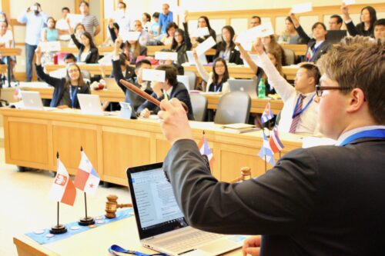

Congratulations! We’re very excited that you will be doing Model United Nations for the first time. You are about to embark on a life-changing journey that will help you develop confidence in leading others, a stronger awareness of global issues, and the chance to make new friends from around the world. Model UN is a valuable experience that can help you get into college, find your first job, and become inspired to change the world. And most importantly, M-U-N is F-U-N!

Model UN can seem intimidating or confusing at first, but we’re here to help with this page. “MUN Made Easy: How to Get Started with Model United Nations” is**divided into five sections:**

1. What is Model UN and how do I sign up?
2. How do I prepare for my first conference?
3. What will a typical day in committee look like?
4. Attend a 101 Workshop
5. Attend a conference

This should help you get started for your first conference. It’s important to dive right in because Model UN is an activity that can only be learned through participation. We’ve also provided resources at the end of this article for you to practice and improve once you’ve finished your first conference and you’re ready to take your experience to the next level.

**What is Model UN and how do I sign up?**

1515

00:00

01:43

Model United Nations is an academic simulation of the United Nations where students play the role of delegates from different countries and attempt to solve real world issues with the policies and perspectives of their assigned country. For example, a student may be assigned the United Kingdom and will have to solve global topics such as nuclear non-proliferation or climate change from the policies and perspectives of the United Kingdom.

Students can attend Model United Nations conferences around the world and from the comfort of their own homes with online conferences(thanks god we don’t have covid districtions this year). These conferences are organized by universities, high schools, non-profit organizations, and other educational groups. Conferences are offered for different academic levels: college and university, high school, middle school, and grade school. There is no central governing body for Model UN — any school can create a Model UN team and register for any Model UN conference they wish to attend.

Once a team has registered for a conference, it receives a country to represent. Each student on that team will represent that country in a different committee with different topics. For example, Best Delegate High School could be assigned China and have different students representing China in the disarmament committee, the human rights committee, the development committee, and so forth. Schools with larger teams will receive additional countries.

When you or your club are first getting started with MUN, you need to select a conference to attend. Visit our [MUN Conferences page](https://bestdelegate.com/model-un-conferences-database) to find a conference to attend. The largest conferences are 4-day events at a hotel with 3,000+ delegates and more than 300 delegates in the same committee, but when you’re first starting out, we suggest finding a small 1-day or 2-day novice conference near you or online so it’s easier to learn how MUN works.

**How do I prepare for my first conference?**

Once you have signed up for a conference, you will receive your country assignment, your committee, and its topics. Most conferences provide a Background Guide or Topic Synopsis that introduces the topics — read that first.

There are typically three items to prepare before you walk into your first conference: the Position Paper (sometimes called a Policy Statement), your Opening Speech, and a Research Binder. Some novice conferences may also require a Country Profile.

**1. Position Paper (or Policy Statement)**

The[Position Paper](https://bestdelegate.com/a-formula-for-the-perfect-position-paper-solution-oriented-research/) is a one or two page document that is essentially **a summary of your knowledge of the topic and the position your country plans to take** when it enters committee. It typically contains four sections: Background of Topic, Past International Actions, Country Policy, and Possible Solutions. Position Papers are usually due before the conference.

The key starting points for researching each section are listed below. They will help you get started with participating in your first Model UN conference, but you will want to dig deeper as you develop more experience.

* **Background of topic**: Background guide of the topic provided by the conference, Google, the news, Wikipedia (to frame the topic)
* **Past international actions**: UN website, your committee’s website, key treaties or resolutions mentioned in your background guide, UN or NGO reports
* **Country policy**: CIA World Factbook, your country’s foreign ministry website, domestic programs within your country, and your country’s voting record on key treaties or resolutions
* **Possible Solutions:** NGO or think tank policy recommendations, past UN resolutions that you’d like to change or expand on, and your own creativity!

**2. Opening Speech**

The [Opening Speech](https://bestdelegate.com/wimun-guide-to-acing-a-debate/) typically lasts about 1 minute or 1 minute and 30 seconds and is the first speech you give to the committee. It is the **best opportunity for you to explain your country policy** and the key sub-issues you would like the committee to focus on. Opening Speeches are the main way for countries to determine who they want to work with, so it’s important to prepare a speech that conveys this. There are many tips and strategies on how to deliver an Opening Speech, but use your Position Paper as a guide when you are starting out. The most important action is to just be brave and make your first speech.

**3. Research Binder**

Research Binders are **optional but highly recommended**, especially since many conferences do not allow the use of technology in committee. An organized Research Binder will be your go-to resource during the conference as new terms and acronyms, previous resolutions and treaties, and possible solutions are mentioned. Here is a suggested list of [15 things every delegate should have for their Research Binder.](https://bestdelegate.com/mun-research-made-easy-15-things-every-delegate-should-have-in-their-research-binder/)

**4. How to Write a Resolution**

Delegates will be **writing a document called a Resolution** in committee along with other countries that they will be working with. It’s important to know the resolution format and phrases, but most conferences do not allow pre-written resolutions since they want countries to collaborate together during the committee. For more specific details, check out [How to Write a Resolution](https://bestdelegate.com/model-un-made-easy-how-to-write-a-resolution/).

**5. Country Profile**

The [Country Profile](https://bestdelegate.com/wp-content/uploads/2011/09/Best-Delegate-Country-Profile.pdf) is a worksheet to **help you understand your country** and may not necessarily be required by your conference. If required, Country Profiles are usually due at the same time as the Position Paper.

[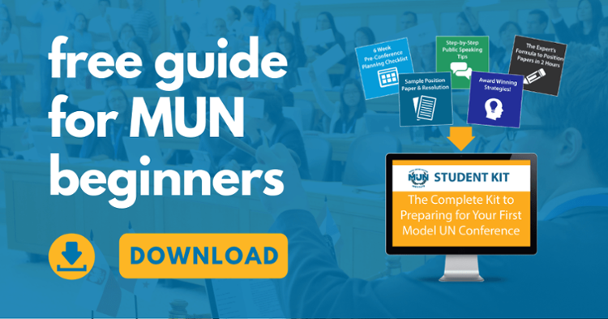](https://info.bestdelegate.com/cs/c/?cta_guid=86915b51-f7bc-4d33-8892-7f35e91991f7&signature=AAH58kF5eXAXLTSr6oIf1Kg4XtZu7AUYww&placement_guid=cd1904f0-a47b-4ac3-a49f-bb1c9b15a40d&click=2f01fcfc-311a-4ead-8157-0cb7e641456d&hsutk=9018c8189e893984bfc4c029193542f6&canon=https%3A%2F%2Fbestdelegate.com%2Fmun-made-easy-how-to-get-started-with-model-united-nations%2F&portal_id=2566615&redirect_url=APefjpGZPw2NU-Z-iRwM8u5oZnNmBqSTULNW1aOg1vdeh1IoSMrkiJbImOAqi9pubcoIvmlbuZ4eKkTkTr8V9nAPHu4xVXKjR407pZT2jofRd0b4u_Zjo3wctbueiLwhm1xs7bsjUgYYmW8q8ugzUkCMcLgieKmopg&__hstc=265751056.9018c8189e893984bfc4c029193542f6.1695888659124.1695888659124.1695888659124.1&__hssc=265751056.1.1695888659125&__hsfp=831256628)

Download the free guide for MUN Beginners!

**What will a typical day in committee look like?**

Note: There are no standards in Model UN and different conferences may run their debate and rules of procedure differently. The two most commonly used rules of procedure are North American/ UNA-USA procedure and THIMUN procedure; most conferences’ rules of procedure are copied or modified from those two. A new procedure based on the actual proceedings of the United Nations has begun to grow, called UN4MUN procedure, and is taking root in MUN committees worldwide. Also, some crisis committees may operate with a customized set of rules and debate formats but you probably will not encounter this during your first conference. Almost all Model UN conferences use some form of parliamentary procedure which varies significantly from the consensus-building procedure used at the actual United Nations.

Nevertheless, there are similarities, and the goal of every committee (with the exception of crisis) is to produce and pass a document called a Resolution which outlines the problems that the countries want to solve within a topic and the proposed solutions to those problems.

**UNA-USA Procedure**

**THIMUN Procedure**

**UN4MUN Procedure**

**Final Note**

Note that the descriptions above are for a typical day. They do not explain the whole flow of debate and rules of procedure, which will vary by conference. We also left out many of the Points and Motions used in committee. The most important thing as a new delegate is to actively participate. Ask a “**Point of Inquiry**” whenever you have a question, ask an experienced delegate to explain what’s going on, or to just go along with what everyone else is doing.

[Click Here](https://bestdelegate.com/video-how-to-get-started-in-model-united-nations/) to learn more on how to get started in Model United Nations.

**Attend a 101 Workshop**

[MUN Workshops](https://learnmodelun.com/pages/2022-2023-workshops) are great for MUN students just getting started and entire teams looking to train their new students.  
We offer multiple times to make it easy for Students around the world.

**Attend a Conference**

You can only understand and improve in Model UN with experience, so make sure to attend your first [conference](https://learnmodelun.com/pages/2022-2023-conferences) and plan to attend a few more! Here is a big global [list of conferences](https://bestdelegate.com/model-un-conferences-database/).